Proposal Success Rate
Contents
Overview 2
Location 2
Prompts 2
Definitions 4
Report Tabs 5

Overview
The Proposal Success Rate Report was created to provide metrics related to the number of proposal submissions compared to the number of proposals that have been awarded by sponsor. It examines proposal submission data over a period of time, presented by a number of key variables and sourced from both the InfoEd and Peoplesoft applications.

Location
The report is located in CU-Data in the following location:
Team content > eRA > CU Denver| Anschutz > Proposal Tracking

Prompts
After the report has been selected to run, the Prompt Page will appear:
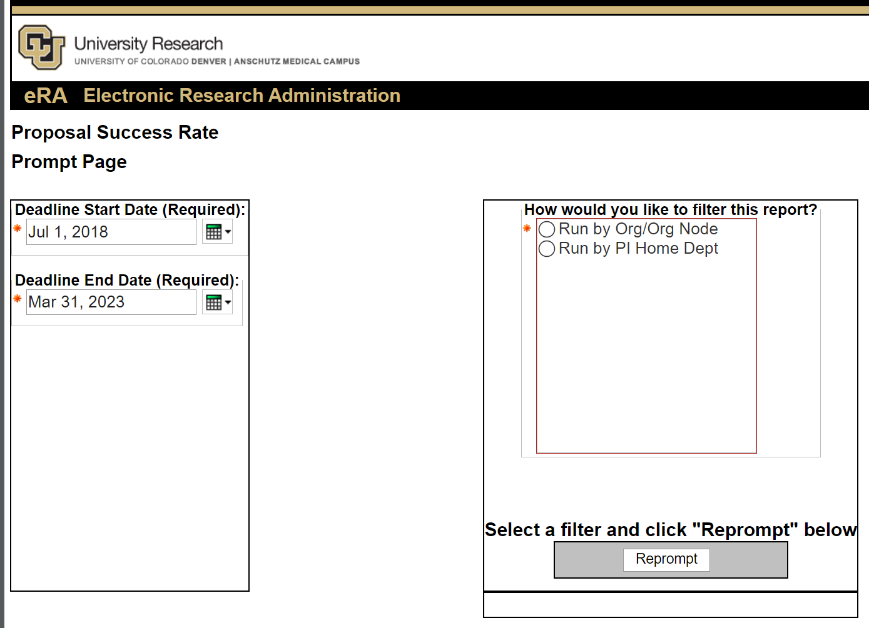
Select a date range for the Proposal Deadline Start and End Date.
The Prompt page will also give you the option to run the report by:
- the Org or Org Node associated with the Proposal in the eRA application, or
- the Home Department of the Principal Investigator in Peoplesoft

Once you have made a selection, click the "Reprompt" button to complete the proper Org prompt.
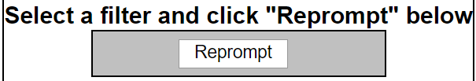
The appropriate prompt type for the Selection will appear below.
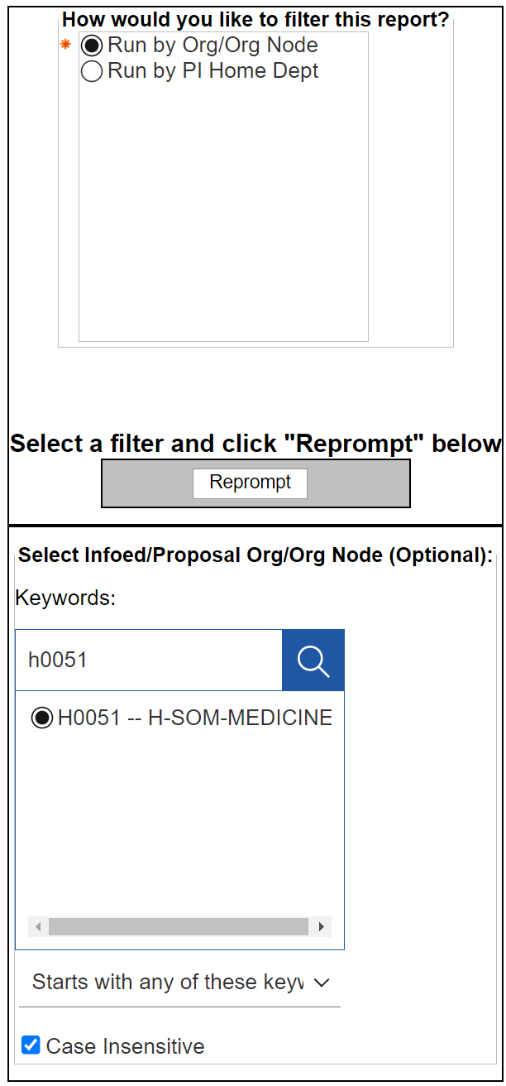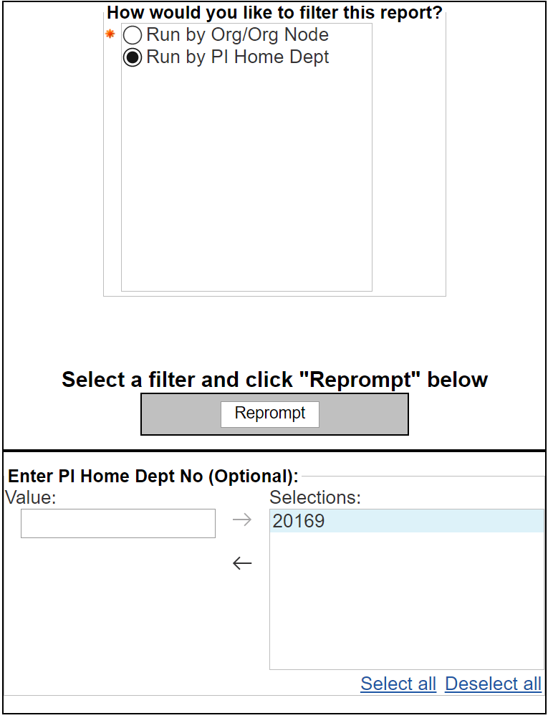

Definitions
Only proposals that are considered new and/or competitive are included in these metrics.
Proposal Types:
- New
- Competing Continuation
- Renewal
- Resubmission – Competing Continuation
- Resubmission – New
- Supplement
- Revision
Contracts are not considered to be competitive proposals in this analysis. The Instrument Type field in InfoEd drives this determination. Instrument Type data has only been validated from fiscal year 21 forward and so the report cannot be run for earlier fiscal years until further data cleanup efforts have been completed.

Submitted Proposals
Proposals are considered to have been "submitted" when the current status of the proposal DOES NOT reflect that the proposal is still in the review/processing stage.
Processing Statuses:
- Default Status
- Grant Proposal Review
- Grant Proposal Supervisor Review
- Grant Return Processing
- In Development
- In Routing
- Not Used
- Grant Routing Intake
- Withdrawn – PI Request
- Routing Review – Returned to PI
- Grant Transfer Out Request
- Grant Transfer Out Approval
Awarded Proposals
Proposals are considered to have been "Awarded" when the current status includes one of the following:
- Awarded
- Award Received
- Award Received ? Budget Hold
- Grant JIT Request
- Grant JIT Submitted to Sponsor
- Grant Extension Request
- Grant Extension Approved

NOTE: If there are awarded dollars recorded on the proposal, it is considered to be “Awarded” regardless of the current status. Additionally, records in a JIT status are considered “Awarded” due to the long lead time between a submission and an award and the very high percentage of proposals that make it to the JIT stage that get awarded. Older records in JIT statuses are cleaned up if awards are not made. This can result in data up to a year and a half old changing. Report users should be aware that numbers in this report will therefore not be static over time.

Report Tabs
Note: Tabs will have a “Home” extension in the tab name if the report has been run to filter for the PI Home Department.

Summary Tab
Represents a high-level summary of the overall counts and dollar amount of routings, overall success, as well as a breakdown by Sponsor Groups for the date range.
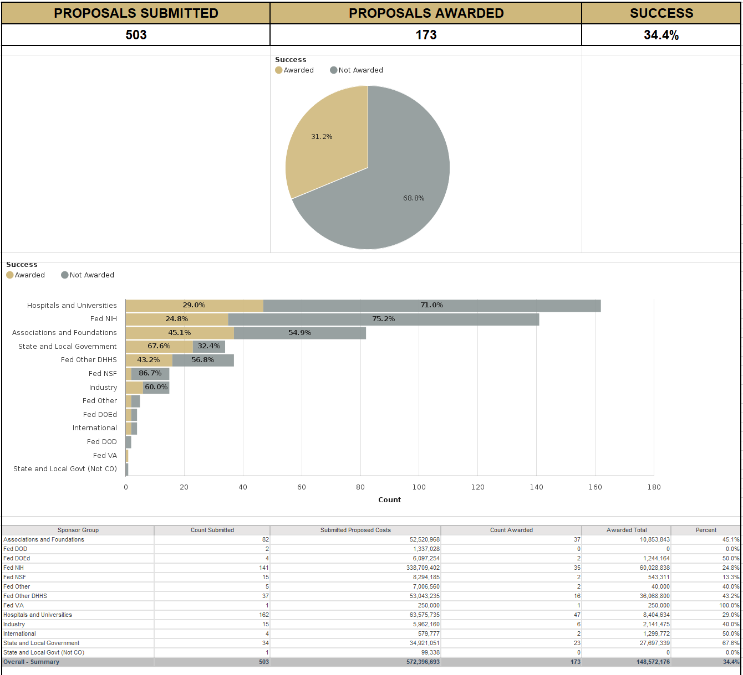

Org Detail Tab
If the report consumer has selected to run the report by Org or Org Node from the Prompt Page, this tab will present a breakdown of proposals at the individual Org(s) assigned to the proposal in eRA (including the Peoplesoft Org Tree hierarchy):

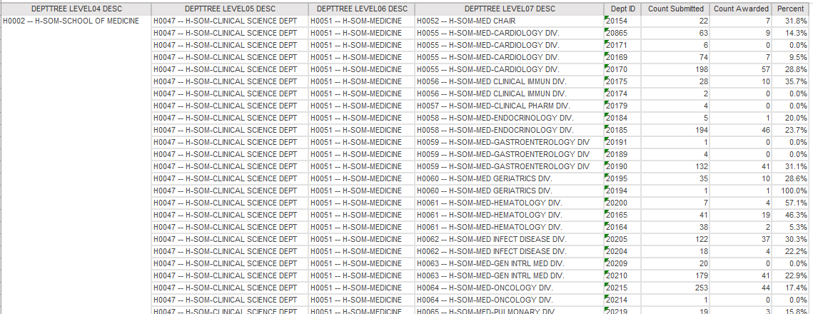

Org Detail_Home Tab
If the user has opted to run the report by the PI Home Department, this tab will present a breakdown of proposals by the Home Org designation of the PI from Peoplesoft, but also includes the department assigned to the proposal in InfoEd.

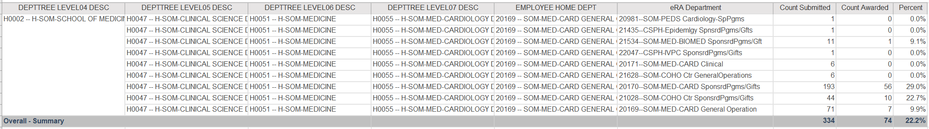

History Tab
The History tab presents the data in a historical perspective by Fiscal Year. Page includes:
- Overall success and submitted counts by Fiscal Year
- Awarded proposals by Sponsor Type as a percent over Fiscal Years
- Counts of Proposals submitted and awarded over Fiscal Years by Sponsor Type
The "Success" visualizations have been varied for the most recent Fiscal Year to reflect that the results are for a partial FY or may include recent Submissions where a final determination has not yet been made by the Sponsor.
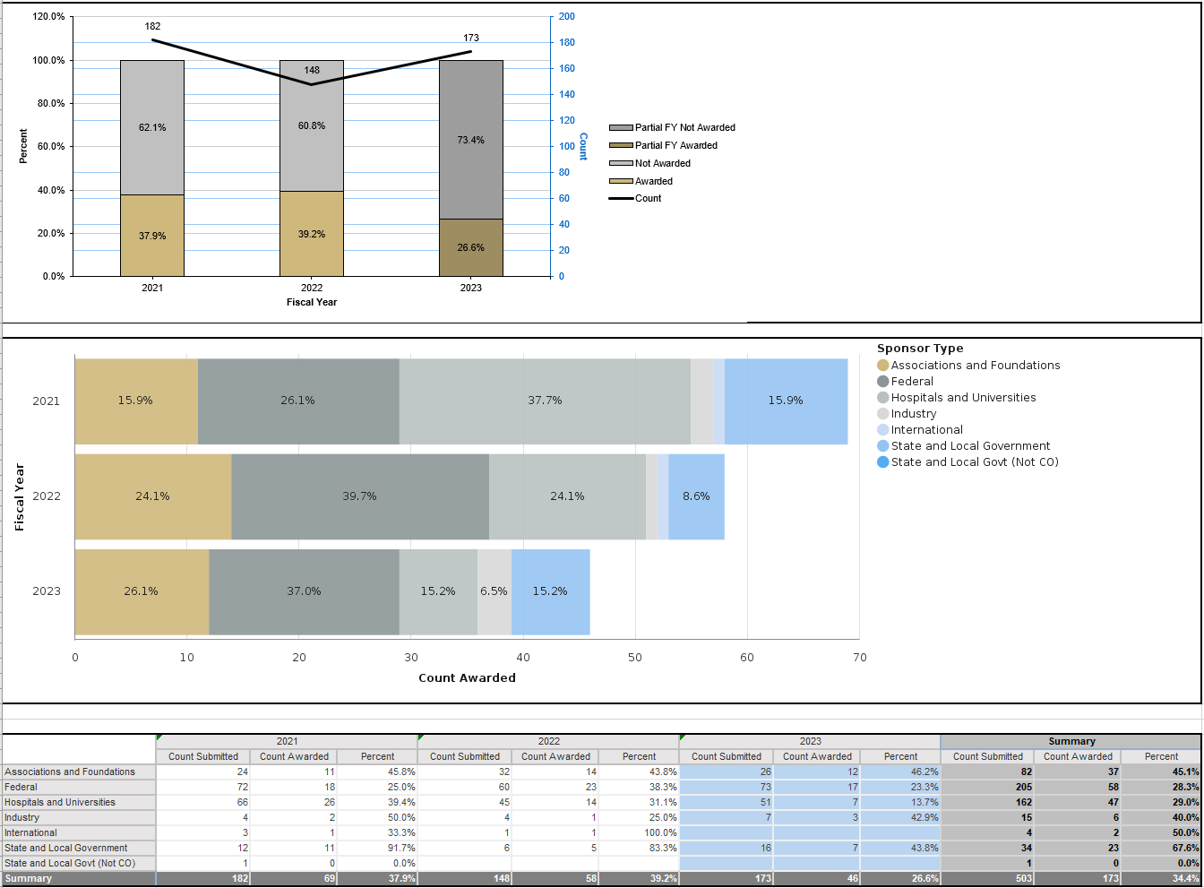

PI Summary
This tab details proposal submission and success information by the Principal Investigator.
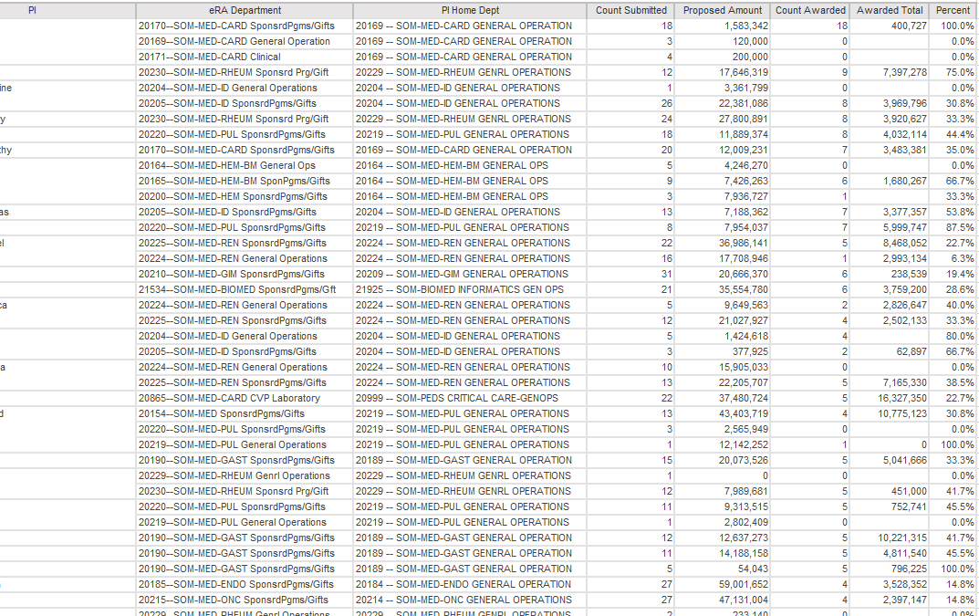

Detail Tab
This tab presents back-up proposal detail for the overall metrics, with the same Proposal Type and Proposal Status parameters. Details from InfoEd are combined with PI Home Department and Org Tree Levels 04, 05, 06, and 07 from Peoplesoft.

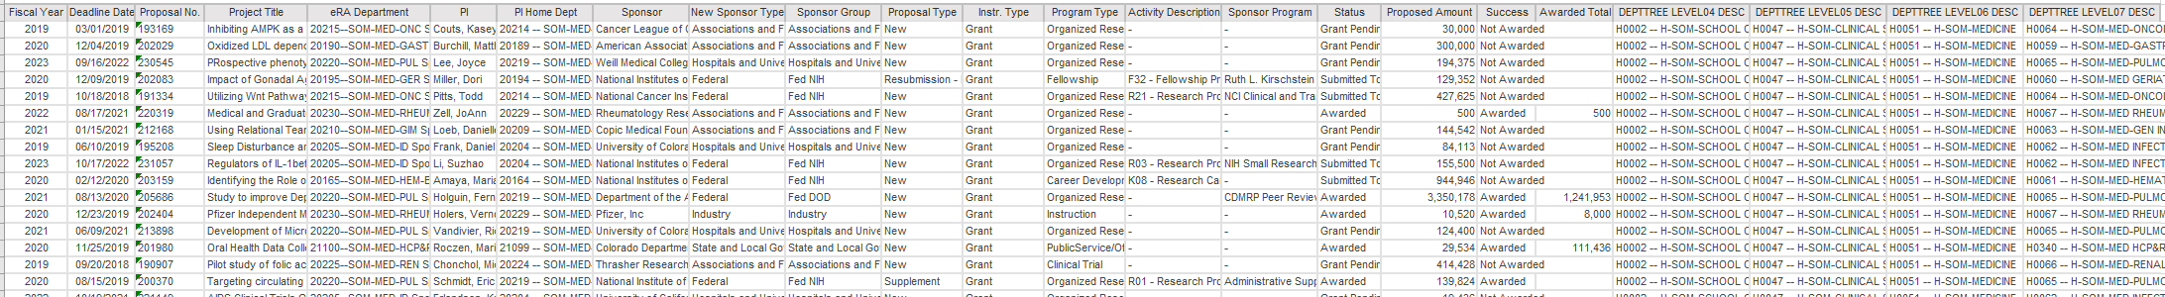

Documentation Tab
Provides a more abbreviated version of the Report Documentation as part of the report for reference.
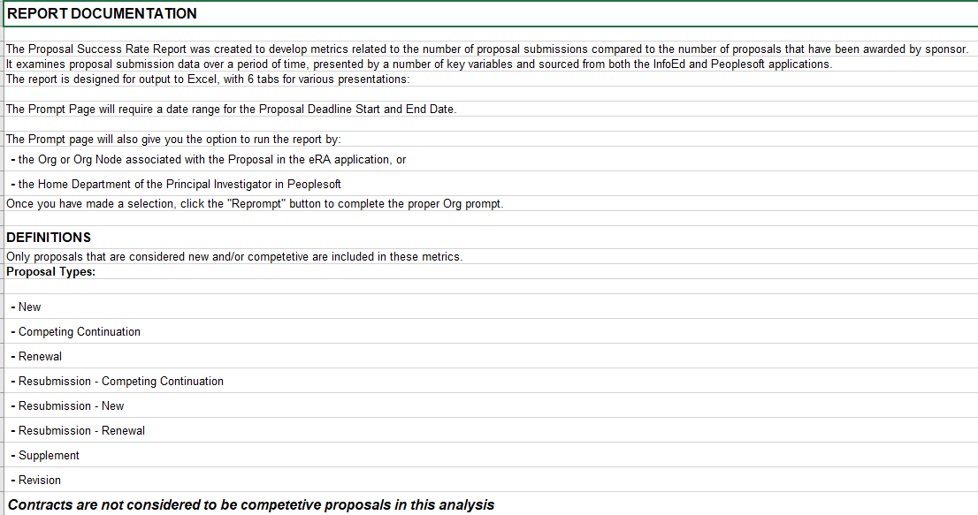

Ctrl+Click: Back to Top

