Project/Speedtype Lookup Report

Contents
Project/Speedtype Lookup 1
Overview 2
Path 2
Prompts 2
Report Columns 3

Overview
The Project/Speedtype lookup tool is a way to find the Project and/or Speedtype by searching a variety of Award data and vice versa if you have award data such as PI you can look up all Projects/Speedtypes for that PI.

Path
eRA > CU Denver| Anschutz > Award Tracking

Prompts
When entering prompts, you can enter one or multiple into your criteria.

Enter Proposal ID – The Master New proposal, i.e., first proposal or new segment proposal are recorded in PeopleSoft and can be used to pull related Projects/Speedtypes and related basic award information.

Select Sponsor Award Ref No(s) - Currently not functioning more information to come.

Enter Speedtype(s) - Enter Speedtype(s) to pull listing of project and other basic award information.

Enter Project No(s) - Enter Project No(s) to pull listing of speedtypes and other basic award information.

Enter Award No(s): This is the same search as proposal ID option above.

Enter Org ID(s): This is based on the 5-digit org number assigned to the Project/Speedtype.

Select Principal Investigator(s): - This is searching on full name with format Last,First. You can use the contains choice in the options, to search by part of the name.

Select Sponsor is full sponsor name- Tip you can enter part of the name and change your search to contains under the options, and then select from listing.

Select Department – This is based on Org Desc and does not include the ID if you want to enter part of a desc change criteria in the Options link for this search.

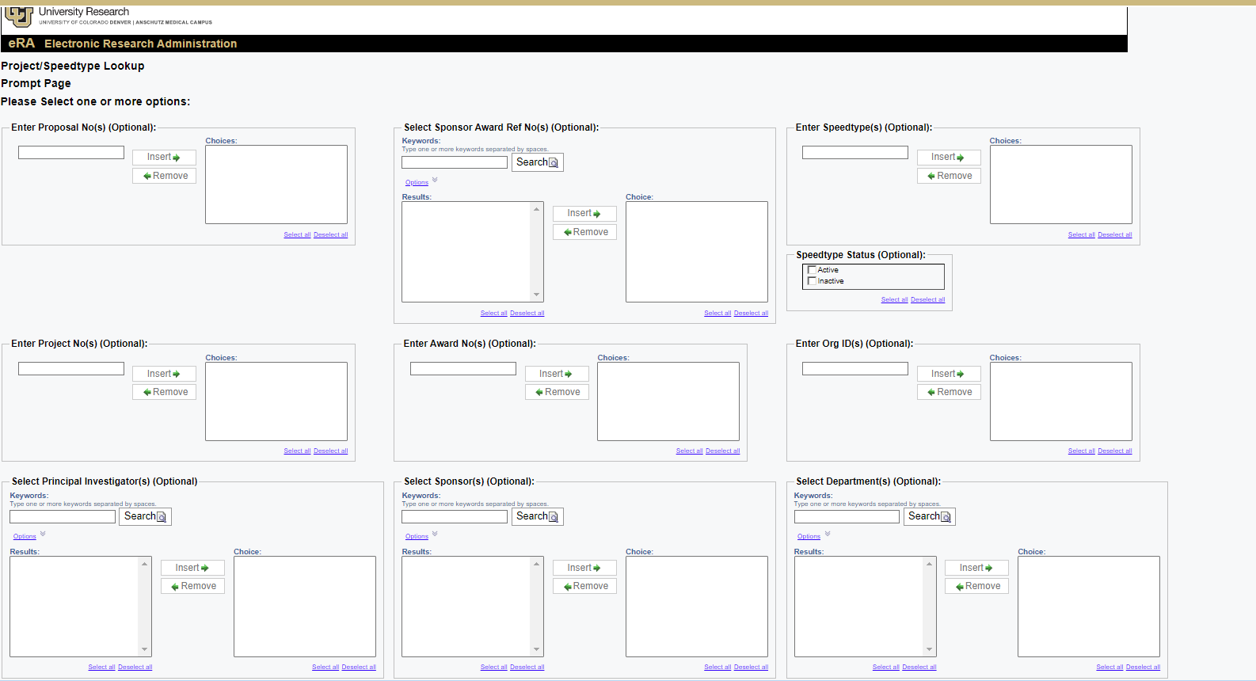

Report Columns
Project Proposal ID
Project Award Code
Project Ref Award Code
FOPPS Proj_ID
Speedtype Code
Speedtype Status Code
FOPPS Project Desc
Project Long Desc
FOPPS Org Desc
FOPPS Project Principal Name
Project Sponsor Name
Project Start Date
Project End Date
Prod Budget Start Date
Project Budget End Date
Budget Dollar Amount
Actuals Dollar Amount
Encumbrance Dollar Amount

Ctrl+Click: Back to Top

