PI’s On Active Projects
Contents
Overview 2
Path 2
Prompts 2
Report Columns 2
Tabs 3

Overview
This report returns PI’s for all active projects recorded in the Grants Module of Peoplesoft, with Active defined by the Project End Date.

Path
eRA > CU Denver| Anschutz > Award Tracking

Prompts
The Prompt Page requires a date which the query then uses to determine if the Project End Date in Peoplesoft is beyond the date in the prompt.
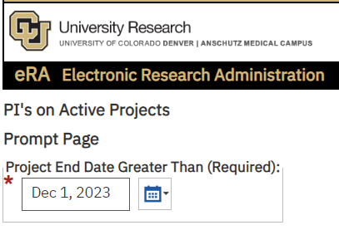

Report Columns
The report is designed to send output to Excel and has 2 tabs:

Summary tab:
Campus
School/College
PI Count

Detail tab:
Campus
School/College
Project
Principal Investigator
Sponsor ID
Org
Org Description
Project Start Date
Project End Date

Tabs
Summary
Detail

The Summary tab groups project counts by School/College
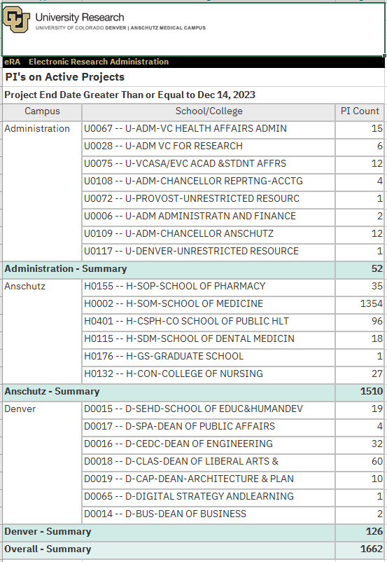

The Detail tab provides additional detail at the Project level from Peoplesoft.
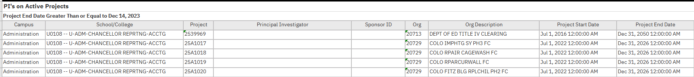

Ctrl+Click: Back to Top

