Grants/Contracts Personnel Report

Contents
Grants/Contracts Personnel Report 1
Overview 2
Path 2
Prompts 2
Report Columns 3
Tabs 4

Overview
The Grant/Contracts Personnel Report supplies several ways to pull personnel and their details on InfoEd records based upon criteria such a specific department or a specific personnel org.
The Associated Department node allows users to pull records for a node and all departments below it in the Org Tree (e.g., H0051 for all SOM proposals). The Report will show all records with an associated record department under that org and show all personnel listed on those projects.
The Personnel Department prompt will pull records based upon the org associated with personnel on the project which can span multiple orgs for the orgs associated with the records in InfoEd but does not list all the personnel for each record displayed, only those in the Personnel Department org selected in the prompt.

Path
eRA > CU Denver| Anschutz > Proposal Tracking

Prompts
Note: Some prompts have a blue Options hyperlink that can be clicked to expand the search criteria. Case sensitivity may be adjusted and any of four search options may be selected: 1) Starts with any of these keywords, 2) starts with the first keyword and contains all the remaining keywords, 3) Contains any of these keywords, 4) Contains all these keywords.

Associated Department (select node)
- The “select node” version of the prompt will include results for the selected node and all orgs below it in the org tree
Personnel Department (select node)
- The “select depts” version of the prompt will only include records that the specific department has been searched for and will not include records for orgs below it in the org tree. All desired orgs must be added individually. This is more suited to multi-departmental searches
Select Investigator Name
- Also allows for searching by Employee ID
Select Proj/Acct/Misc Number
- This will be Project ID(s) for awarded records, an Activity Code, or the potential grant number depending on the stage in the application cycle of records at the time of the search
Proposal Type
Sponsor Type
Current Status
Sponsor
Deadline Date
Process Date
Submit Date

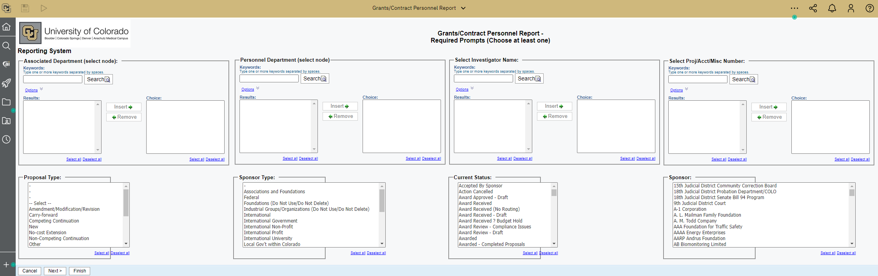

Search Tips
A search by Associated Department shows proposals with the chosen Primary Org and will pull all personnel on those records even if they were added to the record under a different org (Associated Department 20210 sample below):
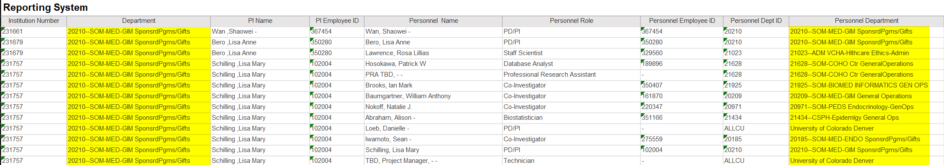

A search by the Personnel Department pulls out proposals where there are personnel from the chosen Personnel Department but ONLY shows the personnel from the department chosen, not all staff on the proposal. This search would be used to find which records personnel from a specific org are on, as opposed to the complete list of personnel on a proposal.
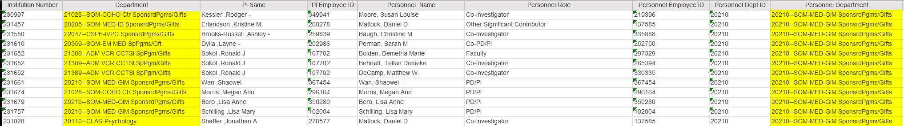

Report Columns
Institution Number
Department
PI Name
PI Employee ID
Personnel Name
Personnel Role
Personnel Employee ID
Personnel Dept ID
Personnel Department
Proposal Created By
Status
Proposal Type
Sponsor
Sponsor Type
Project Title
Program Type
Instr. Type
Process Date
Deadline
Returned to Dpt
Submit Date
Proposal Account Number
Requested Project Period Start
Requested Project Period End
Proposed Direct Costs
Proposed Indirect Costs
Proposed Total Costs
Award Date
Awarded Project Period Start
Awarded Project Period End
Award No.
Awarded Direct Costs
Awarded Indirect Costs
Awarded Total Costs
Create Date
PD?

Tabs
Page 1

Ctrl+Click: Back to Top

