October 2019

FINANCIAL SERVICES CONNECTION
Office of Grants and Contracts

Genomic Arrays policy for NIH Grants, Cooperative Agreements & Contracts

Notice number: NOT-OD-10-097

Genomic Arrays – the process to examine a piece of DNA on a glass slide to detect the different variants of sequence in the genome for the purpose of identifying/mapping variants.

The National Institutes of Health (NIH) issued a notice on May 13, 2010 regarding recovery of Facility and Administration (F&A) costs when purchasing genomic arrays. Effectively, the NIH limited F&A cost reimbursement on purchases of genomic array supplies to the first $75,000 in each budget grant year. Any amount in excess of $75,000 in a given budget year will not be assessed F&A costs.

To properly track genomic arrays expenses and comply with NIH’s F&A restrictions, the following account codes were set up:

530133 Genomic Arrays-1st $50,000-F&A
492756 Genomic Arrays > $50K<75K-F&A
492757 Genomic Arrays >$75-F&A Exempt

The following example illustrates how the account codes are to be used: An award is for three years and genomic arrays expenses will be applied as follows:

$75,000 in year 1; $100,000 in year 2; $150,000 in year 3

Year 1-$75,000
Account code 530133-$50,000
Account code 492756-$25,000

Year 2-$100,000
Account code 530133-$50,000
Account code 492756-$25,000
Account code 492757-$25,000

Year 3-$150,000
Account code 530133-$50,000
Account code 492756-$25,000
Account code 492757-$75,000

A check box has been added on the routing form to identify any Genomic Arrays on the proposal.
New SciENcv Biosketch Is Now Accepted by NSF

Biosketch Update – Effective immediately, the National Science Foundation is designating SciENcv (Science Experts Network Curriculum Vitae(link is external)) as an NSF-approved template and is encouraging faculty to use SciENcv to prepare a biographical sketch for inclusion in an NSF proposal. NSF will continue to accept biographical sketches not prepared through use of SciENcv until implementation of the next iteration of the Proposal and Award Policies and Procedures Guide (PAPPG), which is estimated to be implemented in January 2020.

SciENcv is a researcher profile system for all individuals who apply for, receive or are associated with research investments from federal agencies. SciENcv is available (link is external)in My NCBI.

Click here for a guide for using SciENcv>> (link is external)

Training Survey

Financial Services is planning to expand the sponsored projects training curriculum for next year, and we would like your input on what topics would be most beneficial to you and your department. We invite you to take a one-minute survey to help us identify the training needs on campus. The anonymous survey is found at: https://ucdenver.co1.qualtrics.com/jfe/form/SV_0SsPzaDNoTfpIyx.


The Office of Grants and Contracts is conducting several searches. To see a list of specific job duties, please refer to the job posting in CU Careers.

- Accounts Receivable Specialist – Posted in CU Careers, Req #17461 (replacement position)
- Billing Specialist – Posting Soon (Req #17454)
- Contract Specialist – Posting Soon (Req #17499)

October Team Talks Topic – Compliance

Please join us at the next Team Talks session on October 28, 2019.
This session will focus on gift card programs, petty cash funds, and the recent CU Identity Manager upgrade.
Remember to add this event to your calendar.

REGISTER

Monday, October 28

CU Denver CU Anschutz
Time: 9:00-10:30am Time: 2:00-3:30pm
Location: Business School, Room 4500 Location: Education 1, Room 1400
Zoom: https://ucdenver.zoom.us/j/796089557 Zoom: https://ucdenver.zoom.us/j/363472939

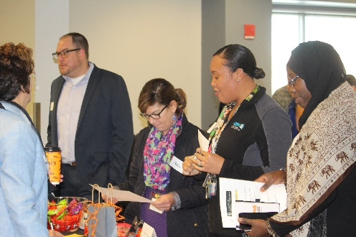
OGC Open House

Thank you to everyone whom attended the OGC Open House event on October 8. The feedback we received thus far indicates the event was a success. At the event, we had food, games, fun, and prizes.

We are all working towards the common goal of “research administration” and often times it is hard to create personal connections via emails and phone calls while all working hard to meet deadlines. The focus of our event was to connect with our department partners, engage in face-to-face communications, expand the knowledge of what our teams do, and to facilitate relationships in a fun environment. Thank you for giving us the opportunity to engage with you.

And the winners were……..
- OGC Drawing winners – Aloha Hoppin, Tyokek Ogemahgeshig, and Pamela Garl
- RAIN Giveaway winners – Phyllis Sevik and Eric Maize

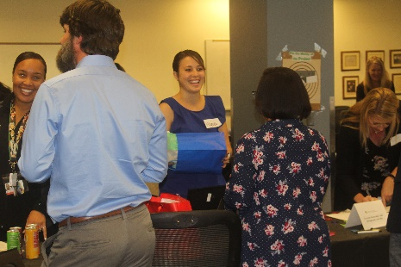
Game Prize Winners:
- Pre-award Game – Natascha Palmer
- Post Award Trivia Pursuit – Jessica Craig
- Contracts Operation Game – Beauty Jobe
- Guess the Gift – Corey Gillette, Carissa Smith and Zac Gonzales
- Guess the number of Award Setups – Alyssa Haberle, Beauty Jobe,
Carol Achziger, Carissa Smith, Chanel Mansfield, and Gabbie Cook

Lastly, a special thanks to the RAIN (Research Administration Information Network) group for hosting and organizing this event with us. We appreciate all you did for this event!

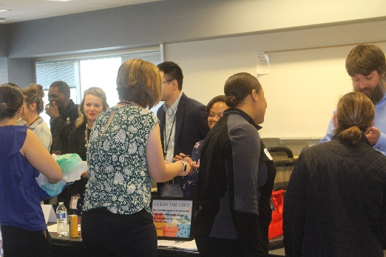
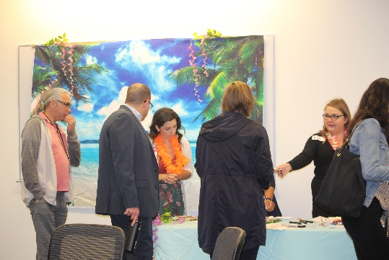


Debra Wright (Debbi) joined the Office of Grants and Contracts Billing team earlier this month as a Billing Specialist (held previously by Rocio Aleman). She will be reviewing new and existing sponsored program agreements to determine billing requirements and process monthly invoicing. Debbi brings over 15 years of finance experience and has her MBA in Accounting & Finance. Her personal life includes five children, and when not working, she and her husband are dividing and conquering between their children’s basketball games. Debbi can be contacted at 303-724-0086 or Debra.Wright@CUAnschutz.edu.

Sarah Spurlock joins the Billing team mid-month as the Sponsored Project Collections and Award Setup Specialist (formerly held by Thai Nguyen). Sarah comes to us by way of Humboldt State University in Acata, CA. Sarah obtained a Bachelor’s and Master ’s degree in Business Administration from Humboldt and was employed as an Accounting Technician at her alma mater. Sarah can be reached at x43162 or Sarah.Spurlock@cuanschutz.edu.

Rochelle Hubbart is a recent CU Denver Business School graduate where she received a Bachelor’s in Business Administration with a Finance emphasis. She was born and raised in Denver and in her free time enjoys reading, painting, spending time with family, and watching movies. Favorite movie is The Great Debaters and has a slight obsession with everything Harry Potter related. Rochelle will join the Award Setup team led by Bryce Walsh. She can be reached at x44094 and Rochelle.Hubbart@ucdenver.edu.

To subscribe to the GC-Updates list serve,
click here.

