March 2019

FINANCIAL SERVICES CONNECTION
Office of Grants and Contracts

Upcoming InfoEd Subawardee Database Changes
Starting April 1, 2019, the subawadee database will be locked down and departmental users will no longer be able to add new institutions to the database in InfoEd. This change is to prevent duplicate and incorrect entries being created in the database and to remove the need to routinely purge the database of such entries.

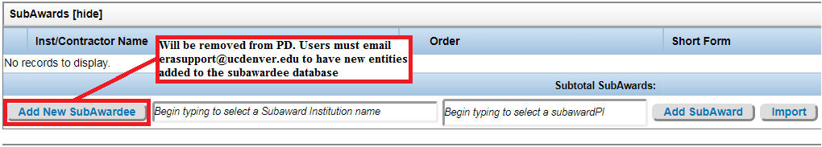

For any new subaward institutions that need to be added starting April 1, please email erasupport@ucdenver.edu with the details of the new entity to be added (entity name, DUNS number, congressional district, and address). Your request will be handled promptly by a member of the eRA Team to minimize any delays in routing.

Approvals blocked in Chrome
Some users have reported issues with approving routings in InfoEd. If you are having difficulties with approvals, the easiest method to resolve this is to use Firefox or Internet Explorer at this time. If using Chrome, a small icon with a red X will appear in the upper right corner of the address bar to indicate a pop-up has been blocked. To accept the blocked pop-up, click the icon with the red X in the top right corner and select “Always allow pop-ups from this page”, then click done. You may have to refresh the page or click on the approval link in your email to go to the approval page again to continue with the approval process.

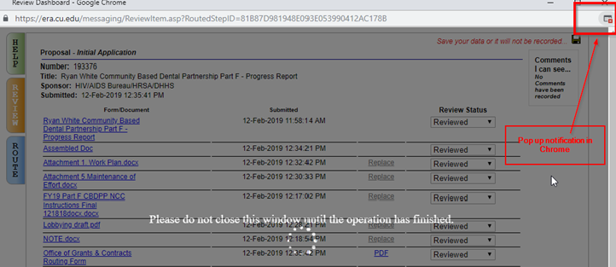

2018 Sponsor Compliance Reviews

Last year, multiple federal sponsors conducted site visits and desk reviews of the University’s grants management practices and procedures. Federal regulations require agencies to monitor recipients to ensure award terms and conditions are followed.

Our recent federal reviews have focused on:
- Cost allowability;
- Documentation of subrecipient monitoring;
- Invoicing;
- NIH Salary cap violations; and
- Departmental adherence to University policy, specifically ePER certification.

Cost Allowability
When charging costs to an award, University personnel must follow the applicable cost principles and the University’s Direct Charges to Federally Sponsored Projects policy. Charges must be:
Allowable under the University’s policy and under the applicable cost principles for the award;
Necessary and reasonable for the project;
Allocable to the project in the proportion of benefit to the project; and
Consistently treated as either direct costs or indirect (F&A) costs.

Unallowable costs must be removed from the award as soon as possible using either a Payroll Expense Transfer (PET) or Journal Entry (JE). Additional information for completing a PET or JE can be found on the OGC website.

Documenting Subrecipient Monitoring
Federal award terms and conditions require the University to adequately monitor our subrecipients. In addition to monitoring, the University has a responsibility to document our monitoring activities. The OGC website provides a sample Subcontract Monitoring Record form. Departments should use this form, or a similar, form to document subrecipient monitoring activities.

Invoicing
The University cannot provide invoices to sponsors based on estimated costs. The University’s policy and federal regulations require the actual incurred costs to be charged to a sponsor.

NIH Salary Cap
Congress limits the salary an individual can receive under NIH awards. The current salary cap is $189,600 per year. This means no individual at the University may receive compensation that exceeds the salary cap. Departments must verify the employees do not exceed the salary cap, and track any excess compensation by using a cost share speedytpe to cover any overages. The salaries for personnel on a 9-month appointment or part-time appointment must be converted to a 12-month base to verify that the salary cap is not exceeded.

University Policies
A full list of policies and procedures related to sponsor project management is found on the OGC website. Adhering to University policies and procedures is a requirement for sponsored projects.

In 2018, multiple federal sponsors reviewed departmental compliance with time and effort reporting. Under the University’s Time and Effort Reporting on Sponsored Projects Policy, employees are required to certify ePERs within 120 days of the ePER creation.

Sponsored Project Trainings for Spring 2019
To help ensure compliance with sponsor requirements, Financial Services offers a variety of training courses related to sponsored project administration. The courses are offered at both CU Anschutz and CU Denver and are open to all employees.

The courses for Spring 2019 are:
- SP 1 – Introduction to Sponsored Projects
- SP 2 – Cost Principles for Sponsored Projects
- SP 3 – Pre-Award Administration for Sponsored Projects
- SP 4 – Post Award Administration for Sponsored Projects
- SP 5 – Products of Research
- SP 7 – Essential Communication Skills for Research Administrators
- SP 8 – Regulatory Compliance Requirements for Sponsored Projects 1
- SP 9 – Regulatory Compliance Requirements for Sponsored Projects 2
- SP 10 – Clinical Trials
- SP 11 – Contracting for Sponsored Projects
- NEW COURSE SP 12 – Introduction to 2 CFR 200 (Uniform Guidance)
- NEW COURSE SP 13 – Introduction to the NIH Grants Policy Statement (NIHGPS)
- NEW COURSE SP 14 – Advanced Pre-Award
- NEW COURSE SP 15 - Advanced Post Award*
- NEW COURSE SP 16 – Subrecipient Monitoring Policies and Procedures
- NEW COURSE SP 17 – Gifts to the University

*Please note that the Advanced Post Award course replaces SP6: Departmental Best Practices.

Registration, course descriptions, and time and date offerings for each course are found in SkillSoft. To register for the courses in SkillSoft, please follow these instructions.

Please feel free to reach out to TK Keith (Thomas.Keithiii@ucdenver.edu) or Shane Jernigan (Shane.Jernigan@ucdenver.edu) if you have questions about the training program.

New OGC Team Members

PreAward Manager – This month we welcome Michael Moore to the team. Michael joins our team from San Jacinto Community College in Houston, Texas where he served as the Director of the Office of Grants Management. He will bring over 15 years of experience in Program Development, Grant Development, and Small Business Capital Funding to the team.

PreAward Specialists – Also this month, we welcome Myka Barnes-Garcia and David Stein to the team. Both are internal hires from other CU departments so we’re excited to have them continue to grow professionally with our team. Myka is currently in the practicum phase of her RAWC Fellowship and is close to finishing as part of the inaugural class. As an Army Veteran, we look forward to the leadership and attention to detail David will bring to the team. Both Myka and David have been integral in the day-to-day operations of extramurally funded projects on campus. We look forward to the diverse perspective they will bring to the team.

Billing Specialist – Cindy Le is our newest billing team member. She has joined the Office of Grants and Contracts from the School of Public Affairs at the downtown campus. She has four years of experience in Accounting, Finance, and Office management. Cindy has a bachelor’s degree in science and business administration, accounting major and minor in economics. She is currently working on her masters in Science and Accounting.
Compliance in the News

The U.S. Department of Justice recently highlighted two cases involving grant mismanagement at other universities.

In January, a university agreed to pay nearly $2.4 million to resolve allegations of misappropriated grant funds. The university is alleged to have placed an order for a large quantity of materials just prior to the end of a grant, then stopped shipment of that material. The university then used the credit from the initial purchase to obtain goods and services unrelated to the project after the close-out of the grant.

In December 2018, a professor at a university pled guilty to stealing money from the federal government. According to court documents, the professor used a credit card to purchase personal items totaling more than $6,900. The professor submitted a fictitious receipt and fraudulent justification for the expenses. Using the fraudulent documents, the university applied the charges to a NASA grant. The professor will be sentenced on March 27, 2019.

New Closeout Reports Folder in CU-DATA
In CU Data a folder has been created to group common reports OGC recommend for use when a project and/or award is coming to a close. These reports can be found under Team Content>Finance>Report View Shared>Closeout Reports

The reports currently included in this folder are:
m-FIN Trial Balance Summary
m-Fin Payments Received
m-Fin Award
m-Fin Compensation Summary
m-Fin Financial Detail

We are working to get a report for “Outstanding Epers by Project ID”. Once that report is available, we will add it to this folder.

For easier access, you can copy this folder to your “My Content” folder for future use. To do this, navigate to the folder and click on the three dots to the left of the Closeout Reports folder. You will have the option to Copy the folder, once you do this, you can choose “My Content” as your destination.

If you have feedback on other reports we should add to this folder or assistance please contact your post award administrator.

Reports to Burst for Projects Ended
In April, OGC post award will be releasing the second batch of closeout reports. These reports will identify projects that have recently ended. The reports will list projects that are 30, 60 and 90 days after the project end date. These reports will be similar in format to the 90, 60, 30 days before end date, but will be color coded for ease of viewing. Your projects in Ended Status will have Yellow headers, and projects in Reporting Status will have Red headers. We have also published on our website both of the closeout checklists. They can be found in our A-Z resources on the Office of Grants and Contracts website under “Closeout”. http://www.ucdenver.edu/research/OGC/Pages/AtoZ.aspx

If you have any feedback once you start getting these reports, please contact Stephanie at stephanie.thompson@ucdenver.edu.
Employment Opportunities
The Office of Grants and Contracts is conducting several searches in the PostAward unit. To see a list of specific job duties, please refer to the job posting in CU Careers.

- PostAward Administrator (15741) – Interviews are in progress. Open until filled.
- Closeout Specialist (15753) – Interviews are in progress. Open until filled.
- Accounting Professional (15909) – Position is posted in CU Careers.
- Sponsored Project Award Specialist (15955) – Position is posted in CU Careers.

