July 2019

FINANCIAL SERVICES CONNECTION
Office of Grants and Contracts

Issuing Pre-Awards
We have been seeing many folks utilizing the pre-award process to keep projects going when waiting for documents to funds continuing awards and contracts and making those requests using the online form. This has been going very well and therefore starting August 1 2019, we will be discontinuing acceptance of the old paper form. All requestors will need to use the on-line form. To access the form please visit the A-Z Resources section of our website under PreAward Request - Establishing and Account - Exhibit A.

Is your Award going to be New or additional funding to an existing award?
Reminder that requests for pre-awards on “New” proposals must be in a fully submitted status and have gone through a complete routing workflow. Requests to continue existing awards with a status of “In Development” will be accepted.

NOTE – If you do not have the documents or information needed to complete a full routing, please save while in development and do not complete your routing, so you can access it again later when you have full routing information or documents to add and complete routing.

Is your Award for a direct federal grant?
For Direct Federal Non Competing Grants we are issuing pre-awards without a form. Please note that in order for these routings to be pre-awarded automatically, the proposal type should be “Non Competing Continuation”, and the start date for the current expected budget period needs to be the start date for your new budget year. We are seeing errors where the segment (project period start date) is being used. When there are errors on these routing submissions the routing does not come to setup for auto generation.

Choosing the Right Supplement Package in InfoEd
InfoEd prompts users to select which package to use when they create a system-to-system supplement submission for NIH. There are different forms, particularly budget forms, between programs such as Training, Research, and Construction grants. When building your application, make sure to confirm you have chosen the correct package. Under the Competition Title column in InfoEd, the system indicates the type of submission. If the wrong selection is made, the Setup Questions tab can be uncompleted, and the package changed. Please note, if you are changing between sets with different budget forms, such as from Research to a Training formset, you should remove all your budget figures before switching your formset, as your budget tab may be locked down depending on which supplement type you chose.

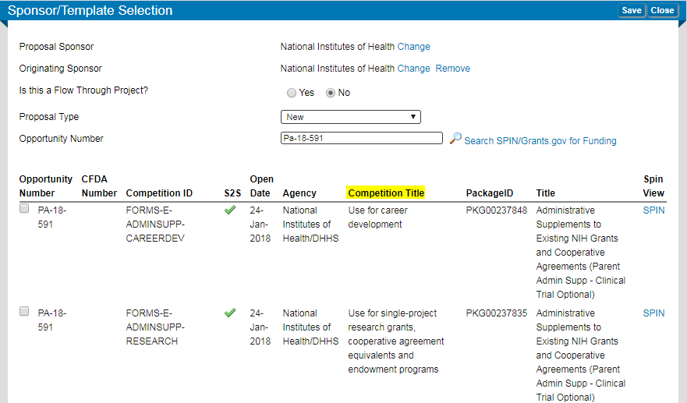
Reminder – Site Visit or Desk Review Requests
Please contact Barb Hayes at 303-724-2276 or barb.hayes@cuanschutz.edu if a
Sponsor requests a Site Visit or Desk Review involving Fiscal and/or Administrative components.

InfoEd Changes – What You Need to Know
Beginning Monday, November 25, InfoEd will look and feel differently to what you are used to. While the functional changes are minimal, there are some new features that may change the way you search the Conflict of Interest (COI), Human Subjects (HS), Proposal Development (PD) and Proposal Tracking (PT) modules.

What is changing?
InfoEd is being upgraded several versions to the most current version – 812.01. With this upgrade, you will primarily see aesthetic changes in color, look and feel. The functionality you are used to will not change significantly.

The most important changes you will see with the upgrade are as follows:
- The new Enable landing page includes Widgets (shortcuts to commonly used features)
- Flyouts with extended navigation functionality were added
- The search function has changed to selection of preferred parameters
- Changes to the titles of certain fields to allow searching across modules (e.g., “Proposal number” or “Certification number” will be shown as “Record Number”)
- The “adding personnel” functionality uses progressive text instead of alpha split
- For COI, you can now submit your disclosure with fewer clicks

Why are we upgrading?
We are implementing the upgrade for the following reasons:
- We are currently several versions behind in InfoEd, meaning that we can’t receive patches, upgrades or enhancements to the software.
- Version 812.01 includes enhancements we need, and lays the foundation to keep current and to accept desired features.
- We are not using InfoEd to its fullest potential today and this upgrade will allow us to do so.

The Regulatory Compliance Office, Office of Grants and Contracts and The Office of Information Technology are partnering to bring this upgrade to you. There will be many opportunities to engage with these departments to learn more about the upgrade, the changes and to provide feedback. Keep an eye out for town halls, newsletter articles, training opportunities and more in the coming months.

Have questions about the InfoEd 812.01 upgrade project? Please reach out to erasupport@ucdenver.edu.

August Team Talks Topic – InfoEd Upgrade & PreAward Processes

Please join us at the next Team Talks session on August 29, 2019. This session will provide more information on the InfoEd upgrade. Also, please let us know which PreAward processes you’d be interested in learning more about.
Don’t forget to add it to your calendar.

REGISTER at https://www.surveymonkey.com/r/TT_Aug29

CU Anschutz
Date: Thursday, August 29
Time: 2:00-3:30pm
Location: Research 1 North, Hensel Phelps East
To join via Zoom, click https://ucdenver.zoom.us/j/848109995

To subscribe to the GC-Updates list serve, click here.

OGC Team Updates

Sub-Contracts Specialist – Robert Ladmirault has accepted the Sub-Contracts Specialist role (formerly held by Eric Maize) within OGC’s PreAward and Contracting Services unit. His first day will be Monday, July 15. Robert will work alongside Will Carter on the Subcontracts team. He recently moved to Colorado from Texas where he received a Master of Public Administration from Texas A&M University. Robert can be contacted at Robert.Ladmirault@cuanschutz.edu or 303-724-7973. Welcome Robert!

Sponsored Project Award Specialist – We’re excited to announce that student worker, Zejian Liu, has accepted the Award Specialist position (formerly held by Caroline Whitaker). Zejian will be working with Bryce Walsh’s team and is responsible for award setup, project costing and billing. Effective July 17, she can be reached at 303-724-0097.

The Office of Grants and Contracts is conducting several searches. To see a list of specific job duties, please refer to the job posting in CU Careers.

- PostAward Administrators – We are conducting a search for two PostAward Administrator positions (formerly Closeout Specialists). The posting is #16702 in CU Careers.

- Contracts Specialist – We’re currently conducting second interviews. Posting #16546 is open until filled. Position previously held by Brent Larson.

