|  |
| --- |
| *C:\Users\esaus\Pictures\dualCampus_sl_clr.jpg*  *May 2018* |
| **FINANCIAL SERVICES CONNECTION**  Office of Grants and Contracts |

**Project Life Cycle Statuses and Future Controls**

OGC announced in July 2017 the use of new PeopleSoft Project life cycle statuses. At this time, those status changes are still updated manually by your Post Award Administrator. Coming in the fall of 2018, these statuses will start changing automatically within PeopleSoft at specific time points after the project end date. We will also be implementing a new control structure behind these statuses to help ensure expenses are posted to the project timely and within the project dates.

Over the next few months, there will be much more information to come on this modification to assess readiness and help you prepare for the change. Please review the status descriptions and future controls listed below. Note these status controls will not be put in place for older projects that are being worked as part of OGC’s closeout initiative.

* “S” Pre-Spending – Status for pre-award spending projects. This status will allow all transactions approved to post.
* “O” Open – Status initiated after award setup through the life of award. This status will allow all transactions approved to post.
* “E” Ended – Status inserted 1 day past the project End Date. This status is intended to stop new requisitions, new purchase orders, and new funding distribution entries.
* “R” Reporting – Status entered at 60 days after project end date. This status is intended to stop transactions from posting while Final Report is being prepared. This status will stop you from entering new transactions as well as stop you from doing PETS on projects.
* “C” Closed – Status changed to closed manually after final reports have been submitted and all payments received. This status is to represent the project is complete and no further reporting or adjustments are needed.

We will be hosting additional Team Talks in June to discuss the fall changes in more detail and impacts to your day-to-day activities. Please keep your eye out for those sessions.

**Grants Team Talk**

Please join us at the next Team Talk session on May 17. We’ll be discussing Proposal Management. The intent of this Team Talk is to assist the Department Grant Administrators with the necessary information to process Sponsored Projects Proposals through the Institution for approval and submission to the funding agency.

Please be sure to register at [**https://www.surveymonkey.com/r/TeamTalk\_May17**](https://www.surveymonkey.com/r/TeamTalk_May17)

**CU Denver CU Anschutz**

**Date: Thursday, May 17, 2018 Date: Thursday, May 17, 2018**

9:00-10:30am 1:00-2:30pm

Location: Business School, Room 3200 Location: Ed 2 North, Room 1102

To join via Zoom, click <https://ucdenver.zoom.us/j/706265236>.

**Duplicate Approval Emails**

Several department users have reached out to us regarding approvers receiving 3-5 duplicate e-mails each time an approval is required on a routing. We have identified a work-around for this issue so no duplicate e-mails should be generating. Please let us know if you have approvers still experiencing this issue and thank you for bearing with us as these notifications clogged your inbox during that time.

[*www.ucdenver.edu/OGC*](http://www.ucdenver.edu/OGC)

**Unsupported Characters in the HS/CT Form**

If the Human Subjects/Clinical Trial form was required for your application in the previous NIH Cycle, it was fairly common you came across errors that prevented the completion of the HS/CT tab. The errors resulted from having curly quotes, elongated dashes, or Greek symbols in the content of those text fields.

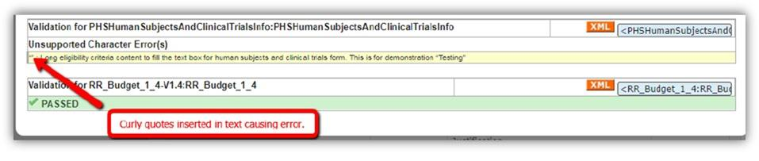

The vendor has released some fixes for this and we are just starting to test this against our campus environments. We are aiming to have this applied to our current production environment within the next 2-3 weeks and another notice will be sent out once the work is complete.



Want to review the basics of Funding Entry, Department Budget Table, Fiscal Year Rollover and PET processes? Get started by registering for upcoming webinars and on-campus training sessions.  Webinars will be offered every other week in May and June.

[**Webinars**](http://view.communications.cu.edu/?qs=de2a1564466314db93b69bf4bc280f367c938aa15d30bb29919d245f95dca4ac82273660c86dd3781c7c408eabda38f199be00b271080318ecf0b093b477b047bfa801fc7c65258bed61f0f929f37286)

From 3-4pm on May 8, an [HCM Funding Entry Basics](https://register.gotowebinar.com/register/2889990837425026563) webinar will provide information about how and why to create funding distributions by examining the relationship between funding and position, considering the impact on encumbrances and more.

From 3-4pm on May 22, a [Department Budget Table and Fiscal Year Rollover](https://register.gotowebinar.com/register/4896575368860429059) webinar will discuss how funding entry data is stored and managed on the department budget table, the requirements for fiscal year rollover and more.

[**On-campus Training**](http://view.communications.cu.edu/?qs=de2a1564466314db93b69bf4bc280f367c938aa15d30bb29919d245f95dca4ac82273660c86dd3781c7c408eabda38f199be00b271080318ecf0b093b477b047bfa801fc7c65258bed61f0f929f37286)

PET Basics will help you understand when and why PETs are needed, how to create a PET and more. Training will be offered on CU Denver | Anschutz campuses during the following dates:

* **CU Denver:**  9:00-10:30am, May 14
* **Anschutz:** 1:30-3pm, May 14
* **Anschutz:**  1:30-3:00pm, May 21

These sessions are open to employees from all campuses. Review the [registration instructions](https://www.cu.edu/doc/ssqrenrolliltpdf), then sign up in Skillsoft.

[*www.ucdenver.edu/OGC*](http://www.ucdenver.edu/OGC)

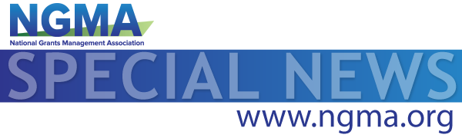

May 9, 2018

The General Services Administration is transitioning 10 online systems that manage procurement and awards processes to one site called [beta.SAM.gov](http://beta.sam.gov/). On May 25, 2018, they are transitioning the Catalog of Federal Domestic Assistance (CFDA.gov) to the new site and calling it Assistance Listings. This means that on May 25, CFDA.gov will shut down, and users who go there will be redirected to [beta.SAM.gov](http://beta.sam.gov/).

**New Team Member – Margaux Johnson**

We’re excited to welcome Margaux Johnson to OGC! She joined the team in April as a PostAward Administrator. Margaux is originally from West Virginia and most recently was employed by West Virginia University. Her experience includes negotiation and execution of outgoing sub-awards and amendments, data management of sub-awards and subsequent amendments, and grant and contract monitoring and closeout reporting. In her free time, she enjoys spending time with her family and exploring Colorado. Margaux can be reached at [margaux.johnson@ucdenver.edu](mailto:margaux.johnson@ucdenver.edu) or 303-724-0244.

[*www.ucdenver.edu/OGC*](http://www.ucdenver.edu/OGC)