|  |
| --- |
| *C:\Users\esaus\Pictures\dualCampus_sl_clr.jpg*  *November 2018* |
| **FINANCIAL SERVICES CONNECTION**  Office of Grants and Contracts |

**Project Status Funding and Spending Controls are now Live**

On October 22nd project spending controls went live. The implementation was completed as planned. The great news is so far the transition has been rather quiet as expected. Projects that ended after October 22nd have cycled to Ended Status. Payroll funding end dates that were blank or past the project end date have been updated as of 11/1/18.

What does this mean for your sponsored projects going forward? For a great resource please visit the UIS project page <https://www.cu.edu/uis/grants-optimization-project> this site has pictorial displays that summarize the change. This site also links back to our UC Denver and Anschutz Medical Campus project site where you can find job aids, and revisit all our prior communications in more detail.

As a reminder, here are some of the key impacts.

* As your current projects are reaching their end dates you will see them cycle through the statuses. These statuses will be displayed on multiple M-fin reports in the coming weeks and as those roll out we will update you.
* Payroll funding distributions cannot go beyond your project end date. Please use the Suspense Job Aid to run suspense data and make funding updates as needed.
* We are now setting up your federal grant awards for the entire segment as new awards and new budget periods are received. If you have questions about this please contact Award Setups.
* As your projects end certain transactions will not be allowed. If you have questions or issues please contact your post award specialist.

Office of Grants and Contracts would like to thank all our partners for their participation and efforts as we prepared for this change and we look forward to more opportunities for continued communications and grants management improvements.

**Reorgs for Sponsored Projects**

We are now completing reorgs for sponsored projects. We have evaluated the backlog of reorg requests, and for Speedtype that were still active, the reorgs have been completed and processed with October close. If you have questions about any reorg requests please contract Seth Hess at [seth.hess@ucdenver.edu](mailto:seth.hess@ucdenver.edu). The reorg process allows you to keep your original speedtype and moves all transactions project to date to the correct FOPPS. For new fund 30/31 requests please send email to [OGC.4status@ucdenver.edu](mailto:OGC.4status@ucdenver.edu) with the project, ST and org information. We will be working to improve the request process by rolling out a form stack based request form in the coming month. We will announce on G&C updates and in the next newsletter when the process is finalized. Thanks for all your patience as we worked through the backlog.

**InfoEd**

A few months ago, we attempted to run a script to update 11,000+ InfoEd records to strengthen reporting efforts on campus. Thanks to the ERA team and UIS, we were finally able to apply the script on Wednesday, Oct. 24th with success! A few key notes about this script:

1. All proposal records with a processed date of 18 months or older with the status of “Grant Pending” or “Submitted to Sponsor” changed to “Turned Down” status.
2. This status change will be recorded by ERA Support in the Status History folder in PT.
3. If there are records that should not be in this status just yet, please reach out to [ERASupport@ucdenver.edu](mailto:ERASupport@ucdenver.edu) and we will revert that record back to its previous status.

*(continued)*

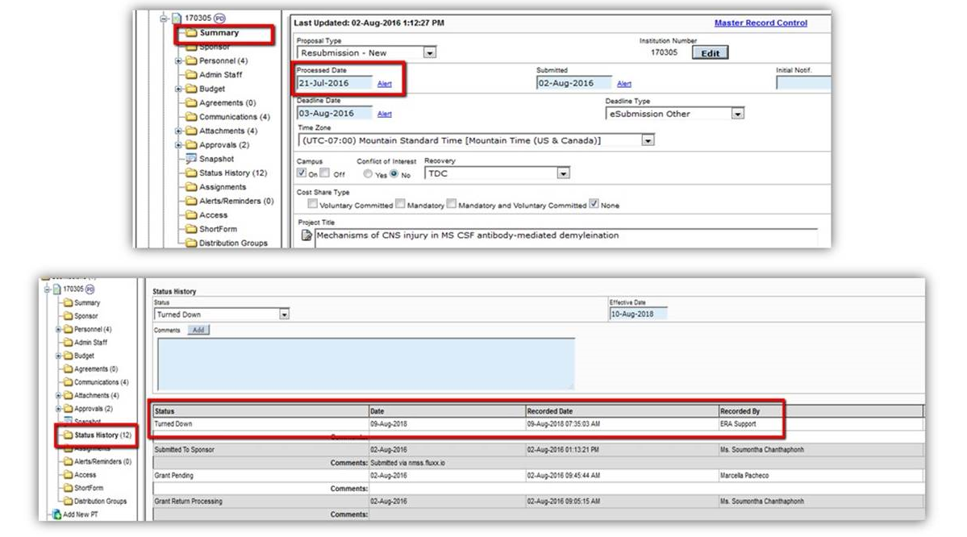

**Next Team Talks Session – Fiscal Compliance for Sponsored Projects**

Please join us at the next Team Talk session on **December 4, 2018**. This session will focus on Fiscal Compliance for Sponsored Projects and the University. The session will include the following topics:

* Federal Hot Topics for Compliance
* Sub-recipient Monitoring
* Government Property
* SBIR/STTR Programs
* Direct Charging and New Spending Controls
* General Award Fiscal Management

***REGISTER at https://www.surveymonkey.com/r/TT\_Dec 4***

**CU Denver**

**Date: Tuesday, December 4**

**Time**: 9:00-10:30am

**Location**: Business School, Room 4500

**To join via Zoom, click** [**https://ucdenver.zoom.us/j/923016318**](https://ucdenver.zoom.us/j/923016318)

**CU Anschutz**

**Date: Tuesday, December 4**

**Time**: 1:30-3:00pm

**Location**: R1 North, Hensel Phelps East, Room 1000

**To join via Zoom, click** [**https://ucdenver.zoom.us/j/729318697**](https://ucdenver.zoom.us/j/729318697)

**NIH Released Revised Grants Policy Statement**

In October, the National Institutes of Health (NIH) released a revised [Grants Policy Statement](https://grants.nih.gov/grants/policy/nihgps/nihgps.pdf). The revision is applicable to all NIH grants and cooperative agreements with budget periods beginning on or after October 1, 2018. The revision supersedes, in its entirety, the NIH Grants Policy Statement of October 2017 as a standard award term and condition. Previous versions of the Grants Policy Statement remain applicable as a standard term and condition for all NIH grants and cooperative agreements with budget periods that began prior to October 1, 2018.

NIH published a [list](https://grants.nih.gov/grants/policy/nihgps/Significant_Changes_NIHGPS_Oct2018.pdf) of significant changes in the 2018 Grants Policy Statement. Most of the changes incorporate previous NIH Notices released in the previous fiscal year. One change to the Grants Policy Statement is the addition of Section 4.1.35 Mandatory Disclosures.

This section requires NIH applicants and recipients to disclose, in a timely manner, in writing to the NIH awarding institute and the Department of Health and Human Services (HHS) Office of Inspector General (OIG) all information related to violations of federal criminal involving fraud, bribery, or gratuity violations potentially impacting the federal award. For sub-recipients, the policy requires written notification to the HHS OIG and the pass-through entity.

If there is an issue to disclose, please contact Financial Services as a first step as they will assist in the coordination of the disclosure to NIH and/or sub-recipient. Contact the Compliance Office by emailing TK Keith at [thomas.keithiii@ucdenver.edu](mailto:thomas.keithiii@ucdenver.edu) or calling 303-724-0489. Additionally, TK Keith should also be informed if a sub-recipient has provided a mandatory disclosure to a PI or departmental personnel.

**Sub-Recipient Monitoring Records**

Adequate sub-recipient monitoring remains a top concern for federal awarding agencies. The University has seen an increase in the number of requests from sponsors requesting our sub-recipient monitoring records.

The [Compliance Supplement](https://www.whitehouse.gov/sites/whitehouse.gov/files/omb/circulars/A133/2017/Compliance_Supplement_2017.pdf) to 2 CFR 200 directs auditors and federal agencies to:

Review the PTE’s documentation of monitoring the sub-award and consider if the PTE’s monitoring provided reasonable assurance that the sub-recipient used the sub-award for authorized purposes in compliance with Federal statutes, regulations, and the terms and conditions of the sub-award.

To ensure compliance, PIs should maintain a current monitoring record that details:

* Contact with sub-recipients
* Receipt of sub-recipient financial and programmatic reports
* Problems associated with the sub-recipient’s financial or programmatic management of the award

OGC provides a [subrecipient monitoring record template](http://www.ucdenver.edu/research/Research%20Administration%20Documents/SubrecipientMonitoringRecord_2015Oct.docx) and a process document for sub-recipient management. Failure to properly document sub-recipient monitoring could result in audit findings and disallowed costs, which would be the responsibility of the department managing the award.

In 2019, the Finance Office will be providing a new Sponsored Projects training course focused exclusively on sub-recipient monitoring. Registration for the course will be through Skillsoft.