Purpose: The purpose of this guide is to explain how to create a Standing Purchase Order for subcontracts in the CU Marketplace system, address common issues related to this procedure, and provide context for the procedure within the overall subcontracts process.
Context: A requisition for a SPO can be created at any point in the subcontracts process, provided that it is created by the time the subcontract is ready to execute. Once the subcontract is ready to execute, a SPO must be created and the requisition # provided to the subcontracts specialist in OGC in order to move forward with final signatures.
Step 1: When it is time to create a SPO, first locate the CU Forms section of the CU Marketplace homepage and select SPO-Sponsored Project Subcontract (SPO) form.
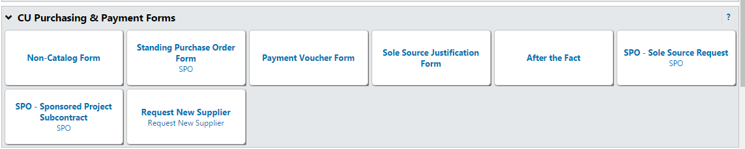
Step 2: In the Standing order details section, enter the supplier or click the supplier search link. Validate that the supplier and order Fulfillment Address selected are accurate. An order fulfillment address is the address to which the SPO will be issued.
You can change the fulfillment address, by clicking on the blue text that reads select a different fulfillment center. [See screenshot on the next page]
Please note that if the supplier does not exist you will need to request a new supplier.
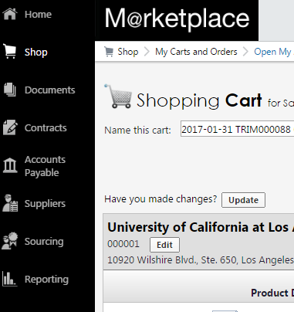
Click on Suppliers -> Requests -> Request New Supplier
Fill out the form [select New Supplier Request from the dropdown], including full contact information and the vendors W-9 if you have it. PSC will contact and set-up the vendor in the system and send a notification to the designated email identified in the form.

Step 3: Enter the required information in the SPO Description section. **Please note this step will differ based on whether the subcontract is greater than or less than $25,000.
Step 3(a) (Subcontract less than $25,000):
- Enter the SPO description
- Enter the SPO encumbrance
- Select Commodity Code 17
- Enter the Begin Date of the SPO
- Enter the end date for the SPO current budget period. The end date must mirror the end date listed in the subcontract.
- In the available actions section, select Add and go to Cart and then click the Go button in the upper right hand corner of the form.
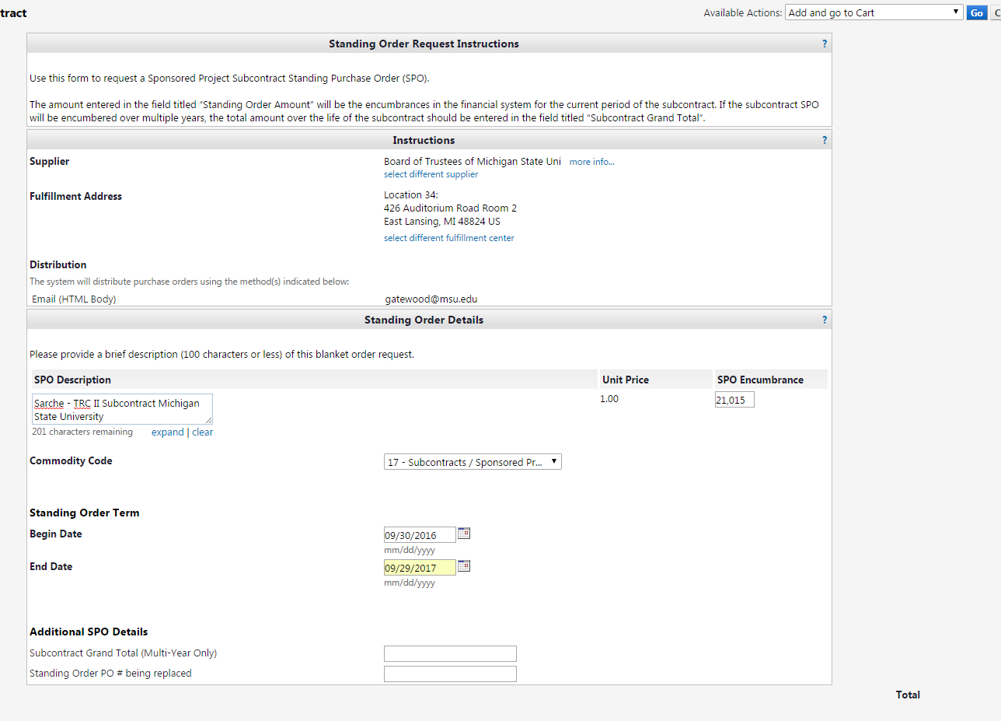
Step 3(b) (Subcontract greater than $25,000):
- Enter the SPO description
- Enter the SPO encumbrance up to the first $25,000. This amount will be encumbered on the financial reports line.
- Select Commodity Code 17
- Enter the Begin Date of the SPO
- Enter the end date for the SPO current budget period. The end date must mirror the end date listed in the subcontract.
- In the available actions section, select Add to Cart and return, and then click the Go button.
  - This allows for 2 lines to be set up so that F&A can be accurately allocated. The SPO will have to be re-created if you don’t select Add to Cart and Return because two lines won’t be created.
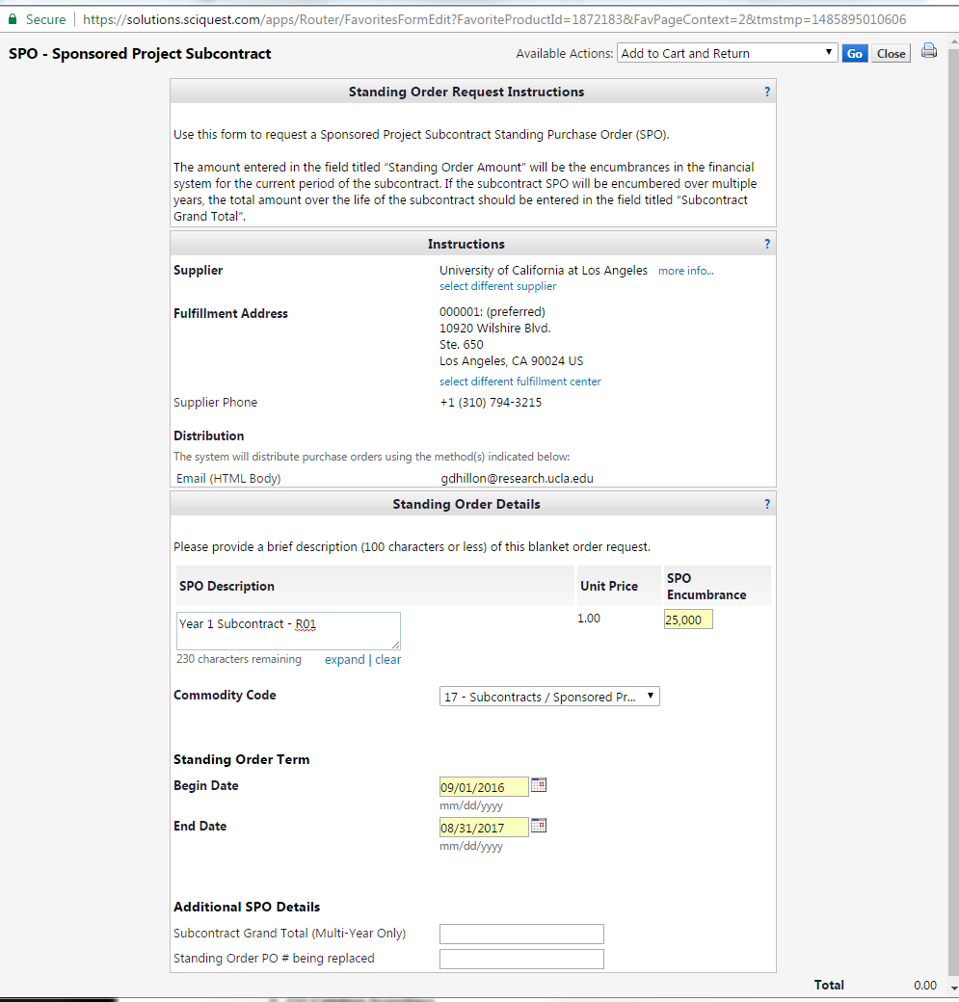

STEP 4: Complete the fields again – enter the balance of the Subcontract encumbrance amount in the SPO encumbrance field. If the subcontract is for $80,000 in this budget period and F&A needs to be taken on the first $25,000 –
After the fields are completed, select the action of Add and go to Cart under Available Actions.

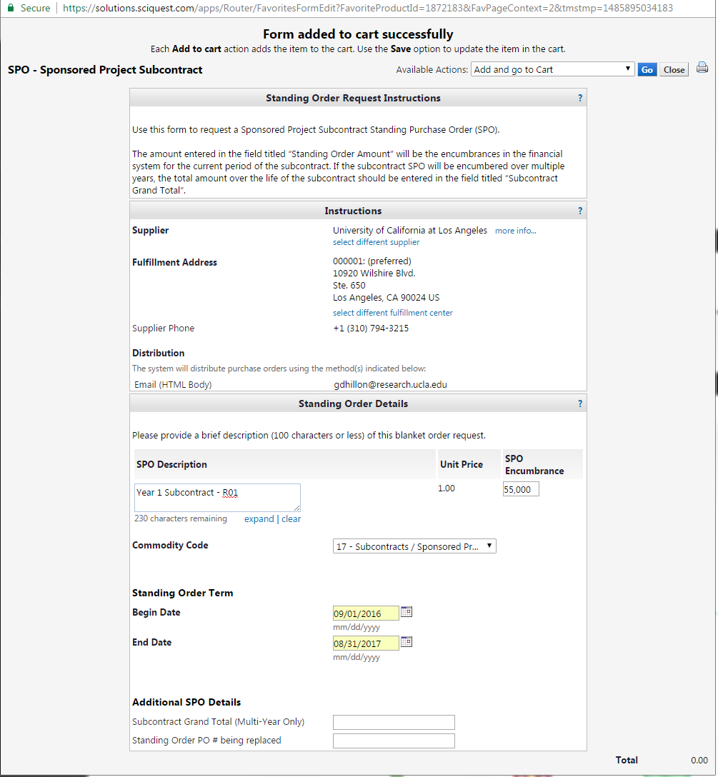

Form is completed first with line 1 of SPO Encumbrance amount of $25,000
Form is added to cart and returned for line 2 of the SPO Encumbrance amount equal to $55,000
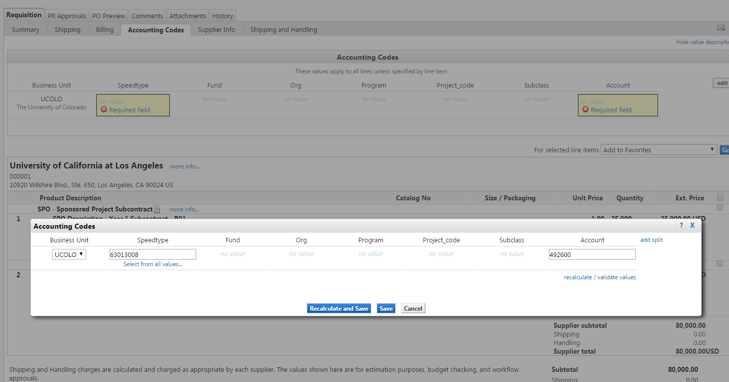

STEP 5: In the shopping cart, enter a unique shopping cart Name (optional) and click the Update button.
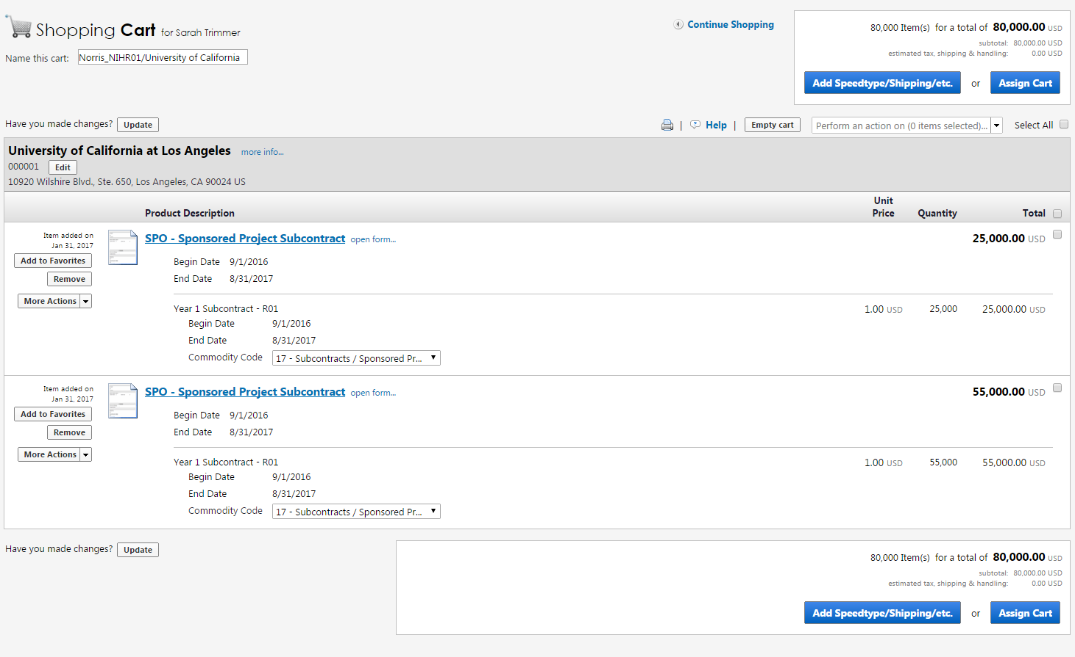

You can accept the default name or enter a unique name which can be used later to easily identify or search for your shopping cart.
The cart will show the 2 lines for the SPO – line 1 for the first $25,000 and the 2nd line for the remaining balance.
The above screenshot in shopping cart-naming step is incorrect (previous page). Notice there isn’t an Edit button next to the dollar amounts. The below shows a properly set-up cart screen shot that has two lines labeled 1. and 2. There is an edit button under each dollar amount.
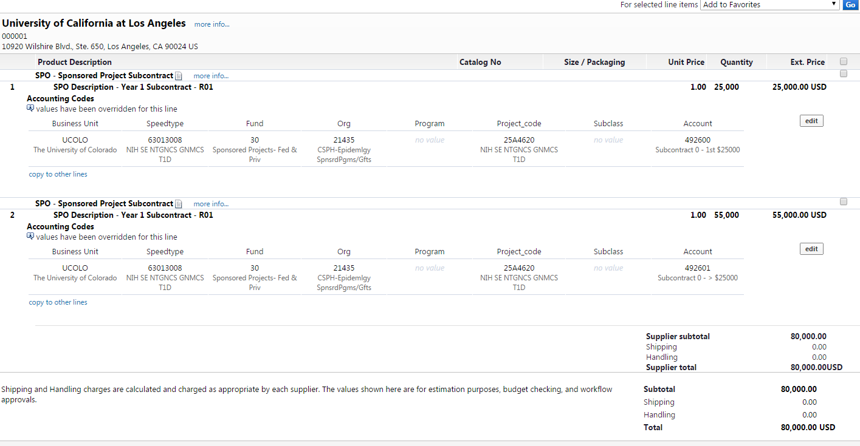

STEP 6: For line 1 select the Edit button and input the project ST and the account code for the first $25k.
Select “edit” and then enter the speed type. Next enter the account code that is appropriate and will allow for F&A to be assessed on the expenses charged. (This account code should end in zero.)
Then scroll to the 2nd line and select the “edit” button and enter the speed type. For the account code, enter the account code that is appropriate to exempt F&A from being charged on the expenses in the account code. (This account code should end in 1.)
Pro-tip: run an operating summary in m-fin and use the account that matches the OGC set-up. (Note – the below is just an example and does not align with our $80,000 example above.)
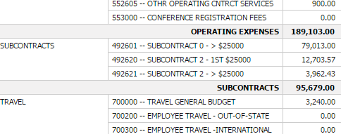

After both changes are made, the lines will be displayed as below. The split for these lines should be in the body not the header. The highlighted below is considered the header.
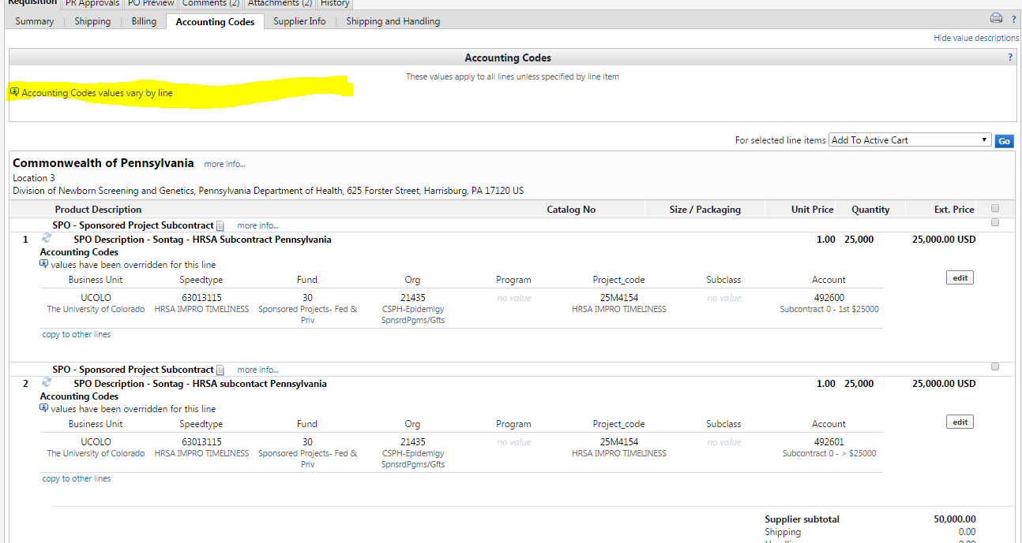

After all the changes are made, then select the “Submit Order” button.
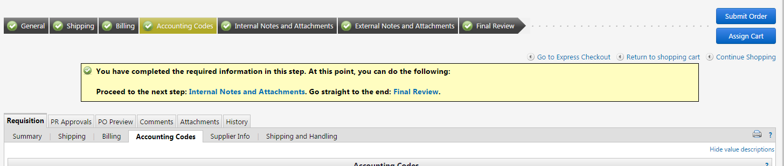

STEP 7: Now that you have your requisition set up, provide the requisition # to your subcontracts specialist along with a partially executed subcontract (with PI and Subcontractor signatures) if you are not using DocuSign, or just a list of signatories if you are using DocuSign.

