InfoEd eRA
Logging in to InfoEd

Logging In
Go to the following internet address: https://era.cu.edu
Tip: Recommended browsers are Mozilla Firefox or Google Chrome

- Type in your InfoEd Login Username in the first box
This is the same username as your university credentials, my.cu.edu portal or CU Outlook email system.

- Type in your current CU Password (as noted above for username)

- Click on the Campus drop-down and select Denver

- Click on the blue button

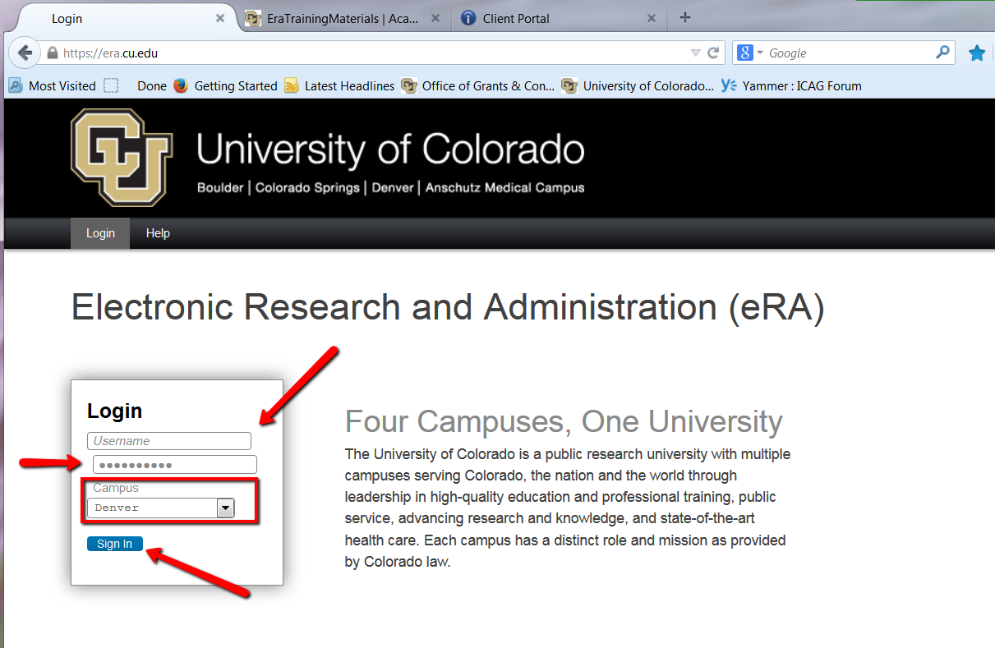

Your screen Login screen may contain messages about the browser not being compatible and/or supported. Do not be concerned nor cancel your login if you are using Firefox or Chrome.

If you have not logged into the CU network in several months your password may have expired. If you receive a message that your password must be reset contact CU OIT (Office of Information Technology) at 303-724-4357 (on Campus 4-HELP) or ucd-oit-helpdesk@ucdenver.edu. InfoEd eRA Support does NOT have access to your password.

