DocuSign Process Overview
DocuSign is an electronic signature program which the University of Colorado has purchased to use for expediting the execution subcontracts/amendments.
Steps to execute a Subcontracts/Amendment through DocuSign:
- Once a subcontract has been fully negotiated, please provide the Subcontracts team with the following information:
  - Name and email of Authorized official of Subrecipient who will sign via DocuSign.
  - Most commonly checked email of the University of Colorado Denver PI.
  - Requisition/PO number.
- The Subcontracts team will then initiate the signature process in the DocuSign program.
- DocuSign will automatically send out the subcontract via email in this order*:
  - UCD Admin: To approve the document
  - Subcontractor Authorized Official: To electronically sign the document
  - UCD PI: To sign the document
  - UCD Authorized Official: To sign the document
*Some institutions may request other approvers approve the document before the Subcontractor’s Authorized Official signs the document.
4. At the same time that the DocuSign email is started, the Subcontracts team will confirm that the MarketPlace Requisition/PO is correct and that funding is available.
5. After the MarketPlace Requisition/PO and funding are confirmed, and all other parties have signed via DocuSign, the UCD Authorized Official will review and sign and fully execute the subcontract.
7. After the subcontract is fully executed, DocuSign will automatically send out a copy of the fully executed document to all approvers and signatories for their records.
8. The Subcontracts team will upload the fully executed subcontract into MarketPlace and approve the Requisition/PO.

Process for Persons Approving Documents in DocuSign
- DocuSign will send an email to the UCD Admin’s email address that looks like this: 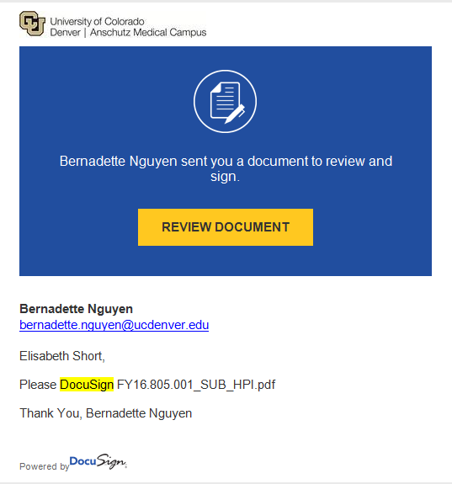
- Click the Button that says “Review Document”.
- DocuSign will open a new screen in your internet browser with the document you need to approve. Click Continue. PLEASE NOTE: Regardless of what the emails say – you do not have UCD signature authority and will never sign the document.

- There will be an “Approve” button at the top of the subcontract document. Once you review the document and confirm it is correct, scroll to the very top of the document and click “Approve”. If there are issues with the document, please contact the Subcontracts team.
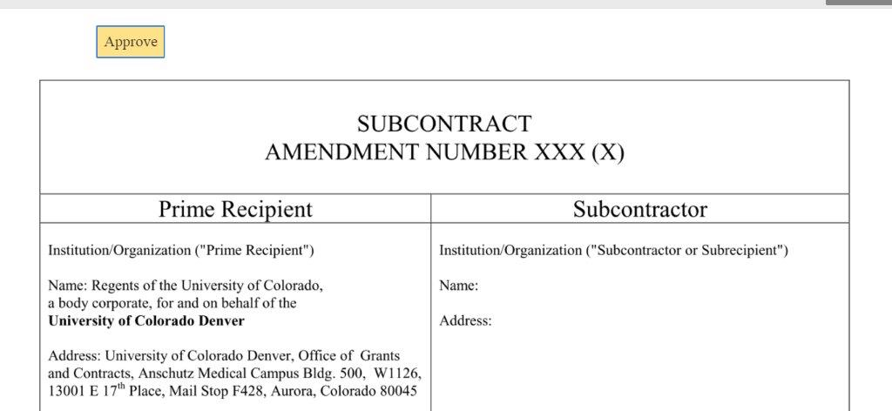

- Once you click “Approve” the subcontract screen will disappear and take you to the DocuSign default Log In page. STOP. YOU DO NOT NEED TO CREATE A DOCUSIGN ACCOUNT. At this point the subcontract has gone on to the next person in the DocuSign process and your part is complete. You can close out the tab or browser at this time.
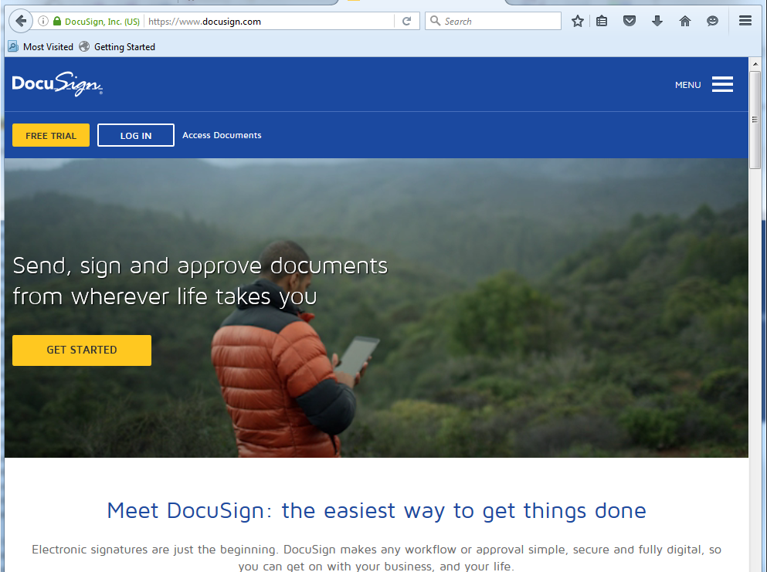
Process for Persons Signing Documents in DocuSign

- DocuSign will send an email to the UCD PI’s email address that looks something like this:
*If the Subcontractor/PI cannot find the email, please have them check their Spam folder.
- Click the Button that says “Review Document”.

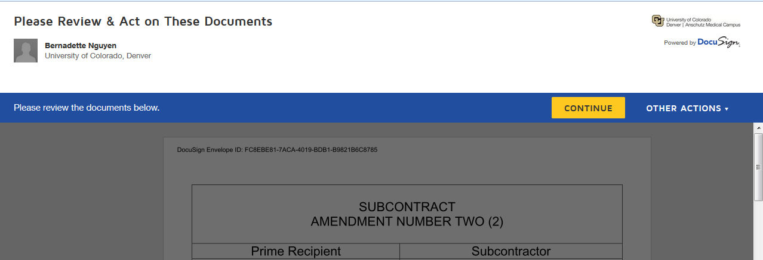
- DocuSign will open a new screen in your internet browser (see below) with the document you need to sign.
- Click the “Continue” button to unlock the document.
- Review the Document and confirm it is correct, then scroll back up to find the “Sign” button.
If there are issues with the document, please contact the Subcontracts team.
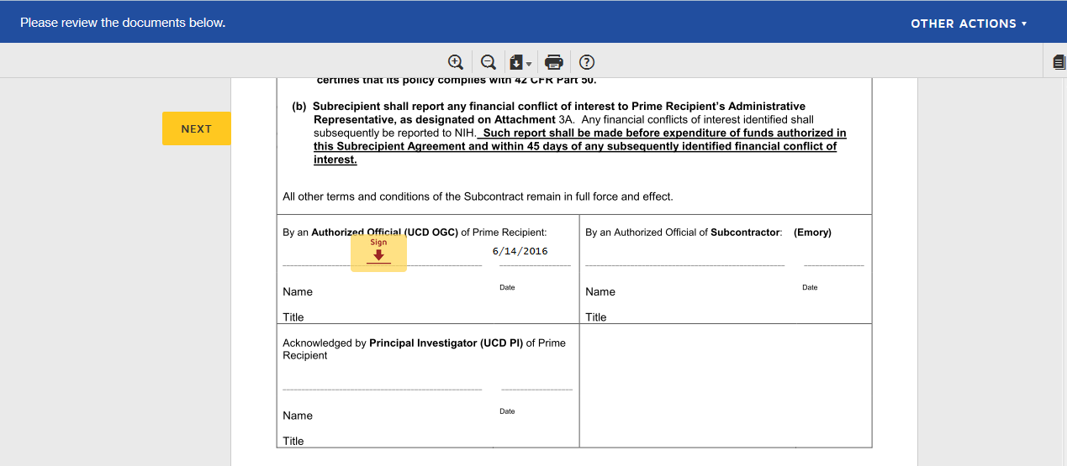
- Click the “Sign” button and a second screen will pop up titled “Adopt Your Signature.”
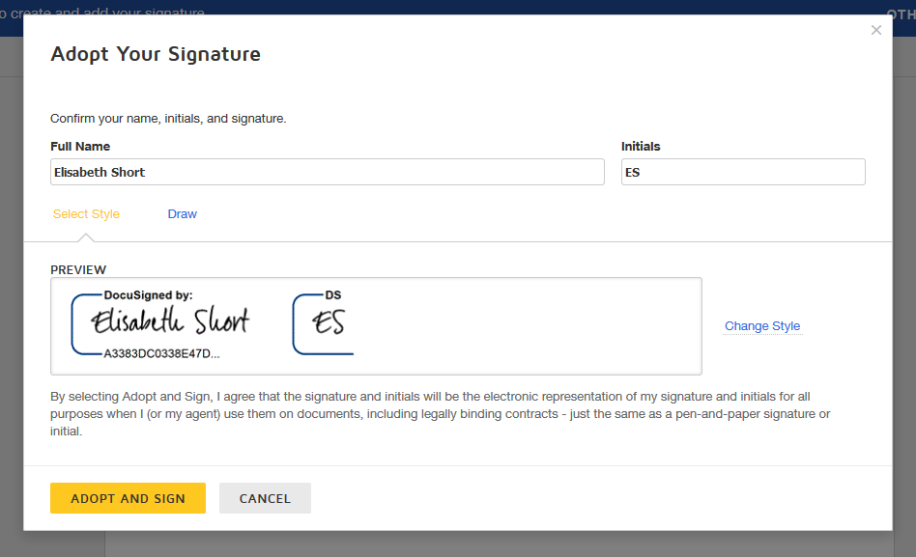

- This screen allows you to change the way your name appears on the document. Please use your legal name when signing the document.
- Once you are satisfied with your signature, click the “Adopt and Sign” button.
- Your signature should appear on the Document along with the date you signed the agreement.
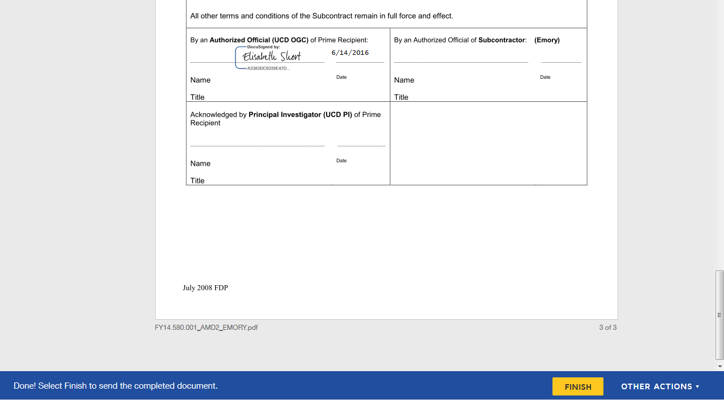
- To send the signed document to the next signatory, click the “Finish” button at the bottom of the screen.
- A “Save a Copy of Your Document” screen may pop up after you click the “Finish” button. You do not need to sign up for a DocuSign Account. Please click the “No Thanks” button.
- A screen should now appear saying “You have successfully signed your document using DocuSign”. This indicates that you have completed signing the document.

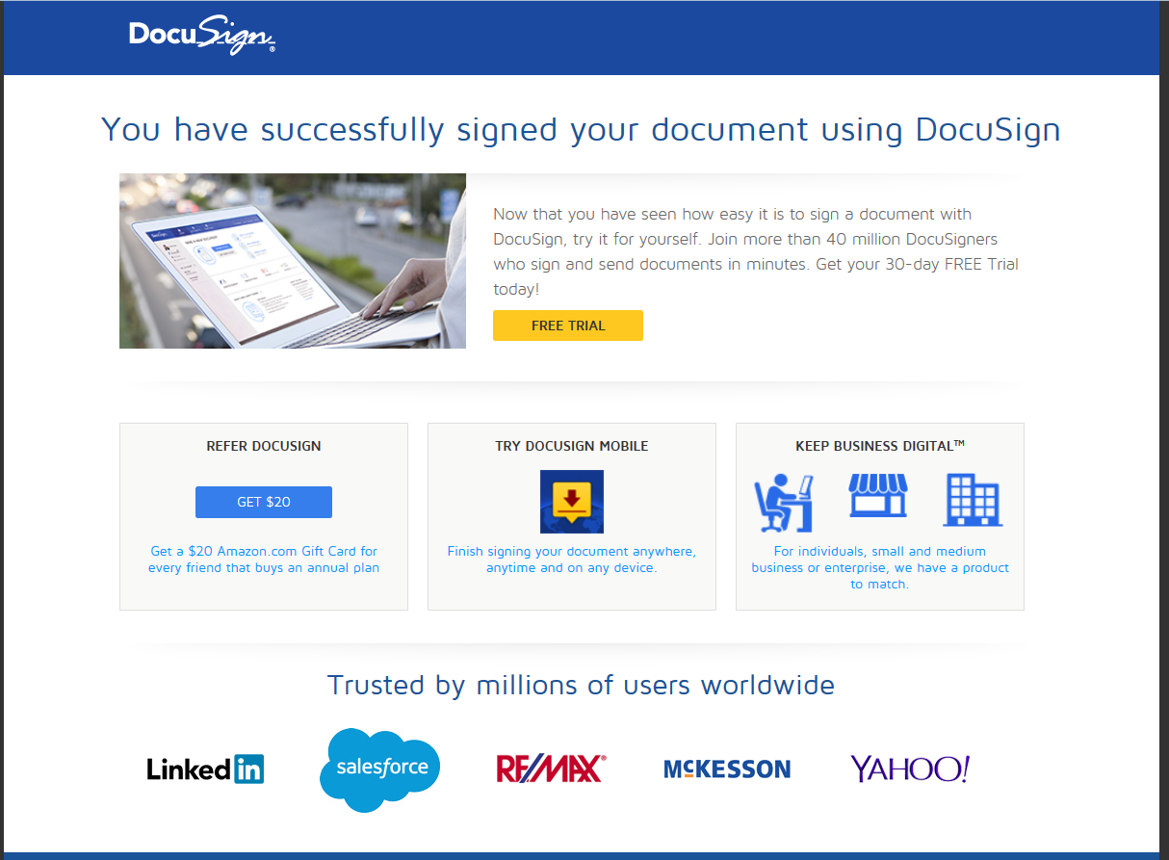

- Once all parties have signed, you should see the following email, which contains the fully executed document.
