Regulated Medical Waste
Management Plan
August 2019

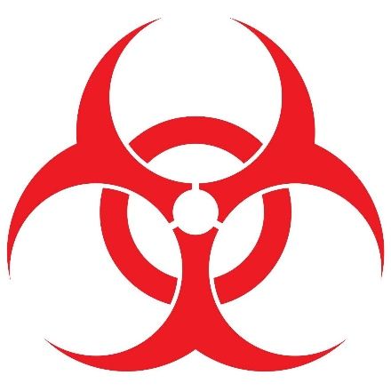

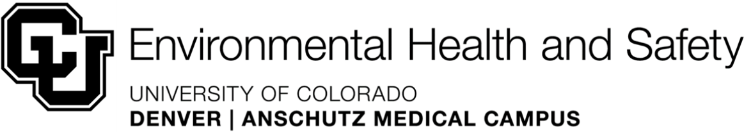

- Introduction
- Purpose
The purpose of this document is to present procedures for compliance with federal, state of Colorado, and local laws and regulations, as they apply to regulated medical wastes (RMW). This plan was developed in accordance with federal standards such as the US Occupational Safety and Health Administration (OSHA) Bloodborne Pathogens Standards, 29 CFR 1910 1030 and/or US Department of Transportation (USDOT) Division 6.2 Infectious Substances (49 CFR Parts 171-180) containment and labeling requirements, and Colorado standards such as Colorado Revised Statutes (CRS) 25-15-401 407 and 6 Code of Colorado Regulations (CCR) 1007-2, Section 13.
- Definition of Regulatory Medical Waste
By Environmental Protection Agency (EPA) definition, RMW have the potential to transmit infection, and/or properties of toxicity, and/or low-level radioactivity. The state designates RMW as waste generated from the diagnosis, treatment or immunization of humans or animals, and/or waste generated by research associated with studies of infectious of other diseases, or in production and testing of biologicals. Recombinant DNA, or synthetic nucleic acid molecules and materials, are also included in the category. RMW does not include hazardous chemical waste or any household waste.
For shipping and transport purposes, RMW is assigned the USDOT identification number UN 3291, which must appear on the USDOT compliant packaging, and on the manifest for transport.
- Roles and Responsibilities
- University of Colorado
The administrators of the University of Colorado system and of the University of Colorado Denver | Anschutz Medical Campus (hereafter, the university) are committed to protecting the environment, and the health and safety of its students, faculty, staff, and the general public in the conduct of all research, clinical and academic endeavors. (Administrative Policy State 2027 from the CU President, “Commitment to Safety” from the Vice Chancellor for Research, CU Denver | Anschutz). The Regulated Medical Waste Management Plan, (hereafter, the “Plan”) specifies how the university operations that generate RMW will comply with applicable safety, health and environmental regulations for such wastes.
- Environmental Health & Safety
The department of Environmental Health & Safety (EHS) is the university’s designee to support compliance with university policies, and federal, state, and local regulations and laws regarding the segregation, handling and disposal of RMW.
- Biological Safety
The EHS Biological Safety division administers this program in compliance with all applicable laws, regulations and policies.

- Biological Safety Officer
The Biological Safety Officer (BSO) is responsible for the development and implementation of the Plan, in compliance with the requirements of Colorado Department of Public Health and Environment (CDPHE). The Associate and Assistant Biological Safety Officers serve as backup if the BSO is unavailable.
- The Plan
- Designation of medical waste
- Provisions for handling, treatment and disposal of medical waste
- Contingency plan for spills or loss of containment
- Staff training
- Designation of a person responsible for plan implementation.
- Responsibilities
As part of the culture of safety on the university campuses, each member of the university community is responsible for the proper identification, segregation and disposal of RMW as it is generated in order to protect others, the environment, and the general public health.
- Principal Investigators, Faculty and Supervisors
- It is the responsibility of all Principal Investigators (PI), faculty and supervisors to assure that all students and employees throughout the university are aware of and comply with the Plan.
- It is the responsibility of all PIs, faculty and supervisors to provide appropriate on-the-job training on the proper segregation and labeling of wastes to all students and employees in their labs, for compliance with this Plan.
- Each PI, faculty and supervisor, in consultation with EHS Biological Safety, shall assess and determine of the segregation of their medical waste stream, and shall instruct students and staff in the appropriate handling procedures.
- Each PI, faculty and supervisor should develop an appropriate written Standard Operating Procedure (SOP) for their waste for the use of their staff and students.
- Individual Responsibilities
- All students, faculty, and staff will comply with the instructions from their supervisor, PI, the Biological Safety division, EHS staff, and/or the vendor regarding proper segregation, packaging, sealing and labeling of biomedical waste for treatment and disposal. Personnel must successfully complete the EHS-provided Regulated Medical Waste Management training (Skillsoft) within 30 days of the date of hire or assignment to tasks involving the generation of RMW.
- Training also applies to PIs and all those who supervise individuals handling or generating RMW.
- Refresher training will be conducted as necessary, as directed by the CDPHE and/or the USDOT.
- Off-Campus Personnel
Those employed by the university who work at off-campus sites (i.e., outpatient clinics, clinical and research labs, etc.) and who handle RMW for disposal, and whose site participates in the university vendor contract for RMW disposal, must follow the requirements of this Plan. These include required periodic training on the procedures for segregation, packaging, completing shipping papers, etc. If an off-campus entity has its own contract for RMW disposal, it must develop and implement its own RMW plan.
- Resources
EHS Biological Safety, 303-724-0345, may be contacted with further questions about proper segregation and disposal of RMW before work commences.
- Local Compliance
The Metropolitan Wastewater Reclamation District is the publicly owned water treatment organization overseeing all sanitary sewer discharges in the Denver metropolitan area, including the Denver and Anschutz campuses. Certain liquid wastes may not be discharged or otherwise disposed of without treatment.
- State Compliance
CDPHE regulates medical waste disposal in the Colorado Revised Statues (CRS) 25-5-401 to 25-15-407, and 6 Code of Colorado Regulations (CCR) 1007-2, Section 13.
- Federal Compliance
- The US Environmental Protection Agency (EPA) regulates discharges into air and bodies of water through the Clean Air Act and the Clean Water Act, respectively. The Clean Air Act governs all incinerators, including those licensed by EPA for incineration of medical wastes. The EPA further regulates the labeling of disinfectants for cleaning of surfaces that may be contaminated with infectious agents or pathogens.
- The USDOT regulates transportation of hazardous materials, including RMW. USDOT specifies standards for RMW transport containers, training for those who prepare materials for transport and those who transport RMW, completion of paperwork for transport, destruction and final disposal of RMW, spill and emergency response, and security plan measures. 49 CFR Part 170 et seq. Federal funding agencies, including the National Institutes of Health (NIH) require the university, as a recipient of federal funds, to remain in compliance with all federal, state and local regulations for health, safety and environmental protection, as stated in the NIH Grants Policy Statement.
- The NIH Grants Policy Statement specifically calls for compliance with OSHA mandates. The OSHA Bloodborne Pathogens Standard contains specific information on how to dispose of human blood, bodily fluids, sharps, and other RMW.
- The NIH Guidelines for Research Involving Recombinant or Synthetic Nucleic Acid DNA Molecules requires the segregation and destruction of all recombinant DNA materials, to prevent damage to the public health or environment.
- The Biosafety in Microbiological and Biomedical Laboratories, a joint publication of NIH and the Centers for Disease Control and Prevention (CDC), provides a framework of best management practices for safe work in the laboratory environment.
- Designation of Regulated Medical Wastes
- By state regulation, medical waste includes waste generated in a healthcare setting, including those occurring:
- During diagnosis, treatment, immunization, or care of humans or animal;
- During autopsy or necropsy;
- During preparation of a body for cremation or interment;
- In research pertaining to the production or testing of microbiologicals;
- In research using human or animal pathogens;
- As a result of an accident, suicide, or other physical trauma.
- “Healthcare setting” is used in a broad context and does not necessarily mean that these wastes are generated in a medical facility or clinic.
- Wastes presumed to be RMW include:
- Radioactive wastes;
- Blood and bodily fluids;
- Potentially infectious waste;
- Pathological waste;
- Non-RCRA (hazardous waste) pharmaceuticals and vaccines;
- Sharps;
- Trauma scene waste;
- Residue or contaminated soil, water, or other debris resulting from the cleanup of a spill or release of medical waste; and
- Other waste determined to pose a sufficient risk of infectiousness, as established by the CDPHE on a case-by-case basis.
- RMW does NOT include:
1. Wastes generated from routine facility maintenance, or cleaning activities not involving a spill or release of RMW.
2. Patient-related wastes such as saliva, nasal secretions, sweat, tears, vomitus, urine or feces that are not contaminated with visible blood and/or are not related to isolation wastes.
3. Lightly to moderately contaminated wastes not capable of releasing liquid or caked on blood, bodily fluids, tissues, or other potentially infectious material in any form during handling.
- University-Specific Waste Streams
1. Recombinant DNA and Synthetic Nucleic Acids (per the NIH Guidelines for Research Involving Recombinant or Synthetic Nucleic Acid Molecules) are:
a. Molecules that are constructed by joining nucleic acid molecules, and that can replicate in a living cell, i.e., recombinant nucleic acids;
b. Nucleic acid molecules that are synthesized or amplified chemically or by other means, including those that are chemically or otherwise modified but can base pair with naturally occurring nucleic acid molecules, i.e., synthetic nucleic acids, or;
c. Molecules that result from the replication of those described in items b or c above.
d. The materials must not be released in the environment, so they must be treated in such a way that the nucleic acids are denatured either through incineration, or physical or chemical treatments.
- Infectious Substances
- Definition: A material known or reasonably expected to contain a pathogen. Waste containing pathogens or biologically active material which, because of its type, concentration and quantity, could present a potential hazard to human health when improperly handled, stored, processed, transported or disposed. Also called biomedical waste or biohazardous waste.
Examples of infectious substances include:
- Stocks and cultures of any animal, plant or human pathogen, and any associated liquid or solid wastes, generated from work intentionally propagating animal, plant or human pathogens, such as:
- Nutrient agars, gels, broths (including those utilizing human blood or blood products);
- Human and primate cell lines;
- Impure animal cell lines.
- Wastes from the production of biologicals, such as:
- Serums;
- Vaccines (discarded live or attenuated);
- Antigens;
- Antitoxins.
- Culture dishes and devices used to transfer, inoculate or mix cultures, such as:
- Plastic or glass plates, flasks, vials, beakers, bottles, jars and tubes;
- Inoculation loops and wires;
- Manual and mechanical stirring devices;
- Rubber, plastic and cotton stoppers and plugs;
- Filtering devices made of natural and artificial substances;
- Materials used to clean and disinfect items listed above after routine use or accident.
- Potentially Infectious Materials
- Definition: A material known or suspected to be contaminated with a transmissible infectious agent potentially capable of causing disease or injury.
- This waste type includes, but is not limited to:
- Cultures and stocks from pathological, medical, research, and industrial laboratories;
- Wastes from the production of biologicals;
- Devices used to transfer, inoculate, and mix cultures;
- Isolation wastes;
- Biohazardous waste;
- Contaminated animal bedding from animals known to have been exposed to infectious substances during research;
- Biological materials generated during research;
- Pharmaceuticals being tested;
- Materials which are known or suspected of being contaminated with infectious substances contagious to humans;
- Liquids generated from work with human or animal subjects (blood, bodily fluids, serum, plasma, Broncho alveolar lavage, etc.), which potentially contain pathogens, or rDNA or synthetic nucleic acids;
- Liquid media used to culture cell lines, with or without rDNA;
- HEPA filters for the BSCs and exhaust systems:
- If they are not decontaminated in place before removal, they are potentially infectious.
- Once they are decontaminated, they are considered solid waste or trash.
- If the BSC was used for the preparation of chemotherapy, antineoplastic, or cytotoxic drugs, the HEPA filter cannot be decontaminated. It is considered hazardous waste and must be handled as such.
- This category also includes items that are capable of releasing blood and body fluids in any form during handling or storage, and items caked with dried blood and body fluids that could be released during handling or storage.
- This determination is not based on actual volume of blood or other materials, but on the potential to release these materials during handling or storage.
- These items may include: sample blood tubes, absorbent pads used for tissue dissection, gloves grossly contaminated with blood, etc.
- Exclusions
- Lightly to moderately contaminated wastes not capable of releasing liquid or caked on blood and body fluids in any form during handling. These are regulated as ordinary solid waste.Blood and Bodily Fluids
- Definition: A waste containing unabsorbed human or animal blood or blood products, components or blood or blood products, or other bodily fluids. This waste type includes, but is not limited to:
- Human blood, plasma; serum; platelets; other blood components and blood products;
- Bodily fluids including exudates, semen, vaginal secretions, cerebrospinal fluid, synovial fluid, pleural fluid, peritoneal fluid, pericardial fluid and amniotic fluid; suction and irrigation fluids contaminated with blood or bodily fluids;
- Liquid residues or contaminated water resulting from the cleanup of a spill of medical waste;
- Blood and bodily fluids from animals known to be infected with diseases that are contagious to humans.
- Exclusions: saliva, nasal, secretions, sweat, tears, vomitus, urine or feces that are not contaminated with visible blood and/or are not related to isolation wastes.
- For identification and segregation purposes, the blood and bodily fluids category includes only liquid wastes. Colorado has limited this waste category due to the limited disposal methods often available for liquid wastes.
5. Pathological Waste
a. Definition: Recognizable tissues, organs, limbs, products of conception, and other body parts removed from the whole body. This waste type includes:
i. Tissues;
ii. Organs;
iii. Body parts removed during surgery, autopsy or other medical procedure;
iv. Human anatomical remains;
v. Contaminated animal tissue (including animal carcasses and body parts) from animals known to have been exposed to infectious substances during research, production of biologicals, testing of pharmaceuticals, or other exposures, and those known or suspected of being contaminated with infectious substances contagious to humans.
b. Experimental animal carcasses
This waste type includes:
i. Animals administered materials considered hazardous OR administered infectious agents (ABSL 2 or 3) such that the carcass must be segregated for incineration in an EPA-permitted medical waste incinerator; or
ii. Animals administered materials considered either non-hazardous, pharmaceutical, ecological hazardous or ABSL 1, and are incinerated in a pet crematorium.
iii. The determination of the waste stream is made during the review of the research protocol, and signage is posted appropriately on the cages and in the housing room.
iv. Exclusion: pathological waste does not include contaminated animal waste that is regulated as compost.
6. Investigational Drug/Pharmaceutical Substance Disposal (non-DEA controlled substance)
a. Definition: Any prescription or over-the-counter chemical product, vaccine or allergenic that is intended for use in the diagnosis, cure, mitigation, treatment, or prevention of disease in humans or animals. This waste stream is managed by EHS Hazardous Materials division (303-724-0345).
b. Once an investigational drug/pharmaceutical substance no longer serves its intended purpose, is expired, or is left over at the conclusion of a study and will be destroyed on site, the following steps must be taken to ensure proper disposal of the investigational agent in accordance with the law. Guidance for Drug Enforcement Agency (DEA) controlled substance disposal is provided by EHS Hazardous Materials division.
- Trace Chemotherapy/Antineoplastic Wastes
- Definition: Solid waste materials containing less than 3% by volume of a chemotherapeutic, antineoplastic, or cytotoxic drug or pharmaceutical (see Appendix C for a list of drugs to which this applies).
- Items such as drug bottles, drug dispensing devices, IV bags, and tubing must be emptied using practices commonly employed to remove the liquid.
- Disposable PPE used when handling or administering drugs is included.
- This waste must be collected and treated off-site by incineration in an EPA-permitted medical waste incinerator.
- Sharps Waste
- Definition: A discarded article that may purposely or accidentally puncture or cut the skin or mucosa, whether or not it have been in contact with anything infectious.
Examples include (but are not limited to):Hypodermic or intravenous needles, syringes with attached needles, lancets, broken blood vials, broken culture tubes, suture needles, Pasteur pipettes, scalpel blades, microscope slides, disposable pipette tips, capillary tubes, dental wires, disposable dental tools.
- Sharps must be handled and disposed in a manner that protects from personnel exposure and possible injury.
- Mixed Wastes
- Regulated medical waste mixed with:
- Radioisotopes
- All SOPs must be documented with the approval of the Committee on Ionizing Radiation, the EHS Radiation Safety and Biological Safety divisions.
- Chemicals/pharmaceutical compounds
- All SOPs must be documented with the approval of the EHS Hazardous Materials and Biological Safety divisions.
- Such wastes generally cannot be autoclaved and may not be suitable for chemical decontamination methods.
- Each laboratory that will generate such wastes must consult with EHS before generating such wastes, to assure an appropriate SOP has been developed and followed.
- RMW may also be mixed with regular, solid waste, and entire mixture is then considered RMW.
- Trash
a. Materials which have not been exposed to recombinant nucleic acids, infectious agents, or potentially infectious agents, and do not contain chemotherapeutic waste, can be disposed of as regular trash in the municipal solid waste stream.
c. Examples include, but are not limited to:
i. Pipette wrappers, gloves worn only for making non-hazardous buffers, cardboard animal transfer boxes (if the animals are not infected).
ii. Glass slides with fixed specimens or uncontaminated broken glass must be sealed in a hard-sided box, labeled “glass disposal”, and placed in regular trash.
d. When disposing of animal tissue (unrecognizable), cells, blood/blood products, or any materials contaminated or potentially contaminated with these animal materials, three points must be considered.
    - Is the animal transgenic?
    - Is the animal Infected or potentially Infected?
    - Was any recombinant DNA/RNA, synthetic nucleic acids, viral vectors, or plasmids introduced into the animal?
If the answer is “YES” to any of the above, the waste is biohazardous and must be disposed of in a red or yellow tub.
If “NO” to ALL of the above, the waste is TRASH and may be placed into a regular trash can.
- General Procedures
NOTE: Certain pathogens or infectious agents may only be possessed, stored or used in accordance with other federal permits and regulations, which may have more explicit requirements for disinfection, decontamination or destruction than described in this Plan. Those laboratories using such items are required to document individual RMW plans to the satisfaction of the EHS Biological Safety division, the Institutional Biosafety Committee, and the federal agency issuing the permit. Such plans are subject to inspection.

- Appropriate Transport Containers
- All RMW containers used for transport of RMW are color-coded and labeled for compliance with USDOT and other regulatory requirements.
- Liners (bags) and containers used to hold RMW must meet applicable OSHA Bloodborne Pathogens Standards, 29 CFR 1910.1030 and containment and labeling requirements USDOT Division 6.2 Infectious Substances (49 CFR Parts 171-180).
- NO LIQUIDS are allowed to be placed into the tubs. Liquids must be solidified before being placed into the appropriate container.
- Transport containers, lids, and liners are provided to campus entities by a third-party vendor under a contract managed by the EHS Biological Safety division. These transport containers are a shared resource in campus laboratories, and are not meant to be point-of-use containers for widespread use at each laboratory bench. They are staged for use for biohazard waste disposal in the linear equipment corridors in the research towers.
- When determined to be full, liners must be secured closed by laboratory personnel using one of the three methods described in training (see image below):
  - Twist the liner closed and tie in a single knot (like tying a balloon);
  - Twist the liner closed, loop the twisted liner and used duct tape to secure;
  - Twist the liner closed, loop the twisted liner and use a zip tie to secure.
- Once the liner is closed, laboratory personnel must secure the lids onto the tubs, compliant with USDOT requirements for packaging and transporting RMW. Full tubs will be picked up routinely in the research towers by EHS staff, and held in a secure location for further transportation and disposal off-campus by the disposal contractor, during working hours (Monday – Friday, exclusive of holidays).
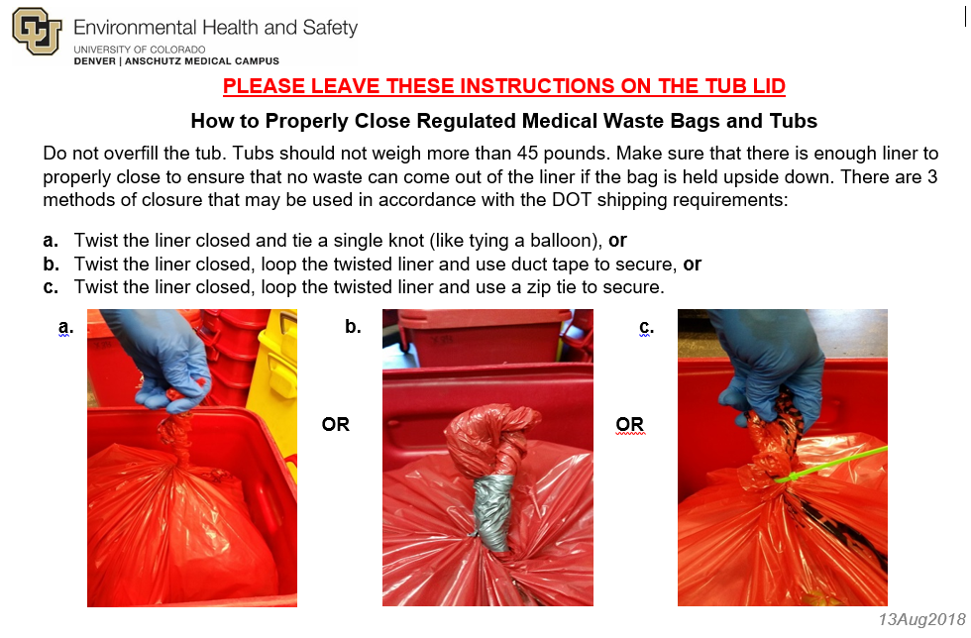
- Segregation of RMW
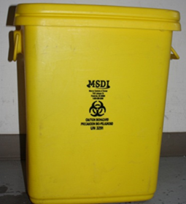
- RMW must be segregated by the known characteristics at the point of generation, per the categories listed below:
- “Incinerate Only” wastes must be treated and disposed of by incineration in an EPA-permitted medical waste incinerator. These wastes will be segregated into lined, marked and labeled YELLOW tubs, as provided by the third-party vendor.
- “Trace Chemotherapy” wastes must be treated by incineration in an EPA-permitted medical waste incinerator. For further examples, see Appendices C and F.
- “Pathological” wastes that are human or animal origin AND recognizable in size (larger than a thumbnail), must be incinerated in an EPA-permitted medical waste incinerator.
- Animal carcasses which have hazardous chemicals/compounds introduced into them will be processed by the Vivarium staff.
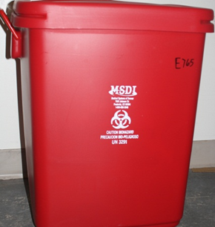
- Other materials may be identified which require incineration as the appropriate means of decontamination and destruction. Research or clinical laboratories working with such materials are identified by risk assessment, and/or the submission of an IBC Protocol, and will develop a laboratory-specific SOP for segregation of those wastes. This is a very limited waste stream.
- “Autoclave” wastes are those which may be appropriately treated and decontaminated by steam decontamination (autoclaving). These wastes will be segregated into a lined, marked and labeled RED tub, as provided by the third-party vendor. However, some materials may need to be treated on-site prior to commingling with other RMW for transport, treatment and final disposal.
- “Pathological” wastes that are of human or animal origin and NOT recognizable in size (smaller than a thumbnail) may be autoclaved.
C. Risk Group 3 Infectious Materials
1. Research or clinical laboratories working with any Risk Group 3 (RG3) materials (see Appendix A, Glossary of Terms and Definitions) will be identified by risk assessment and/or the submission of an IBC protocol and approval prior to the initiation of that work.
2. Each laboratory with RG3 materials will develop a laboratory specific SOP for on-site autoclaving or other treatment of those wastes. Refer to Appendix D for further information to develop an autoclave validation plan and SOP. Validation documents must be retained for a minimum of three years.
3. For those RG3 materials which can be treated by autoclave/steam sterilization/decontamination, there is a requirement for those laboratories to document and implement an autoclave validation plan prior to approval by the IBC for the proposed work.
4. For those RG3 materials which must be treated by other means (chemical inactivation, rather than autoclave), that treatment shall be documented in an SOP prior to the approval by the IBC for the proposed work. Those materials which must undergo chemical inactivation will be addressed on a case-by-case basis for final disposal.
5. Once these wastes have been adequately treated on-site, they will be co-mingled with other wastes for final disposal. These wastes will be segregated into red tubs, lined with red biohazard bags.
6. Bags must be tied shut and lids secured on tubs in compliance with USDOT requirements for packaging and transport of RMW. Full tubs will be picked up by EHS staff and transported to a secure location for transportation from the campus by the contractor, for final treatment and disposal.
7. Each laboratory is responsible for documenting that all wastes are appropriately treated. The records must be retained for three years.

- Risk Group 2 Infectious Materials
- Anyone working with Risk Group 2 (RG2) materials (see Appendix A, Glossary of Terms and Definitions) or tissue culture materials must use the autoclave waste stream as described in this Plan.

- These wastes will be segregated at the point of generation, into biohazard waste containers lined with biohazard bags. For removal from the lab, biohazard bags will be placed into red tubs lined with red biohazard bags.

- Bags must be tied shut and lids secured on tubs in compliance with USDOT packaging and transport requirements. Full tubs will be picked up by EHS staff and transported to a secure location for transportation off-campus by the contractor, for final treatment and disposal, Monday – Friday exclusive of holidays.

- All Other Infectious Materials
- These wastes will be segregated into biohazard waste containers lined with biohazard bags. For removal from the lab, biohazard bags will be placed into red tubs lined with red biohazard bags.
- Bags must be tied shut and lids secured on tubs in compliance with USDOT packaging and transport requirements. Full tubs will be picked up by EHS staff and transported to a secure location for transportation off-campus by the contractor, for final treatment and disposal, Monday – Friday exclusive of holidays.
- Recombinant Materials and Synthetic Nucleic Acids
- These wastes will be segregated into biohazard waste containers lined with biohazard bags. For removal from the lab, biohazard bags will be placed into red tubs lined with red biohazard bags. Bags must be tied shut and lids secured on tubs.
- Full tubs will be picked up by EHS staff and transported to a secure location for transportation off-campus by the contractor, for final treatment and disposal.
- Mixed Wastes
1. If a laboratory is generating regulated medical wastes that have other contaminants, i.e. chemical or radioactive materials, the PI, faculty member or supervisor must consult with the appropriate EHS divisions to assure all such wastes are appropriately identified, segregated, labeled and handled.
2. Generally, the biological material is deactivated by some means other than autoclaving, and then it is disposed of as the radioactive or chemical waste.
3. For radioactive materials users, researchers must consult with EHS Radiation Safety division.
4. For chemicals, researchers must consult EHS Hazardous Materials division.
- Point-of-use Containers
1. Point-of-use containers are those suitable, rigid, leak-proof containers used at the point of generation of wastes (the laboratory bench), to appropriately collect and contain RMW.
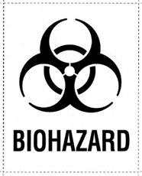
2. Point-of-use containers must be purchased by the laboratory. They may be disposable (e.g. for solidification of liquid wastes) or reusable. If reusable, they must have an appropriate liner, bearing a biohazard symbol. All containers must be clearly marked and labeled for RMW (i.e. a biohazard label) as illustrated. Labels may be requested from Biological Safety.
- Sharps Containers and Disposal
NOTE: All radioactive sharps must be disposed of by Radiation Safety.
1. All sharps (see Appendix A, Glossary of Terms and Definitions) must be disposed of in labeled sharps rigid, puncture-proof containers labelled with the biohazard symbol. Improper disposal of any sharps in regular trash presents a risk of injury to lab workers, students, facilities personnel, housekeeping staff and the community.
2. All sharps containers must be able to fit into the designated RMW containers (tubs) provided by the third party vendor. No standing liquid is allowed in a sharps container. The sharps container cannot exceed 18 gallons.
3. Any sharps used with radioactive materials (RAM) will be segregated and disposed of as directed by the most current Radiation Safety Manual, and in the CIR-approved protocol for those materials. These steps should be documented in an SOP for use by laboratory staff.
4. Any sharps exposed to hazardous chemical materials, and which have only trace amounts or no residual liquid, may be placed in a sharps container and disposed of in the red or yellow tubs. Questions may be directed to biosafety.program@ucdenver.edu.
- Treatment and Disposal of Liquid Wastes
1. No standing liquids are permitted in RMW containers, as they present a risk of leaks, spills and exposures.
2. Metropolitan Wastewater Reclamation District, has strict prohibitions for sink/sanitary sewer system disposal of wastes. (See Appendix B, Sink Disposal Guidelines) Contact Biological Safety with any questions on appropriate sink disposal practices.
3. Liquid wastes from research shall be treated and segregated appropriately. Labs will prepare a written SOP for addressing any liquid RMW generated in their processes. Consult with the Biological Safety regarding specific waste streams generated.
4. Liquid waste disposal options are as follows:
a. Certain liquid wastes may be solidified with a commercial product, in a disposable container, and segregated into the vendor’s red tubs lined with red biohazard bags. Biological Safety sells suitable products for solidifying aqueous liquid RMW.
b. Certain liquid wastes may be autoclaved in a validated on-site autoclave, and may be sink-disposed upon demonstration of adequate decontamination; this requires a written SOP approved by Biological Safety.
- Management of HEPA Filters
  - BSC and some exhaust system HEPA filters are designed to remove harmful biological material and certain chemicals.
  - HEPA filters used to remove biological material can be disposed of as solid waste after gas decontamination.
  - However, filters contaminated with certain chemotherapy or antineoplastic drugs must be disposed of as hazardous chemical waste due to their toxicity, if they are a “U” or “P” listed waste.
  - Some of these filters may be considered a combination of hazardous and RMW, depending on the nature of the materials manipulated in the BSC.
  - A filter, which is deemed a combination mixed waste, must always be treated as a hazardous waste.
  - Where hazardous drugs are prepared, the laboratory must implement a waste management plan for HEPA filters in collaboration with EHS. (See Appendix G for a list of some of the hazardous drugs which might contaminate a HEPA filter).
  - BSC and exhaust HEPA filters, which are hazardous wastes, must be disposed of at a permitted hazardous waste treatment, storage or disposal facility.
  - Contact EHS Biological Safety to assess the appropriate disposal category for a HEPA filter which may be removed from a BSC during certification, to determine the correct handling and disposal.
- Spill Response Plans
- All spills and accidents must be reported to the lab supervisor and immediate medical attention must be sought, if needed. University of Colorado employees or students must complete a Risk Management Incident form within 4 working days of the accident. Forms can be found at https://www.cu.edu/risk/incident-procedure.
- Responders:
  - Within labs, Laboratorians are trained to respond to chemical and biological spills, including RMW.
- Outside of labs but within buildings, the janitorial contractor will respond to spills.
- Outside of buildings Facilities Management will respond to spills.
- An EHS biowaste technician, animal care technicians, and/or the RWM vendor will respond to spills occurring on a loading dock, depending upon the source of the spill.
- EHS is available for evaluation and consultation regarding spill cleanup.
- Spill kits and PPE supplies are located in the RMW room in the dock areas of all buildings where RMW is generated.
- See Appendix H, Clean-up Procedures for RMW.
VI. Training
A. A training program has been developed and maintained by EHS for all students, faculty, staff and employees who are generators of RMW.
B. The online general RMW training is mandatory for all generators of RMW, and is required every three years.
C. Online training covers topics determined by EHS staff to comply with elements of state, federal and local regulations, as well as topics covered by the university RMW Management Plan. D. Personnel must successfully complete the EHS-provided RMW Training, within 30 days of the date of hire, or of the assignment to tasks involving the generation of RMW.
E. Training also applies to PIs and all supervisors who supervise individuals who handle or generate RMW.
F. Additional refresher training will be conducted, as necessary to ensure compliance with state and agency regulations as they change.
G. Personnel responsible for overseeing RMW packaging and transport, as well as signing RMW waste manifests, have an additional in-person training covering the specifics of the USDOT requirements, and how the university complies with those requirements. The initial training must be completed within 90 days of employment, or of a change in job function that includes the generation of RMW, and/ or the handling or preparation of this waste for shipping; and every three years thereafter. H. Documentation of training is maintained for at least three years, and becomes a part of employees’ permanent training record with the university.
VII. Records Management
A. EHS shall maintain all appropriate records for compliance with state and federal regulations. All records required by 6 CCR 1007-2, Section 13 must be maintained onsite for three (3) years, in hard copy and/or electronically.
B. The following records shall be maintained by EHS in an easily retrievable format:
1. The RMW Management Plan;
2. University RMW Training materials;
3. Personnel training records;
4. Contractual agreements with an approved commercial medical waste storage, treatment or disposal facility;
5. Records (manifests) for all RMW sent off-site for treatment and destruction and/or disposal;
6. Records of all spills and exposure incidents, and all actions taken to investigate and remediate.
VIII. References
1. U. S. Department of Transportation 49 CFR Parts 170-180
2. U. S. Environmental Protection Agency, to include: Clean Air Act, Clean Water Act, Federal Insecticide, Fungicide, and Rodenticide Act (FIFRA)
3. NIH Guidelines for Research Involving Recombinant DNA or Synthetic Nucleic Acid Molecules
4. NIH-CDC Biosafety in Microbiological and Biomedical Laboratories
5. OSHA Bloodborne Pathogens/Needlestick Safety Standard, 29 CFR 1910.1030
6. Colorado Revised Statutes (CRS) Title 25-Article 15-Part 4
7. Colorado Code of Regulations 6 CCR 1007-2
8. Metro Wastewater Reclamation District Rules and Regulations
10. EHS Hazardous Materials Management Plan
11. EHS Radioactive Waste Disposal Manual

APPENDIX A
Glossary of Terms and Definitions
Antineoplastic drug: acts to prevent, inhibit, or halt the growth of a tumor; many are considered hazardous.
Autoclave: pressurized, steam-heated vessel used for decontamination or sterilization.
Autoclave wastes: those wastes that are appropriately decontamination or treated by steam sterilization or autoclaving. This encompasses the majority of our regulated medical waste stream.
Biohazardous waste: any waste containing infectious materials or potentially infectious substances such as blood. Of special concern are sharp wastes, such as needles, blades, glass pipettes, and other wastes that can cause injury during handling.
- Human blood and blood products. This includes items contaminated with enough blood that could release blood in a liquid or semi-liquid form when compressed.
- Human body fluids: include, but are not limited to, semen, vaginal secretions, amniotic fluid, saliva, and pleural fluid.
- Microbiological waste: discarded live and attenuated microorganisms, discarded specimen cultures, and disposable culture dishes.
- Pathological waste: waste biopsy materials, and any human tissues or body parts from autopsy, surgery, or other procedure. Also includes contaminated animal tissue (including animal carcasses and body parts) from animals known to have been exposed to infectious substances during research, production of biologicals, testing of pharmaceuticals, or other exposures, and those known or suspected of being contaminated with infectious substances known to be contagious to humans.
- Sharps waste: used needles or any sharp object (scalpels, glass slides, broken glass) that have been contaminated with potentially infectious materials.
Bloodborne pathogens: microorganisms present in human blood that can cause human disease, including, but not limited to, Hepatitis B Virus (HBV); Hepatitis C Virus (HCV); Human Immunodeficiency Virus (HIV).
Chemotherapy drug: any synthetic, semisynthetic, or natural chemical substance used in the treatment, prevention, or diagnosis of disease, or for other medical reasons; selectively toxic to the causative agent of the disease, such as a cancer/tumor cells, virus, bacterium, or other microorganism
Chemotherapy/antineoplastic/cytotoxic waste: any leftover or waste chemotherapy/cytotoxic /antineoplastic drugs, any non-empty containers of chemotherapeutic & antineoplastic drugs (e.g., full or partially full vials, ampules, IV bags, tubing); any items used for dosing human or animal patients with chemotherapy, cytotoxic or antineoplastic drugs or agents; gowns, gloves; or any disposable surgical mask or N95 respirator; animal bedding, if so designated by EHS and IACUC review; emptied needles, syringes, IV bags and tubing, drug vials or bottles; any material used to clean up a spill of chemotherapy drugs are considered “trace chemotherapeutic waste” or “RCRA-empty” waste.
Controlled substance: a drug or other substance, or immediate precursor, included in schedule I, II, III, IV, or V of the Controlled Substances Act (Title 21 Chapter 13 Subchapter I, Part B (USC)).
Cultures: microorganisms or cells propagated on or in a solid or liquid medium for purposes of isolation, identification, diagnosis, research or storage.
Cytotoxin: an agent or process that is toxic to cell, designed to destroy rapidly growing cancer cells, shown to be mutagenic, carcinogenic and/or teratogenic, either in treatment doses or animal and bacterial assays.
Decontamination: use of physical or chemical means to remove, inactivate, or destroy microbes so that they are no longer capable of transmitting infectious particles, making the material safe for unprotected personnel to handle and safe to dispose of; the inactivation of microorganisms by a log 10⁻⁶ reduction, but not necessarily to zero; NOT necessarily equivalent to sterilization.
Disinfectant: a chemical agent used on inanimate objects (e.g., floors, walls, or sinks or medical devices) to destroy virtually all recognized pathogenic microorganisms, but not necessarily all microbial forms (e.g., bacterial endospores). The effectiveness of disinfection is impacted by a number of factors, including nature/number of contaminating microorganisms, amount of organic matter present, type/condition of the materials, and temperature.
The EPA categorizes disinfectants on the basis of whether the product label claims limited, general, or hospital disinfectant capabilities.
- High-level chemical disinfectant: kill vegetative microorganisms; inactivates viruses; not necessarily active against high numbers of bacterial spores. Germicides which are very potent sporicides are classified as “sterilants” for use with medical devices which cannot be autoclaved.
- Intermediate-level disinfectant: kills vegetative microorganisms (including M tuberculosis, all fungi), inactivates most viruses. Corresponds to EPA registered hospital disinfectant with tuberculocidal properties.
- Low-level disinfectant: Kills most vegetative bacteria EXCEPT M. tuberculosis and some fungi, inactivates some viruses. Also, called “sanitizers”. Might be registered with EPA as a hospital disinfectant. OSHA requires low-level hospital disinfectants to also have a label claim for potency against HIV and HBV, if used for disinfecting clinical contact surfaces.
Disinfection: the elimination of most or all pathogenic microorganisms on inanimate objects, with the exception of bacterial spores.
Disease vector: any animal, insect, bacterium or virus capable of transmitting disease, illness or harm to humans.
Dry, solid wastes: those regulated medical wastes which are appropriately disinfected or treated by steam sterilization or autoclaving which renders them safe to handle and dispose.
Drug: substances defined by the Federal Food, Drug, and Cosmetic Act, as amended (21 USCS Section 321(g)(1)) including (1) substances recognized in the official United States Pharmacopoeia, official Homoeopathic Pharmacopoeia of the United States, or official National Formulary, or any supplement to any of them; (2) substances intended for use in the diagnosis, cure, mitigation, treatment, or prevention of disease in man or other animals; (3) substances (other than food) intended to affect the structure or any function of the body of man or other animals; and (4) substances intended for use as a component of any substance specified in any of the above.
Empty container: a container or inner liner removed from a container that has been emptied by the generator as much as possible using methods commonly used to remove waste or material from containers (e.g., if the material was pourable, then no material can be poured or drained from the container; if the material was not pourable, then no material can reasonably be removed by scraping). This also meets the definition of RCRA-empty.
Environmental release: any event when an infectious material is released outside of any protective packaging, or containment device (biological safety cabinet, containment centrifuge, etc.) resulting in a potential release to the non-laboratory environment.
Exposure: any event when an infectious material is released outside of its protective packaging, or containment device, resulting in known or suspected physical contact with humans or animals; any actual and specific eye, mouth, other mucous membrane, non-intact skin or parenteral contact with blood or other potentially infectious material resulting from performance of employee's duties.
Hazardous waste: those substances and materials defined or classified as such by the Hazardous Waste Commission pursuant to 25-15-302, C.R.S., as amended.
Household medical waste: any medical waste generated by households. Does not include medical waste generated at health and residential care facilities regulated under the Standards for Hospitals and Health Facilities (6 CCR 1011-1).
Incinerate-only wastes: those wastes which cannot be appropriately disinfected or treated by steam sterilization or autoclaving, and which must be treated by incineration in an EPA-permitted medical waste incinerator, followed by landfill disposal of the ash generated in the incineration process.
Note: The university uses this method for some regulated medical wastes, in an incinerator engineered to burn these wastes completely and stay within EPA emissions standards.
This waste stream typically consists of recognizable human pathological specimens, tissues, etc. and trace contaminated waste items generated in the preparation or use of cytotoxic or chemotherapy drugs in laboratory or clinical settings. Animal tissues and specimens will normally be disposed of in the OLAR tissue digester. Types of biomedical wastes which must be incinerated are listed below. A list of common cytotoxic/chemotherapy drugs is available from EHS and in Appendix C of this document.
Examples of trace chemotherapy (antineoplastic/cytotoxic) drug wastes include intravenous tubing, bags, bottles, vials and syringes incidental to the preparation and administration of chemotherapy drugs. Such wastes must be EMPTY per the RCRA criteria and definition, containing only residual amounts of cytotoxic or chemotherapy drugs, that are less than 3% by volume.
Absolutely NO full or partially full chemotherapy containers or vials may be disposed of as infectious waste. They must be turned in as RCRA hazardous chemical waste.
Any pathological specimens which are in a chemical preservative, must have the preservative decanted prior to disposal of tissues in the biomedical waste containers, for incineration.
Infectious materials: any material known or reasonably expected to contain a pathogen, a micro-organism (including bacteria, viruses, rickettsia, parasites, fungi) or other agent, such as a proteinaceous infectious particle (prion), that can cause disease in humans, animals or plants.
Infectious waste: waste containing pathogens or biologically active material which because of its type, concentration and quantity could present a potential hazard to human health when improperly handled, stored, processed, transported or disposed of. Includes contaminated animal bedding from animals known to have been exposed to infectious materials during research.
Isolation waste: contaminated material from humans or animals that are isolated because they are suspected or known to be infected with an infectious agent capable of causing a highly communicable, possibly lethal disease. National biosafety guidelines developed by agencies such as the U.S. Department of Health and Human Services, National Institutes of Health or the Centers for Disease Control and other medical professionals should be referenced when making this determination.
Liquid waste: any waste material that is determined to contain “free liquid”. Liquid wastes will include those liquids generated in tissue culture work, from work with human or animal subjects (blood, bodily fluids, serum, plasma, bronchoalveolar lavage, etc.), which may or may not contain pathogens or rDNA, which can be effectively and appropriately treated by steam sterilization or autoclaving.
Liquid biological or biohazardous wastes: any liquid waste containing known infectious materials, potentially infectious materials, rDNA materials; or human blood, blood products (such as serum, plasma, and other blood components) or other bodily fluids. Some liquid biological wastes, particularly the media used to culture cell lines, (with or without rDNA) or infectious agents, will require sterilization or disinfection to inactivate the agent before disposal to the sewage system.
Medical waste: any kind of waste containing infectious material (or material that’s potentially infectious; waste generated during medical research, testing, diagnosis, immunization, or treatment of either human beings or animals. Some examples are culture dishes, glassware, bandages, gloves, discarded sharps like needles or scalpels, swabs, and tissue. Other terms used interchangeably but actually have regulatory differences: biomedical waste, clinical waste, biohazardous waste, regulated medical waste (RMW), infectious medical waste, healthcare waste.
Medical waste generator: any person whose act or process produces medical waste. This includes, but is not limited to, generators at medical, dental or veterinary facilities, clinics, hospitals, or surgery centers; ambulances and other emergency medical responders; medical or research laboratories; facilities holding shot clinics or health fairs; other health-related facilities or events; educational and research facilities.
Medical Waste Management Plan: a document that must be developed and implemented by medical waste generators that designates all of the medical wastes generated by the facility, waste handling techniques to be used at the facility, contingency plans for spills or releases, staff training requirements, and designation of the person responsible for implementation of the management plan.
Medical waste treatment: any validated method, technique or process designed to change the biological character or composition of a medical waste so as to minimize its potential to harm human health or the environment.
Microbiological: a diagnostic, preventive, or therapeutic preparation made from living organisms and their products, intended for use in diagnosing, immunizing, or treating humans or animals, or in related research.
Mixed infectious / chemical wastes: wastes containing some infectious biological agent (i.e. human, animal or plant pathogen) in addition to a chemical waste. Such wastes generally cannot be autoclaved and may not be suitable for other chemical decontamination methods. Consult with EHS before generating such wastes.
Municipal solid waste (MSW): includes general household, community, or other wastes or trash, which does not contain hazardous materials.
Pathogens: disease-causing organisms.
Pathological waste: all recognizable tissues, organs, limbs, products of conception, and other body parts removed from the whole body. This waste stream includes, but is not limited to, tissues; organs; body parts removed during surgery, autopsy or other medical procedures; and human anatomical remains. It also includes contaminated animal tissue (including animal carcasses and body parts) from animals known to have been exposed to infectious substances during research, production of biologicals, testing of pharmaceuticals or other exposures, and those known or suspected of being contaminated with infectious substances contagious to humans.
Pathological wastes must not include preservative agents, e.g. formalin, formaldehyde. These must be decanted into an appropriate container and disposed of as chemical wastes.
Pharmaceutical: any prescription or over-the-counter chemical product, vaccine or allergenic that is intended for use in the diagnosis, cure, mitigation, treatment, or prevention of disease in humans or animals. This waste stream includes, but is not limited to, drugs, pills or tablets; medicinal gums or lozenges; medicinal liquids, ointments and lotions; intravenous or other compounded solutions; live vaccines; non-hazardous attenuated vaccines; allergenics; medicinal shampoos; antiseptics; medicinal dermal patches; and any delivery devices with the primary purpose to deliver or dispense a medicinal chemical product, vaccine or allergenic. This category includes drugs as defined by the Federal Food, Drug, and Cosmetic Act, as amended (21 USCS Section 321(g) (1)).
Point of Use Container: Any container or receptacle used in the lab to store the RMW prior to disposal in the designated RMW transport containers.
Potentially infectious waste: any waste known or suspected to be contaminated with a transmissible infectious agent potentially capable of causing disease or injury.
Prion: Protein particle lacking nucleic acid that has been implicated as the cause of certain neurodegenerative diseases (e.g., scrapie, CJD, and bovine spongiform encephalopathy [BSE]).
Putrescible wastes: those solid wastes that contain organic matter capable of being decomposed by microorganisms, and of such a character and proportion as to be capable of attracting or providing food for birds or disease vectors.
Radioactive medical waste: Low-level radioactive wastes generated by administering radiopharmaceuticals, performing nuclear medicine procedures, performing radioimmunology procedures or by using radioactive traces in diagnostic procedures or medical research. Includes, but is not limited to, contaminated wastes from humans or animals undergoing procedures using low level radioactive materials, such as biological waste and discarded materials contaminated with blood, excreta, exudates or secretions; contaminated laboratory trash; and containers used to store radioactive materials. See the university Radiation Safety Manual and Radioactive Waste Disposal Manual for specific instructions.
Recombinant and synthetic nucleic acids: In the context of the NIH Guidelines, recombinant and synthetic nucleic acids are defined as:
- Molecules that a) are constructed by joining nucleic acid molecules, and b) that can replicate in a living cell, i.e., recombinant nucleic acids;
- Nucleic acid molecules that are chemically or by other means synthesized or amplified, including those that are chemically or otherwise modified but can base pair with naturally occurring nucleic acid molecules, i.e., synthetic nucleic acids,
- Molecules that result from the replication of those described in 1) or 2) above.
Render non-infectious: to treat infectious waste by inactivating pathogens and other biologically active material to a level that will no longer presents a potential hazard of infection when managed, stored or disposed.
RMW transport container: Color-coded (red or yellow) and appropriately marked containers provided by the contracted vendor, for the transport of Regulated Medical Wastes.
Risk Group 1 (RG1): unlikely to cause disease in healthy humans or animals; no or low individual and community risk.
Risk Group 2 (RG2): agents associated with human or animal disease that is rarely serious, and for which preventive or therapeutic interventions are often available; moderate individual risk, low community risk.
Risk Group 3 (RG3): agents associated with serious or lethal human disease for which preventive or therapeutic interventions may be available; high individual risk, low community risk.
Risk Group 4 (RG4): agents likely to cause serious or lethal human disease for which preventive or therapeutic interventions are not usually available; high individual risk and high community risk.
Refer to USDA-APHIS for agents affecting animal or plant health.

Sharps: any discarded article that may purposely or accidentally puncture or cut the skin or mucosa. This waste stream includes, but is not limited to, used needles; scalpel blades; syringes (with attached needle); pen needles; lancets; Pasteur pipettes; broken blood vials; needles with attached tubing; suture needles; razor blades; broken culture tubes and culture dishes, regardless of presence of infectious substances; broken and unbroken glassware which were in contact with infectious substances (e.g., used slides and cover slips); disposable trocars; discarded unused or expired hypodermic needles, suture needles, syringes, and scalpel blades. Other items to be included when they have been in contact with potentially infectious materials include: plastic serological pipettes, glass (including broken glass), plastic pipette tips, etc.
Sharps container: a container that is closable, puncture resistant, leak proof on the sides and bottom, and labeled or color-coded in accordance with OSHA requirements (i.e. with biohazard symbol and identified for sharps disposal).
SOP: Standard Operating Procedure; a written document or instruction detailing all relevant steps and activities of a process or procedure. In this context, SOPs for segregation, transport, treatment and disposal of RMW, which can be incorporated into the laboratory procedures for clinical, academic or research processes or experiments.
Sterilization: treatment method that destroys all forms of viable microbial life including high numbers of bacterial spores, either by steam under pressure (autoclave), gas (ethylene oxide), dry heat, or immersion in EPA-approved chemical sterilant for prolonged period of time, e.g., 6-10 hours or according to manufacturers’ instructions. Sterilization may require validation of a log 12 reduction in microorganisms.
Steam sterilization: dependable procedure for the destruction of all forms of viable microbial life. Steam sterilization generally denotes heating in an autoclave utilizing saturated steam under a pressure of approximately 15 pounds per square inch to achieve a chamber temperature of at least 121ºC (250ºF) for a minimum of 15 minutes. The time is measured after the temperature of the material being sterilized reaches 121ºC (250ºF).
Stocks: bacterial or other microbial strains that have been maintained under laboratory conditions as representative of its type.
Trace chemotherapy waste: any empty container used to hold an antineoplastic drug (except P-listed hazardous waste), and contaminated items used with these drugs, such as gowns, wipes, or gloves; no standing liquids. Trace by definition must be less than 3% by volume of the empty container.
Transportation: take or carry from one place to another; regarding the transport of RMW, regulated by the USDOT, 49 USC 5101.

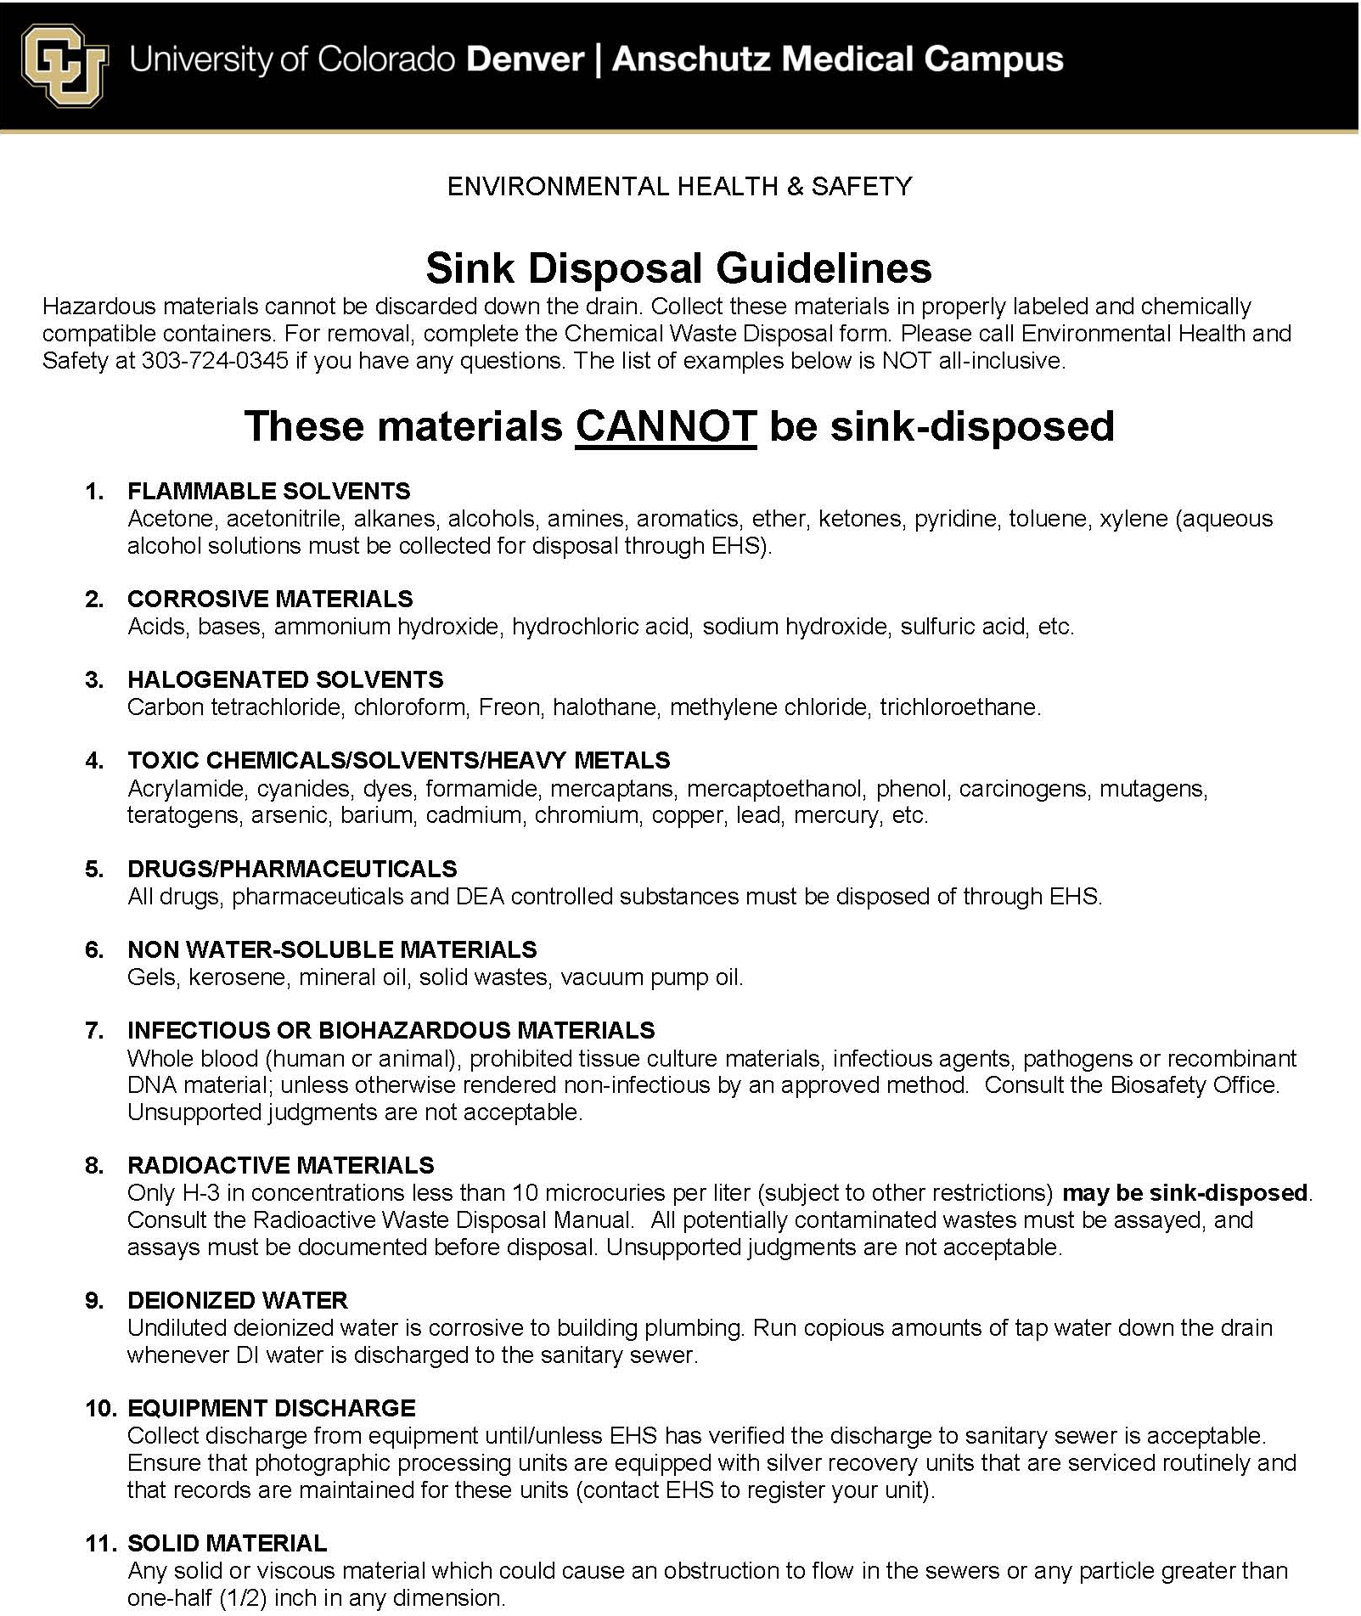
APPENDIX B

APPENDIX C
Cytotoxic/Chemotherapy Drugs
DRUG | TRADE NAME DRUG | RCRA LISTED
Actinomycin D
Adriamycin
Asparaginase | Elspar, Oncaspar, Pegaspargase
Bleomycin | Blenoxane
Carboplatin | Paraplatin, CBDCA
Carmustine | BCNU, BiCNU, Gliadel
Chlorambucil | Leukeran, U035
Cisplatin | Plantinol
Cyclophosphamide | Cytoxan, Neosar, CTX
Cytarabine | Cyosar-U, Ara-C, Cytosine arabinoside, BepoCty | U058
Dacarbazine | DTIC, DTIC-Dome
Daunorubicin | Daunomycin, Cerubindine | U059
Doxorubicin | Rubex
Epirubicin
Etoposide | Etopophos, Toposar, VP-16, VePesid
Fluorouracil | Adrucil, Efudex, Fluoroplex, 5-FU
Gemcitabine | Gemacitabine
Hydroxyurea | Hydrea
Idarubicin | Idamycin
Irontecan
Melphalan | Alkeran | U150
Mercaptopurine
Methotrexate | MTX Injection
Mitomycin | Mytamycin, Mitomycin-C | U010
Mitozantrone
Oxaliplatin
Procarbazine
Steroids
Streptozotocin | Zanosar | U206
Taxol
Taxotere
Tamozolomide

APPENDIX C continued
Cytotoxic/Chemotherapy Drugs
DRUG | TRADE NAME DRUG | RCRA LISTED
Thioguanine
Thiotepa
Timudex
Topotecan | Hycamtin
Treosulfan
UFT (uracil/tregufur)
Uracil | Mustard | U237
Vinblastine | Velban
Vincristine | Oncovin, Vincasar

APPENDIX D
Autoclave Validation/Quality Assurance
Standard Operating Procedures
All infectious wastes known or suspected of harboring Category A infectious agents must be treated by autoclaving on campus, in an appropriately maintained and serviced autoclave, prior to collection, transport and further off-site treatment and final disposal.
All Category A materials and wastes will be appropriately treated on-site then wastes have co-mingled with other RMW for secondary treatment off-site and final disposal. This is mandatory to comply with DOT regulations for the movement of Category A infectious agents in the RMW stream.
For each autoclave used to decontaminate Category A materials, monthly spore testing will be conducted by Biological Safety, or the PI or laboratory staff.
Each autoclave must be checked by a competent service provider not less than every 3 months (quarterly) to assure proper function. The university Facilities Operations & Maintenance autoclave team is the competent service provider of record.
The services must include preventative maintenance, temperature calibration, and verification of adequate disinfection. Verification of adequate decontamination shall be completed by the use of a spore test which adequately demonstrates that decontamination has occurred.
Records to be maintained include:
- Documentation of each (quarterly) autoclave maintenance service visit. The record should show that the autoclave is fully operational, as well as the date that service was performed.
- Documentation of any deficiencies and their correction.
- Documentation of monthly spore testing conducted by Biological Safety, the PI or laboratory staff.

APPENDIX E
Biomedical Radioactive Wastes
Biological non-carcass waste is a radioactive waste classification which applies to any biological material that does not qualify as animal carcasses or tissue, including:
- Animal bedding from animals dosed with radioactive isotopes;
- Sharps contaminated with biological materials and radioactive isotopes, in approved sharps containers;
- Plastic tubing, culture vessels of various types, and all other liquid and solid materials contaminated with small amounts of biological materials and radioisotopes.
The category of biological non-carcass wastes includes all solid or liquid radioactive waste materials that were ever previously classifiable as infectious before they were disinfected, no matter how clean and dry these materials may appear to be after the process of disinfecting them is completed.
Biological non-carcass wastes should be packaged in the manner prescribed by EHS Radiation Safety.
Biological non-carcass liquids, apart from their classification, are packaged the same as aqueous liquid wastes.
Infectious Radioactive Wastes include all wastes that have ever been in contact with human blood, serum, or other human bodily fluids, human, animal or plant pathogens, and are also radioactive. Human cell culture lines are also considered a potentially infectious material, unless they have been specifically demonstrated to be free of pathogens.
Infectious radioactive wastes must be disinfected by appropriate methods and classified as biological non-carcass wastes for the radioactive waste stream.
Autoclaving may be feasible as a means of disinfecting, but Radiation Safety must be contacted for specific direction to address the potential for release of radioactive materials. A written SOP should be reviewed and approved by the RSO and Biological Safety for autoclave treatment of infectious radioactive wastes.
Liquid, potentially infectious wastes that cannot otherwise be autoclaved must have a documented SOP that complies with both Radiation Safety and all Regulated Medical Waste requirements.
Solid materials, including absorptive materials, are typically treated by immersion for appropriate periods of time in the appropriate disinfectants, followed by pouring out or decanting off the disinfectant liquid into a liquid waste container.
Radioactive sharps contaminated with human blood or other infectious materials must be disinfected before or after being placed into a sharps container. The resulting container of disinfected sharps can then be presented to EHS as biological non-carcass waste.
Direct questions to Radiation Safety or Biological Safety, 303-724-0345.

APPENDIX G
HEPA Filter Disposal as Hazardous Chemical Waste
BSC HEPA filters are designed to remove harmful biological material and certain chemicals. HEPA filters used to remove biological material can be disposed of after gas decontamination as solid waste. However, filters contaminated with certain chemotherapy or antineoplastic drugs must be disposed of as hazardous chemical waste due to their toxicity, if they are a “U” or “P” listed waste as designated by the EPA, 40 CFR, Part 261.
The BSC certifying vendor must be informed if any of the following drugs were used in a BSC being serviced. Refer to the EPA’s 40 CFR, Part 261, Subpart D-Lists of Hazardous Wastes for a complete list of “U” and “P” listed waste.
Chemical | Listed Code
Chlorambucil (Leukeran) | U035
Cyclophosphamide (Cytotoxan, CTX, Neosar, Procytox) | U058
Daunomycin (Daunorubicin, Cerubidine, DaunoXome, Rubidomycin, Liposomal) | U059
Melphalan (Alkeran, L-PAM) | U150
Mitomycin C (Mitomycin, Mutamycin) | U010
Streptozotocin Chlornaphazine (Zanosar) | U206
Uracil Mustard | U237
Ethyl Carbamate | U238
Azaserine | U015
3-Methylcholanthrene | U157
Arsenic trioxide | P012

APPENDIX H
Cleanup Procedures for RMW
- Restrict access to the area until cleanup is complete. Use caution tape or placards to warn the public and keep them away from the site.
- Avoid stepping on spilled materials.
- Use safety glasses and disposable latex or nitrile gloves.
- Use tongs or a similar device to pick up any broken glass or sharps.
- Cover the spilled materials with absorbent pads or paper towels to clean up all pooling liquids or tissue.
- Reapply clean absorbent pads or paper towels over all contaminated areas to prevent splashing up or spreading out.
- If the spilled materials are infectious or potentially infectious, pour the disinfectant (do not spray; check expiration date) on the absorbent pads or paper towels until thoroughly soaked.
- Allow maximum contact time and follow dilution instructions (if applicable) as indicated on bottle of disinfectant.
- If the spilled materials infectious or potentially infectious, but are trace contaminated items used with chemotherapy drugs, cytotoxic drugs, etc., or pharmaceutical wastes, use an appropriate cleaner to thoroughly soak absorbent pads or paper towels.
- Absorb the material, working from the outside towards the center. Repeat if necessary.
- Dispose of used clean up materials, gloves, and any other disposable items (i.e. absorbent materials, etc.) that ca\ome in contact with the spill in the appropriate RMW container: red tub, yellow tub, or sharps container. All reusable items (tongs, dust pan, brush, etc.) must be thoroughly disinfected with appropriate chemical disinfectant or autoclaved immediately.
- Wash hands thoroughly with soap and water or apply hand sanitizer if sink is not immediately available, then wash hands at the closest sink.

Regulated Medical Waste Management Plan

Prepared By: Marcia Finucane, MS, CBSP, Biological Safety Officer

Approved by: Ethan Carter, Director of Environmental Health and Safety

Effective Date: August 1, 2019
Replaces: Version 3, April, 2018
Applies: University of Colorado Denver | Anschutz Medical Campus

Animal wastes in these categories, generated at the Anschutz Medical Campus CCM vivarium, will generally be disposed of through incineration.
All RCRA wastes are to be turned in to EHS Hazardous Materials as chemical wastes.
Preservatives are to be turned in as chemical waste to EHS Hazardous Materials.
NOTE: Animal blood is classified as "animal tissue," not "biological non-carcass", Radioactive Waste Manual,

