How to fix CITI Certs not populating to infoEd
The most common reason that CITI certifications are not appearing in your infoEd profile is a mismatch of Employee ID between the systems. Follow the directions below to compare and fix this in your profile.
You will need to identify your Employee ID in your profile to compare against your CITI profile. You can do this by going to “My Profile” in the top left navigation bar.
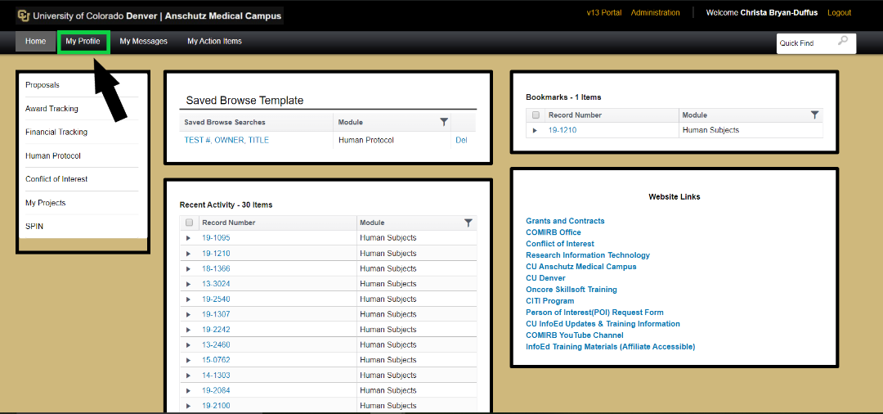
Once you have opened your profile look for “Employee/Student ID” in the main body.
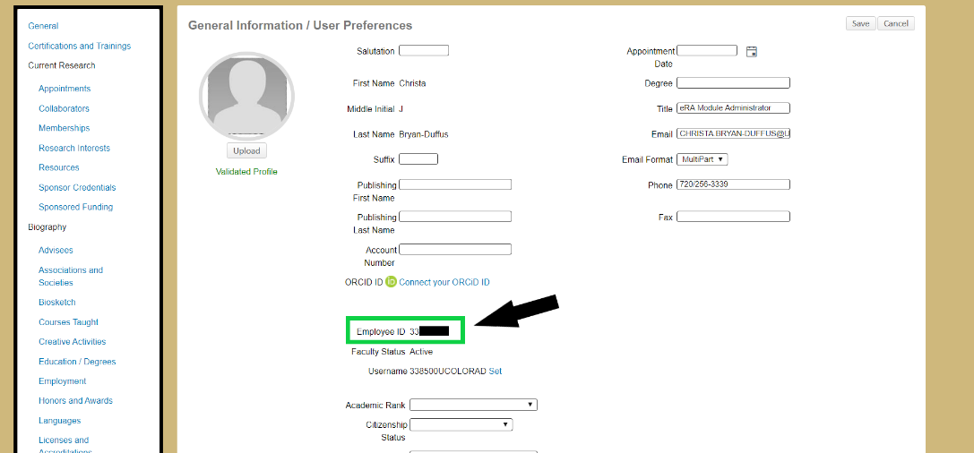
Next, you will need to log in to CITI and click the arrow next to your name in the top right corner. This will open a drop down menu, where you will select “Profiles”.
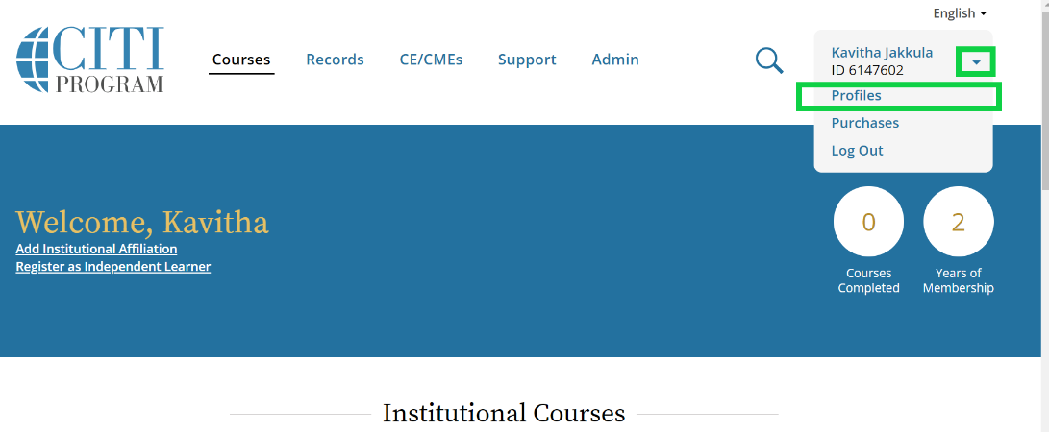
On this new page, look for “University of Colorado Denver” under “Institutional Profiles”. Click “Edit Profile”. This will open your profile for editing. Compare the Employee ID from you infoEd profile to the Employee ID# or POI# on this page. If these numbers do not match, you will need to add the ID from your infoEd profile here and save.
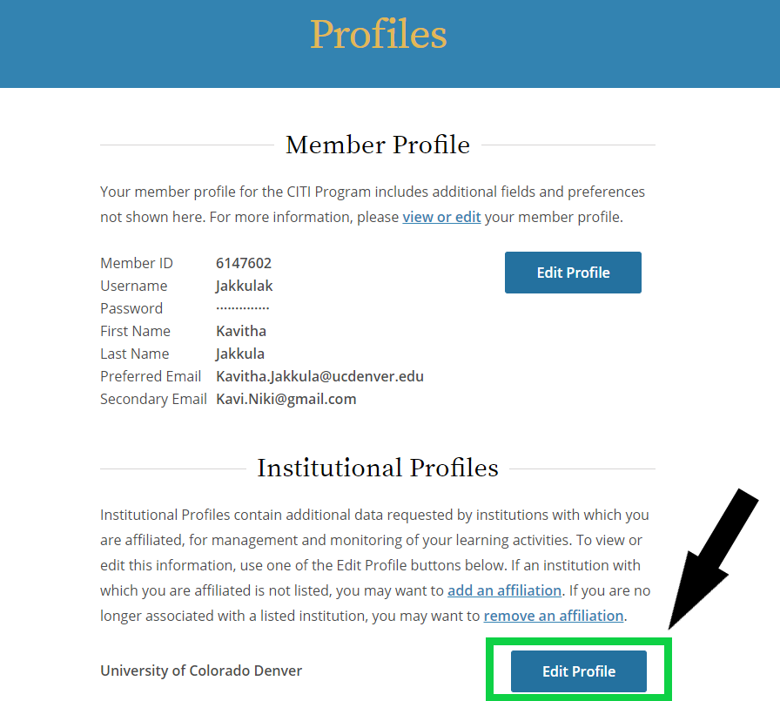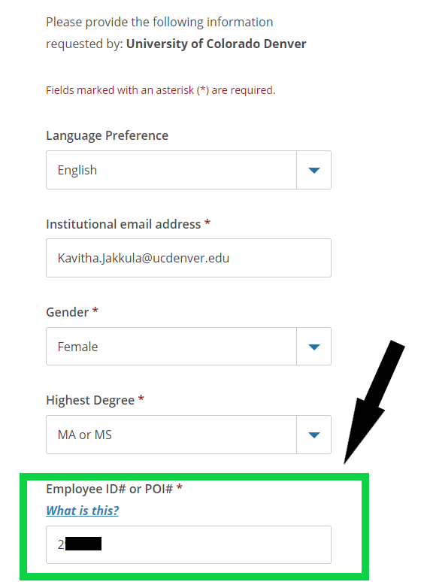
The syncing process can take up to 48 hours. Please contact ERA Support if you do not see your certifications after that time.

