How to add a Delegate

In order for other users to see your protocols, proposals, messages, action items, or calendars, you will need to add them as delegates to your infoEd profile. Only you can add someone as a delegate for your profile, so to gain access to another person’s protocols or proposals you will need to request that they add you.
To begin, click on My Profile in the top navigation bar
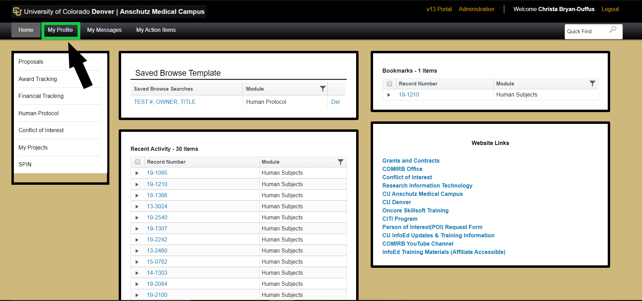
This will open up your infoEd profile and you will find “Delegates” at the bottom on the left menu:
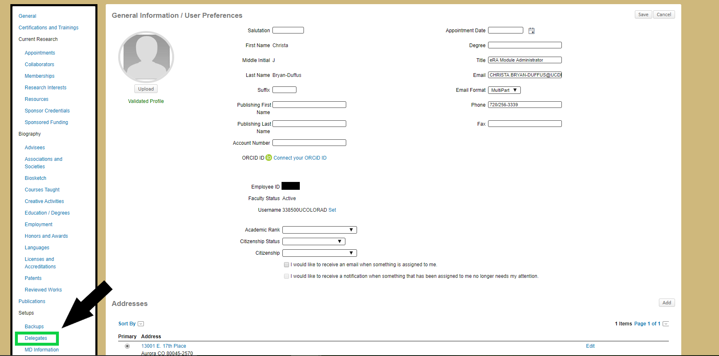

Clicking this will open your Delegates screen, which may be blank or you already have delegations from others. In the top right you will see an “Add” button, click this to add a delegate to your profile.
You should now see a pop-up where you can use progressive search to find the name of the person you would like to grant access to. At this stage you can choose to give this delegate access to your messages, work queue, and calendar (This can be changed at a later step).
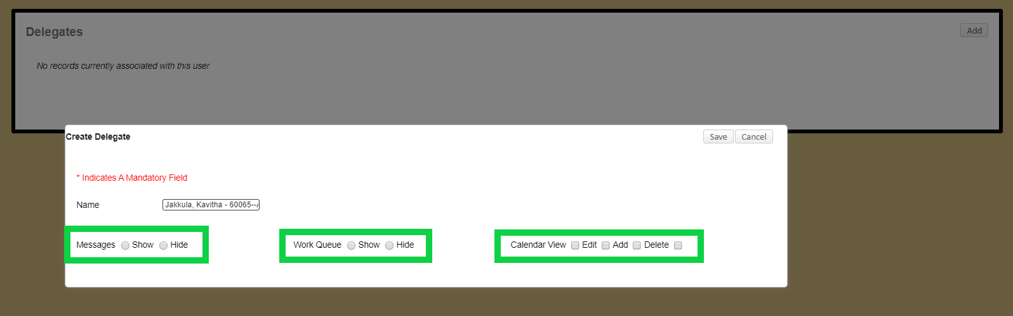
Once “Save” is clicked, you will now see a line item for the new person. If you stop at this point, the delegate will only have access to the previously selected items, not proposals or protocols. Clicking their name will open additional options for delegation.
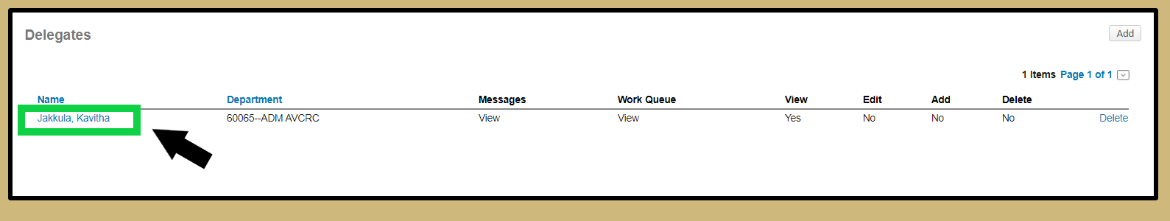
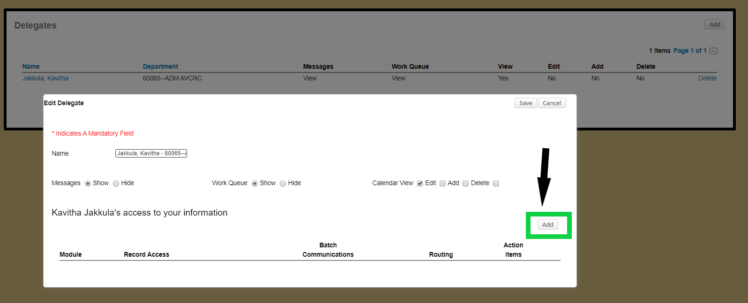
If you want to grant access to your protocols or proposals, you will need to add the module access by clicking “Add”. This will open another pop-up that gives options for modules. You can multiple modules by holding Ctrl and clicking each module.
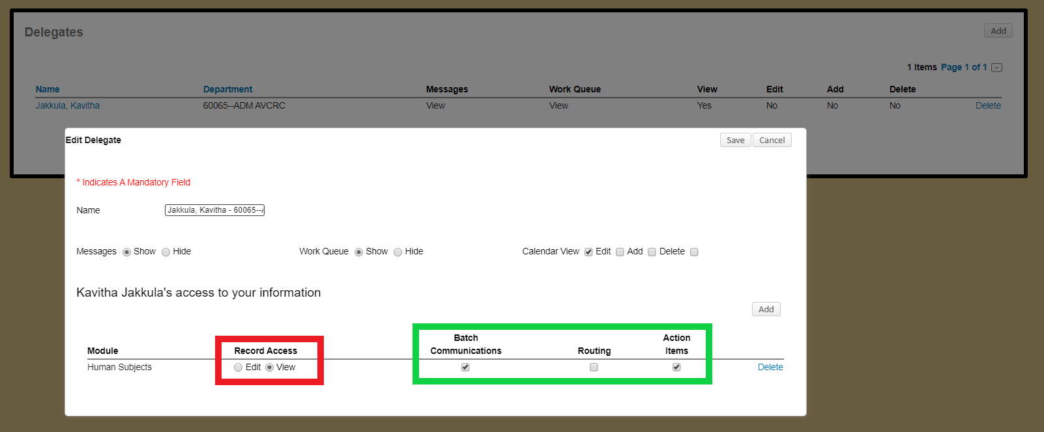
Once the module is added you will be able to choose either “Edit” or “View” access, as well as Batch Communications, Routing, or Action Items related to the module. It is important to note that only “Edit” access will allow others to edit your protocol or proposal. Once the changes have been saved, the delegate will have access immediately. To revoke access you can either click “Delete” next to the delegates name to remove all access or click “Delete” next to the module to remove the module access.

