Resources about “The Rule Makers”
- Federal Regulations - 45 CFR 46.116 (HHS) or 21 CFR 50 (FDA) Click: HERE to access federal regulations.
  - General requirements and 8 required elements for informed consent. Click HERE to see basic elements of consent, and 8 required elements.
  - Clinical Trials.gov requirement (See attached document from COMIRB)
  - Special Considerations (Vulnerable Populations)
    - Pregnant Women, Fetus and Neonates Subpart B. Click HERE for regulation
    - Prisoners – Subpart C Click HERE to assess COMIRB policy regarding prisoners in research
    - Children – Subpart D Click HERE here for Subpart D. Click HERE to assess COMIRB new policies on children in research and Click HERE for COMIRB summary table about children involved in research
- Institutional Policies and Procedures
  - COMIRB Policies and Procedures Click HERE to access COMIRB Policies and Procedures which are searchable by word or topic.
  - UCHealth Research Administration Click HERE to access “The Source” – login required
  - Departmental SOPs and Guidance documents

- Sponsors
  - Government agencies sponsoring research
  - Institutional Principal Investigators (PIs) as a sponsors (IITs)
  - Industry Sponsors – pharmaceutical companies

Resources about “The Processes”
- Create it
  - Required content Click HERE for COMIRB “forms” library; then select “Consent Forms” for templates to use in creating a consent form.
  - Reading grade level and logical structure
  - Short forms Click HERE for COMIRB short form policy
  - Assent. Click HERE for COMIRB policy on Assent forms in research
  - Waivers. (please see attached form “Waivers of Consent, Documentation of Consent, and HIPAA Authorization​
- Present it
  - See attachment “Standard Operating Procedure for Informed Consent” from the Clinical Research Toolkit
  - See attachment, “Electronic Consent” for information on eConsent
  - Who can perform consent? Qualified team members will have training and specific knowledge
  - When and where – in a private, quiet area; after COMIRB approval (discuss approval stamp and date) after initial screening; before any procedures
  - What is used - approved consent, short form, assent form, translations - (see SOP)
- Assess it
  - Assess communication needs See “Further Resources” for links to Health Literacy, Readability, comprehension, and assessing communication.
  - Assess comprehension
  - Use proven methods
- Document it Click HERE for COMIRB’s policy and procedures, and go to Section 14.3 to read COMIRB’s policy on documentation of informed consent
  - What is documentation?
  - How do we document?
  - Who needs to sign the consent form?
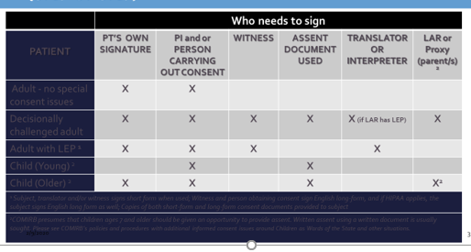

Further Resources

- Assessing understanding -
- Clinical Trials.gov information, see COMIRB Policies and Procedures, 14.2.1:
  - Clinical investigations involving drugs or biologics which are controlled and other than Phase I investigations. Clinical investigations involving medical devices which are prospective, controlled, and other than a small feasibility study; For applicable FDA-regulated studies information about ClinicalTrials.gov. Applicable studies include:
  - Revision: CT.gov – Common Rule (Revised): A version of the Informed Consent used to consent the subject must be posted after enrollment closes, but no later than 60 days after the last study visit. This posting does not need to be updated with new versions of the consent. Applies to clinical trials initiated on/after Jan 21, 2019 that receive federal funding or support (including from our CTSA grant)

- COMIRB guidance and policies – click HERE to access
- Electronic Consent – see attachment
- Health Literacy
  - Click HERE for HRSA Health Literacy Information
  - Click HERE for tips on readability
- Secondary Research Application – see attachment Seconday Research Policy - see attachment
- SOP for Informed Consent – see attachment

