Routed Proposals by Department

Contents
Routed Proposals by Department 1
Overview 2
Location 2
Running the Report / Prompts: 3

Overview
The Routed Proposals by Department report identifies Proposals that have been recorded in the Status of “In Routing” within the time frame selected in the prompt, for the Department that has been selected.
It is sourced from the InfoEd application.

Location
The report is available in CU-Data in the following location:
Team Content > eRA > CU Denver| Anschutz > Proposal Tracking
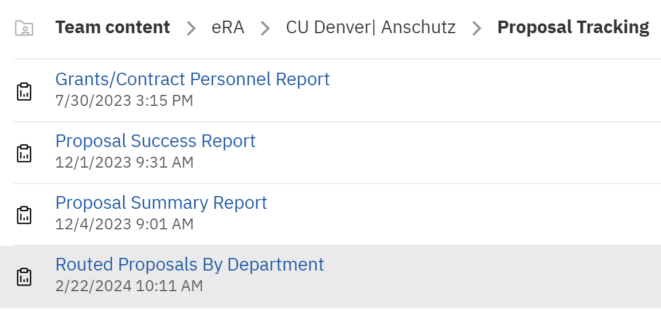
Definitions:

- Proposals are determined to be “In Routing” for this report when the first occurance of the “In Routing” status from the Proposal Summary Status History table falls within the date range selected in the prompt. The Proposals returned are then joined to Proposal data to complete the information.

Running the Report / Prompts:

The report is designed to be formatted in Excel.
When you run the report, you will see a prompt page as shown:

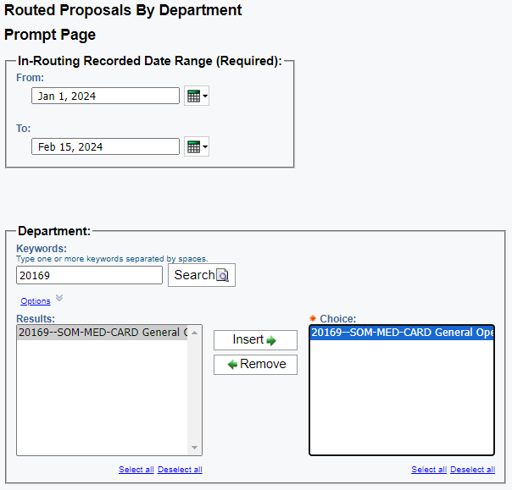

Both the In-Routing Recorded Date Range prompt and the Department prompt are required for the report.

Once the Date Range and Department Options have been selected, the report is returned as shown:

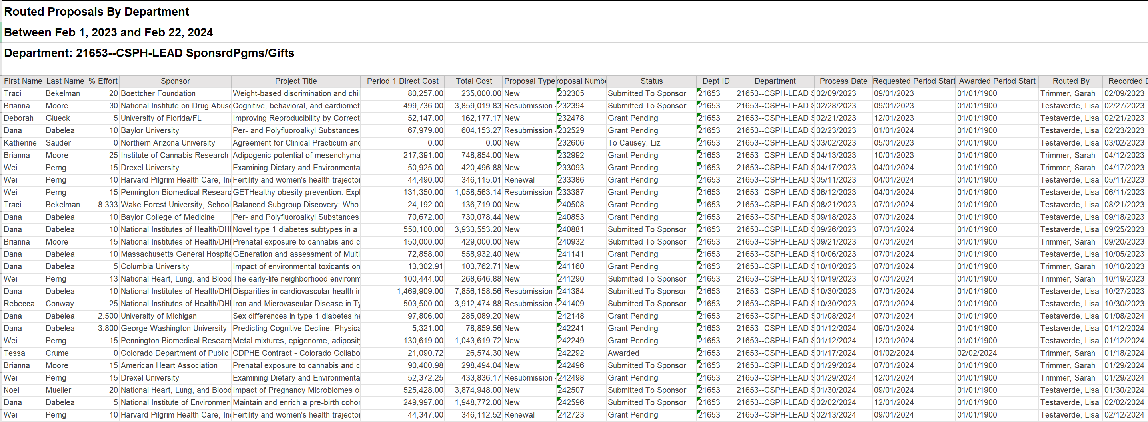
- The Period 1 Direct Cost column pulls the amount from the first proposed Budget Increment (Increment Period = 1.)
- The Total Cost column represents the sum of all increments that have been proposed for the Award.

