Proposal Summary Report Expanded Search Criteria

Contents
Proposal Summary Report Expanded Search Criteria 1
Overview 2
Location 2
Prompts 2
Columns 3
Tabs 4

Overview
The Proposal Summary Report supplies various standard information on InfoEd records. It is a flexible report that does not supply a filtered output like the Award Summary Report and so may require more care when interpreting the data. It is not meant to be used for data relating to awards.
Department proposal counts over time, sponsors applied to, or other details can be pulled from the report, however, because a specified output such as only proposals submitted to sponsors is not built into the report, users must manually filter the statuses of records in the report to get to this kind of answer. For example, records still in the In Development or Grant Proposal Review stages will still appear on the report and shouldn’t be counted toward submission metrics. Many status history entries relate to internal OGC (Office of Grants and Contracts) business processes, so consult OGC for any data questions.

Location
Team content > eRA > CU Denver| Anschutz > Proposal Tracking

Prompts
Note: Some prompts have a blue Options hyperlink that can be clicked to expand the search criteria. Case sensitivity may be adjusted and any of four search options may be selected: 1) Starts with any of these keywords, 2) starts with the first keyword and has all the remaining keywords, 3) Contains any of these keywords, 4) Contains all these keywords.

Associated Department (select node)
- The “select node” version of the prompt will include results for the selected node and all orgs below it in the org tree
Associated Department (select depts)
- The “select depts” version of the prompt will only include records that the specific department has been searched for and will not include records for orgs below it in the org tree. All desired orgs must be added individually. This is more suited to multi-departmental searches
Select Primary Investigator Name
- Also allows for searching by Employee ID
Select Project/Acct/Misc Number
- This will be Project ID(s) for awarded records, an Activity Code, or the potential grant number depending on the stage in the application cycle of records at the time of the search
Proposal Type
Sponsor Type
Current Status
Sponsor
Deadline Date
Process Date
Submit Date

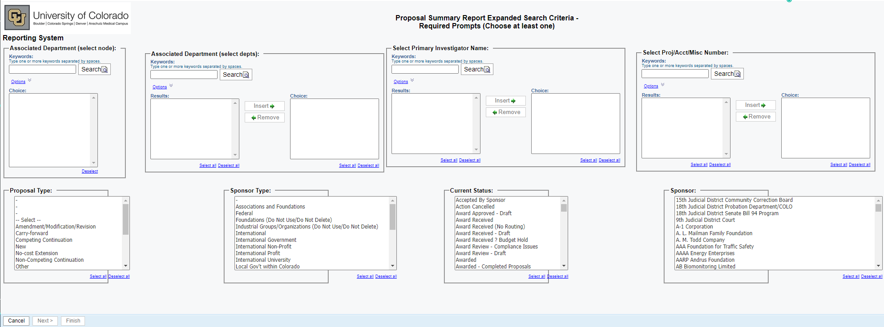

Columns
Institution Number
Department
PI Name
Proposal Created By
Status
Proposal Type
Sponsor
Sponsor Type
Project Title
Program Type
Instr. Type
Process Date
Deadline
Returned to Dpt
Submit Date
Activity Code
Activity Description
Proposal Account Number
Requested Project Period Start
Requested Project Period End
Proposed Direct Costs
Proposed Indirect Costs
Proposed Total Costs
Award Date
Awarded Project Period Start
Awarded Project Period End
Award No.
Awarded Direct Costs
Awarded Indirect Costs
Awarded Total Costs
Create Date
PD?

Tabs
Page 1

Ctrl+Click: Back to Top

