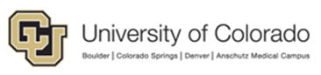
Awards Report
​
Contents
Overview 2
Path 2
Definitions: 2
Running the Report: 3
Tabs 3

Overview
​​
The Awards Reports look at Award Budget Increments that have been funded during a specific time period. The report examines various metrics to include sponsor types, schools/departments, and prior history. There are three different reports that pull data for the Anschutz Campus and the Denver Campus separately, as well as a combined report.
It is sourced from the InfoEd application.
The Awards Reports look at Award Budget Increments that have been funded during a specific time period. The report examines various metrics to include sponsor types, schools/departments, and prior history. There are three different reports that pull data for the Anschutz Campus and the Denver Campus separately, as well as a combined report.
It is sourced from the InfoEd application.

Path
The reports are available in CU-Data in the following location:
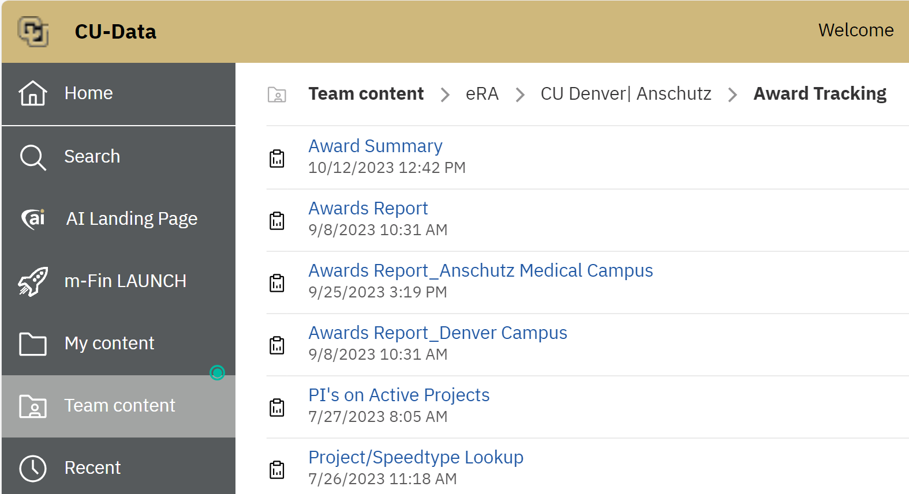

Definitions:

- Only increments that have received new funding within the time period are included on the reports.
  - Award Budget Increments that are not shown in the analysis include De-Obligations
  - Increment Types that have been created for the purpose of prior year corrections

Running the Report:
When you run the report, you will see a prompt page as shown:
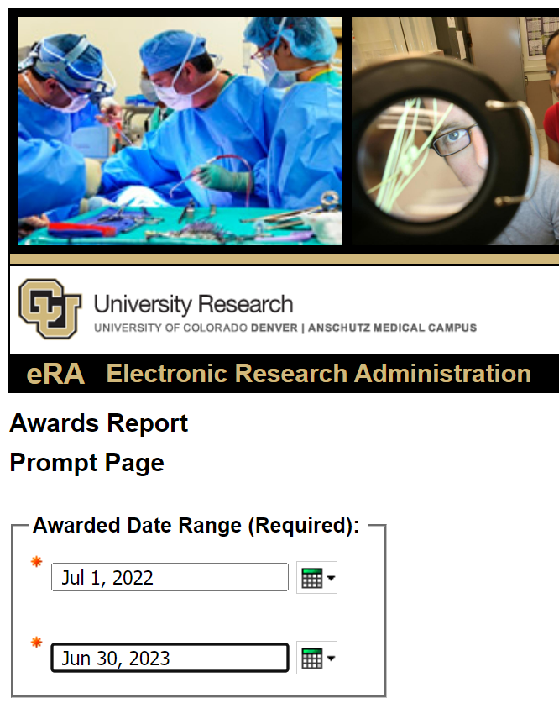
The report is designed to be formatted in Excel, and there are several tabs that will be displayed:

Tabs
The Awards by Sponsor tab groups Awarded amounts by pre-defined Sponsor Groups, based on the direct sponsor of the award.
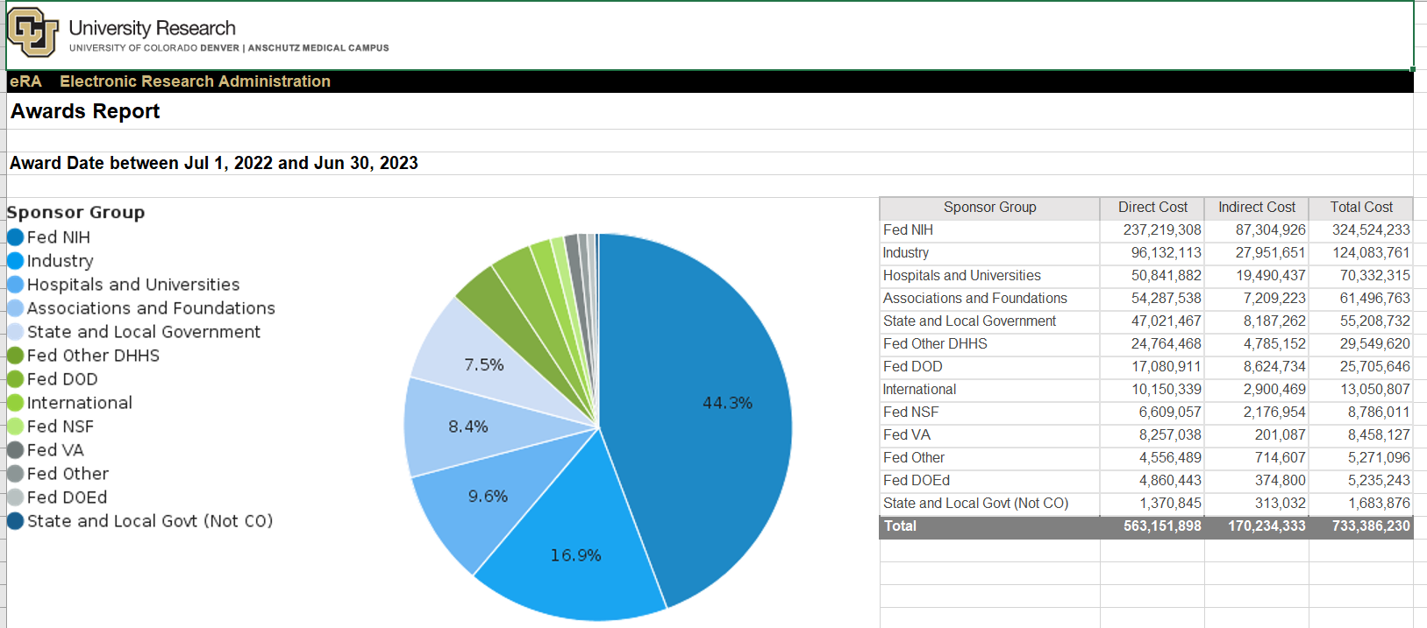
The Awards by Prime Sponsor tab presents the same awarded amount information, grouped by the original sponsor supplying the funds as flow-through.
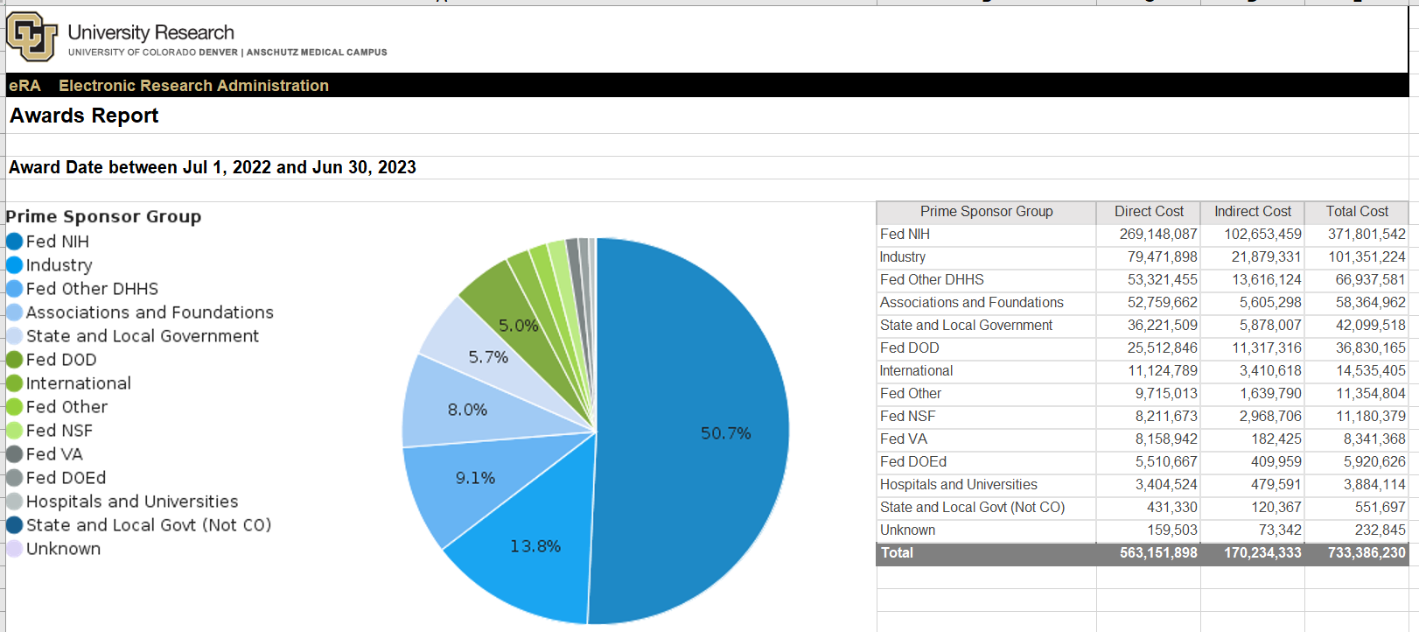

There are 2 “History” tabs that automatically supply the same data from the prior year for whatever date range you selected on the Prompt Page.
For example, if the report is run for July 1 through December 31, the prior year would reflect that same time frame to make the data compatible.

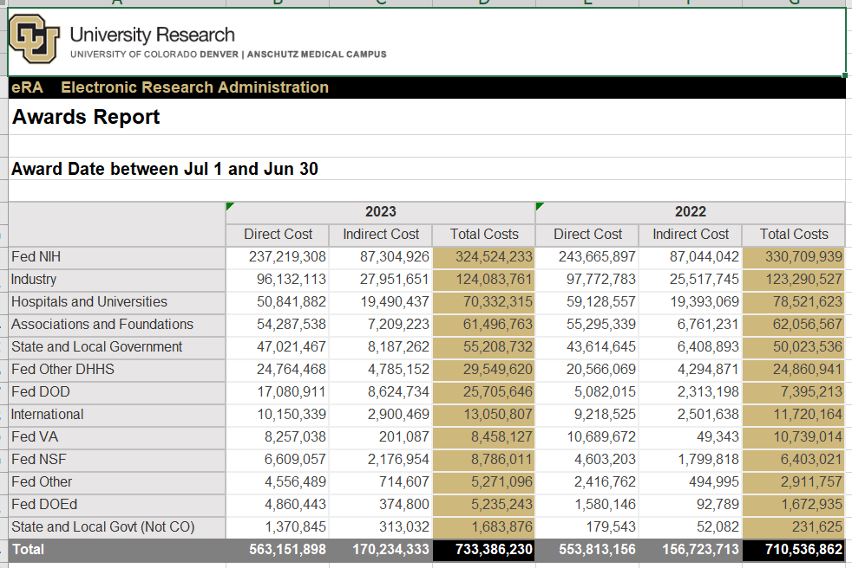

The Awards by School and Awards by School_Hist tabs present the data at the School/College and Department/Division levels.

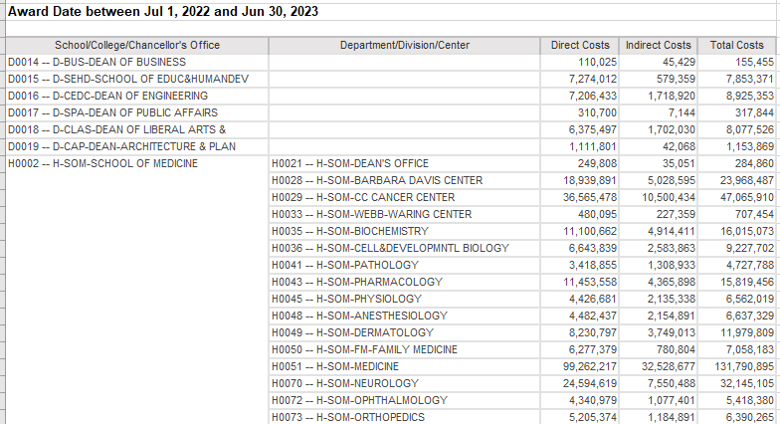

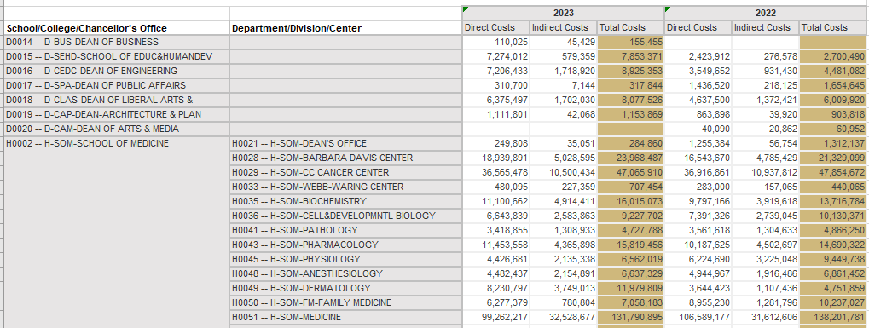

The NIH (National Institutes of Health) tab presents metrics specific to the largest source of funding for the Anschutz Medical Campus
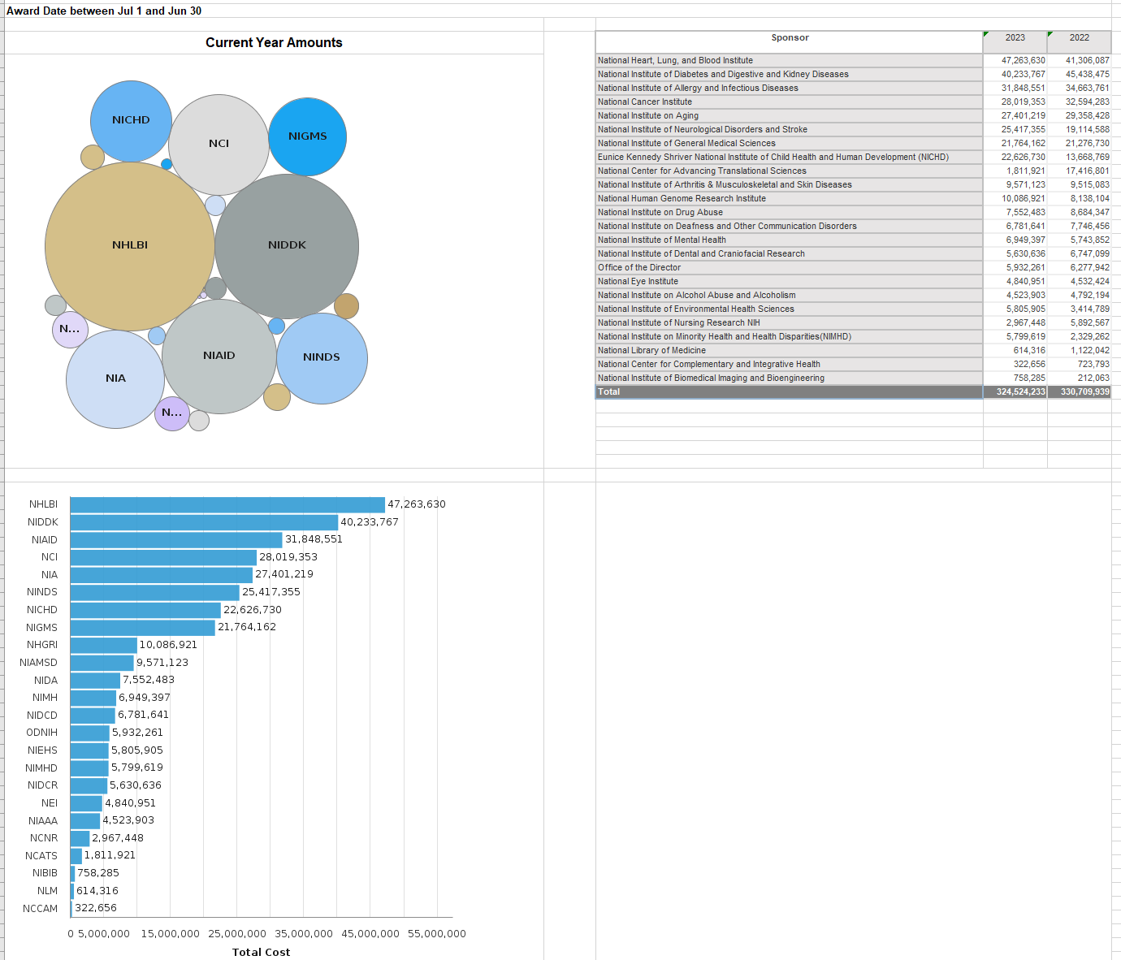

For those who might be interested in spotting patterns over the time period, the Awards by Month Sponsor and Awards by Month School tabs show award data by Month at the Sponsor level, and by School/Division.

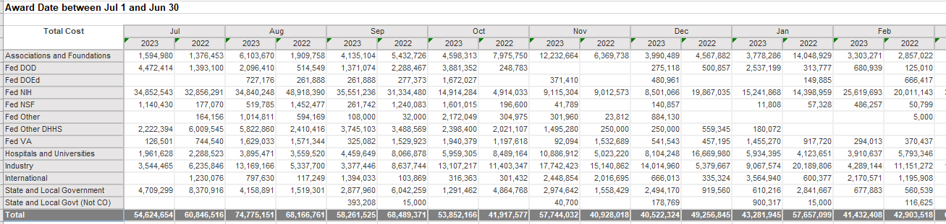

The last tabs return the detailed information behind the Award metrics, by Fiscal Year, and any Prior Year Corrections recorded. For ease of analysis, the detail tabs include Org Level definitions from the Peoplesoft Org Tree.

