Awards Summary
​
Contents
Overview 2
Path 2
Definitions: 2
Running the Report: 3
Tabs 3

Overview
The Award Summary report presents the same information as the Awards Report. It includes Award Budget Increments funded during a specific time period. It allows, however, for more precise filtering at several levels:
- Date range
- Org/Org Tree node
- Department description
- Org number
- Principal Investigator
- Sponsor
- Sponsor Type

Path
The report is available in CU-Data in the following location:
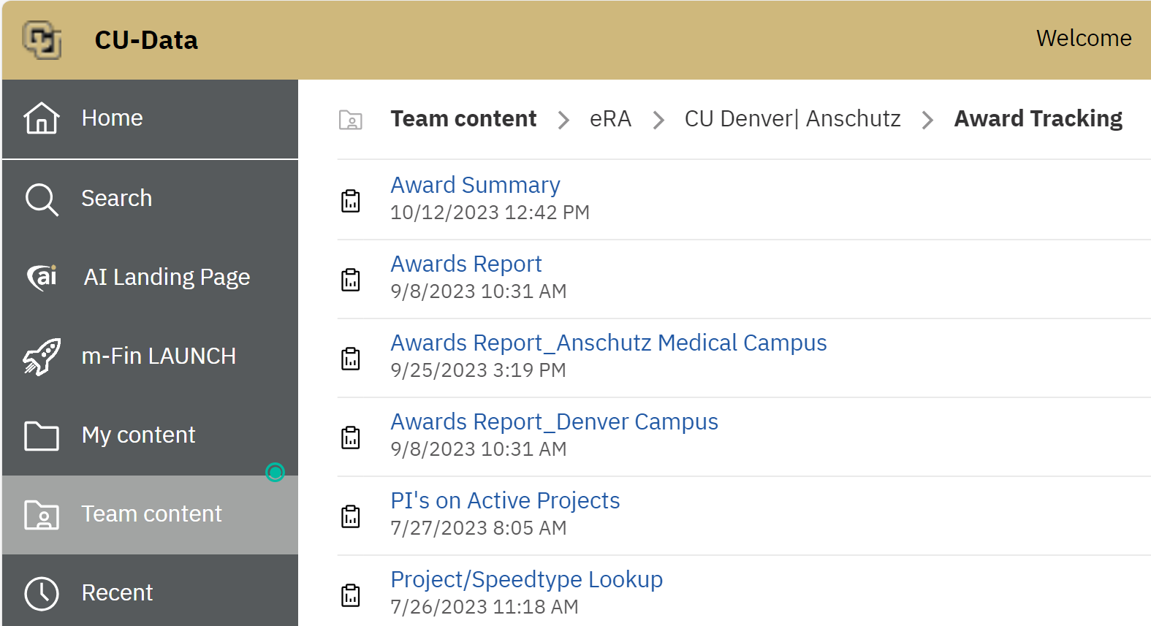

Definitions:
- Only increments that have received new funding within the time period are included on the reports.
  - Award Budget Increments that are not shown in the analysis include De-Obligations
  - Increment Types that have been created for the purpose of prior year corrections (corrections are displayed on a separate tab)

Running the Report:
When you run the report, you will see a prompt page as shown:
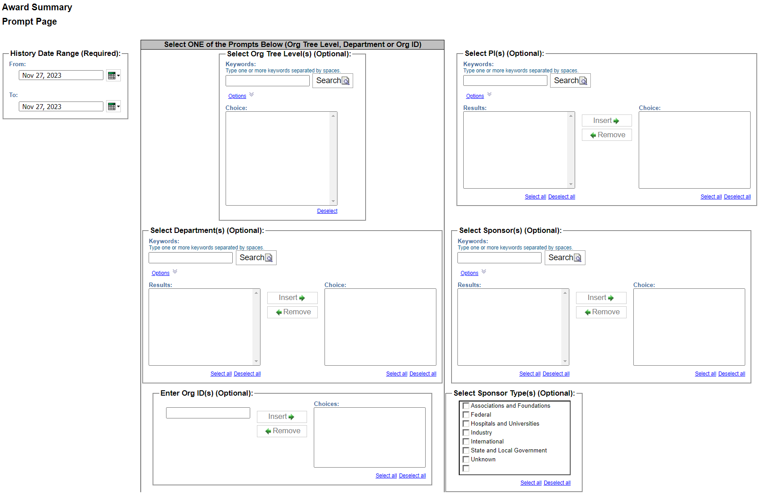

Tabs
The report is designed to be formatted in Excel, and there are several tabs that will be displayed:

The Detail tab includes specific detailed information about the funded Award increments during the time period.
The Corrections tab displays any corrections from the prior year that were discovered after that reporting year data has been finalized and cannot be captured in the current year.

The Awards by Sponsor Type tab summarizes the Award data by Sponsor Type:

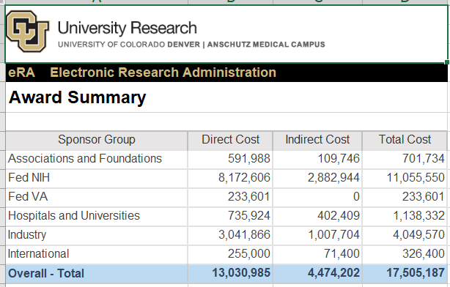
The Total by PI (Principal Investigator) tab displays Awards summarized by the Principal Investigators assigned:
